Procedure for CCR-BPW, OASIS and export GUI

Acquiris DCS 222 digitizers for BPW pick-ups

Four separate digitizers are used to acquire at a fixed rate of 8 GS/s the signals (sum and difference) from the two BPW pick-ups 317.98 (horizontal) and 319.31 (vertical).

OASIS: settings and limitations

A global has been defined in OASIS:

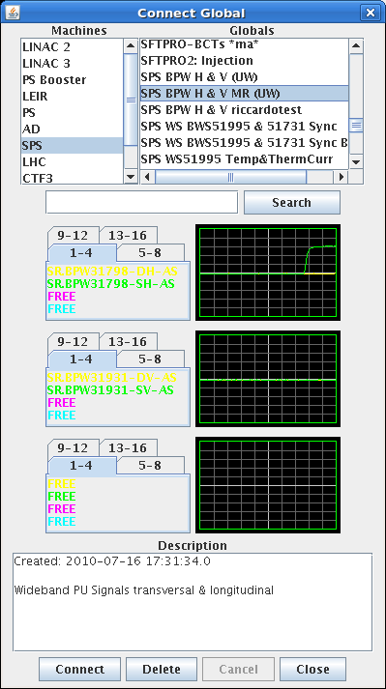

Currently the limitations in OASIS are:

- Class Fesa: 1’000’000 points (per trace ?) and 125’000 traces
- Viewer (?): 4000 turns at 160 points (640’000 points)
- Using the built-in export function gives a JavaHeap error when large data quantities are handled
Adjust in menu Scope<#> the following as desired:

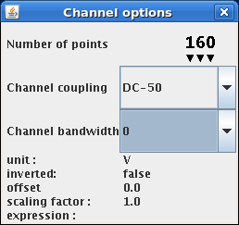

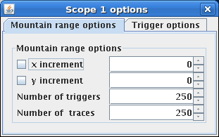

Use with a single bunch:

A good compromise for settings in OASIS within its current limitations is:

- 8 G/s → 125 ps
- 160 x 125 → 20 ns
- 1000 turns ok → 160’000 points, tested
- 4000 turn → 640’0000 points. This is the limit, imposed by the OASIS scope software → 9.6 Mbyte for the csv file saved by the new GUI export
- Currently B = 1661 in the VTU (see below) to see the single bunch on the OASIS scope

Use with multi-bunch LHC type beam:

- 4 batches: 4x72 bunches = 8 μs → 400 x 160 = 64’000 points per trace required
- 2 batches: 2x72 bunches = 4 μs → 200 x 160 = 32’000, 250 traces, saving data tested

More turns are required, but currently a limit exists that does not allow the full use of the memory of the cards. As not all traces are displayed one would need to filter for the viewer, still enabling storage of the full data set. Moreover, saving 32’000 points per trace and 250 traces required ~20 seconds. This would be the approximate limit for logging of each cycle, unless the software can be made faster.

Trigger control (VTU)

The trigger is generated in the Faraday cage, transmitted to the CCR room and distributed within the rack with the digitizers. Cables from the two pick-ups have been equalized such that a single trigger can be used for all digitizers while always displaying the same bunch of the beam (i.e. time of flight compensation between signals from the two pick-ups done by a cable loop).

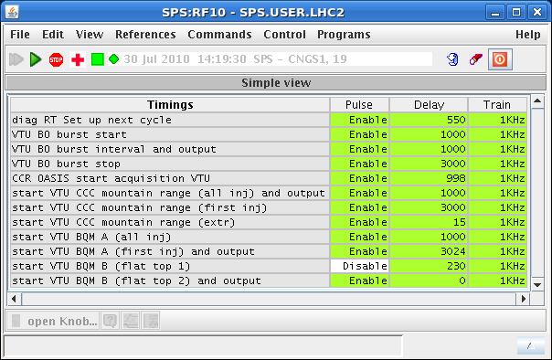 timing RF10
In the working sets menu, the timing knob CCR OASIS start acquisition VTU, RF10-0-8 must be enabled. It generates the “NEXT” for the trigger unit (VTU) and hence initiates the train of trigger pulses. Its default value is 998, which corresponds to 2 ms before injection of the beam. Disable the timing for all cycles that are not being observed.

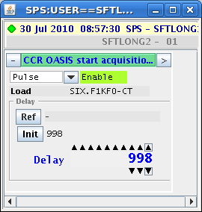

To control the trigger unit, open the ALLVTU class in the FESA navigator:

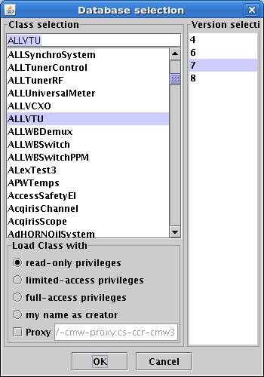

Pay attention to select “read-only privileges” (sic !) and version 7

Select the crate cfv-ba3-alldiag1 which houses the VTU that needs to be programmed.

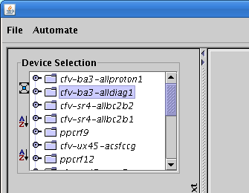

The device is called VTU_OASIS_CCR

Settings have been copied to all users and the outputs of the VTUs. Note that for the copy operation with the COPYPL property the destination (sic !) is selected in the left column and the source (cycle) on the right panel (value !)

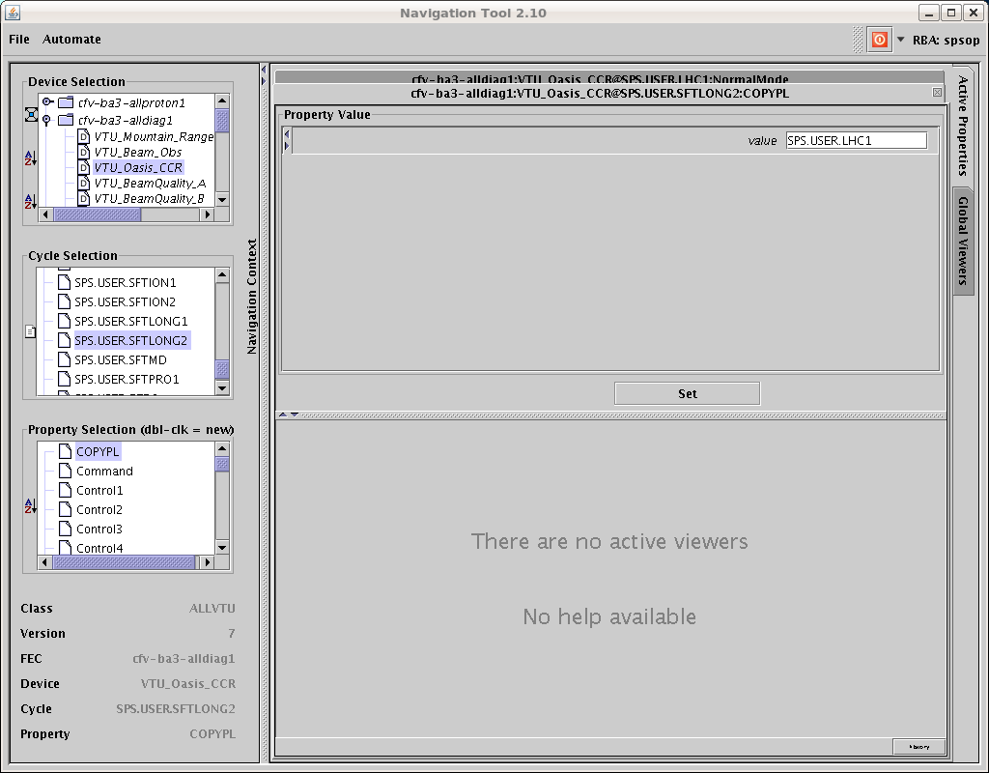

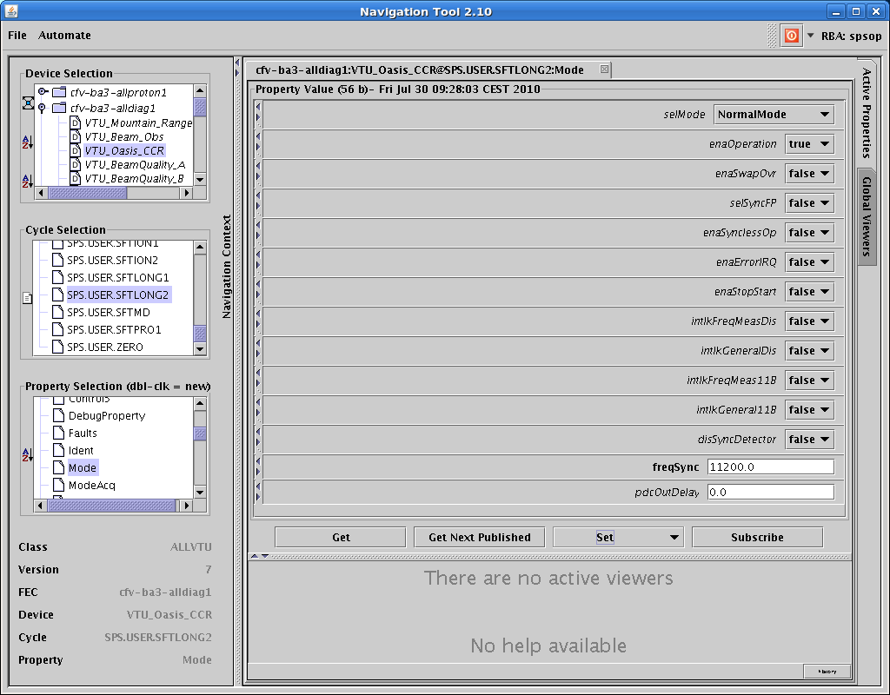

In the mode property set the enaOperation to true. This switches ON the output train of the VTU provided the timing is enabled for this cycle (timing see above). Note that to read a property you need click on GET. The values displayed before GET are not the values (not necessarily) actually in the hardware. Another feature requires that when selecting a property one has to double click extremely fast, otherwise no action is taken. Moreover, after pushing SET there is no confirmation given. It is recommended to do a GET after a SET in order to have a confirmation the value has really changed.

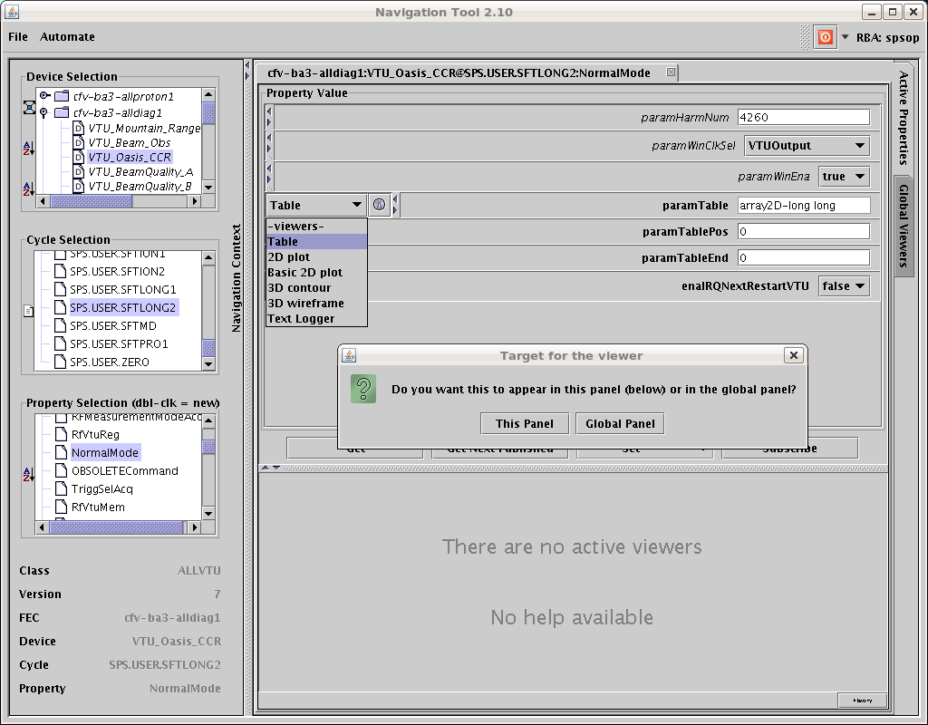

The parameters of the triggers are adjusted with the NormalMode property. Open the parameters table as indicated above. Verify that the harmonic number is 4620 (upper left corner).

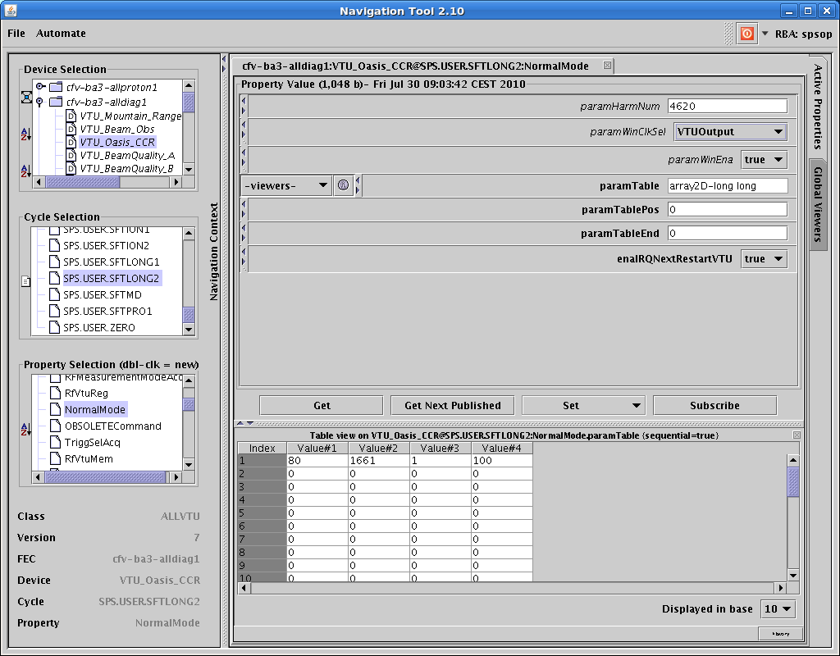

Value #1: D: Delay in number of turns of first trigger with respect to the timing
with the default timing knob setting 998 and D=80 the first trigger arrives
just before injection of the beam (2 ms → 86 turns, some jitter of injection with
respect to ms possible …)
Value #2: B: Delay of first trigger with respect to revolution frequency reference, units of 5 ns
Value #3: T: distance in number of turns between triggers pulses (1→every turn)
Value #4: W: Number of triggers

Note that the number of triggers (W) must match the number of traces programmed in OASIS. As OASIS seems to be capable of collecting triggers from different cycles or a different super cycle when the correct number of triggers is not received some confusion can arise. It is recommended to only generate triggers on a single cycle and exactly match the number of triggers to the traces displayed. Freezing and unfreezing OASIS after a change of trigger settings may be advised to start a clean acquisition.

Hi Wolfgang,

Here is a screen capture of the application.

So first, I should say the GUI is far from perfect but you should have enough information of what's going on in the console (so click on the triangular button at the bottom to un-wrap it).

The menu let you choose the signal (if you need to record more than one signal at a time, then open the application multiple time). Then click on the connect button but first disconnect the signal in Oasis as the application need to be master of the scope to work in single shot mode with automatic re-enable.

The text field is for the path of the exported file. Please put a full path (use / on Linux and \ on Windows) and use the % as a placeholder for a 6-digits counter. Then the first spinner is the start value for this counter and the last spinner is the stop value.
So in the screen capture you can see (in the console) that 3 files were created :
RF_MD_EXP000001.zip, RF_MD_EXP000002.zip, RF_MD_EXP000003.zip

The export will start when you click on the start Export button. This will either stop automatically at the stop value of the counter or when you click again on this button (the label will be Stop export).
The zip checkbox let you choose between a zipped csv file or a plain csv file. It would be good to let this checked as zip offer around 95% compression on those kind of data.

This application can be found here : http://cs-ccr-www1/~rfacsop/java/accsoft-rf-oasisexport/OasisExport.jnlp

I hope everything work fine (if you see this mail before midnight, I might reply to any of your question).

Cheers,

Michael

