BSRT for dummies

by C. Hansen (updated by O. Domínguez, 26/August/2011)
An extreme simplified "step by step" description of how BSRT data was measured and analyzed during April 2011 scrubbing MD in LHC.
NB:
- We strongly recommend that BSRT users apply for an account in the cs-ccr-dev4 machines some days before the MD in order to have access to the analysis tools.
- Send email and ask this to Jean-Michel Elyn
- This is needed for the dbaccess application (see below)
BSRT How To:
Main window
- Open an xterm in any of the lhcop computers: ~bravin/bin/bsrt
- Choose Mode (under Control label): e.g. Pulsed
- Make sure that the boxes Gain and Filter are checked and that the Pos is ON (under Feed Back label)
- Under the label Gate you have to select the right length: =1 for 25 ns, =2 for 50 ns, …
- Open a second window for Beam 2: File -> New -> Device -> BSRT2
- In principle nothing should be touched unless there are problems (e.g. sometimes the mirrors are displaced due to heating):
- If you start losing the beam spot from the window you need permission to make changes:
1) Ask OP people to set lhcop user as an Rbac-BIexpert
2) File -> connect (Operators will provide you with the password)
3) Change Pos from ON to Ref. If we see again the spot, change again from Ref to ON. Otherwise, contact F. Roncarolo before playing with the position of the mirrors.
- Sometimes the beam spot is too small or too big for the window size and it’s useful to resize the window:
  - Change Pos from ON to OFF (you need permission also for that).
  - Click on max window (Under Display label). You’ll see the beam small at some point of the new window.
  - Create with your mouse the desired window (white square) around the beam spot.
  - Click on Set window.
  - Change again Pos to ON.
Gate scan window
- Open the gate scan window (for both beams): View -> Gate Scan Window
- Choose the number seconds to measure each bunch: e.g. # of points 3 (if the number of bunches is not too high, is better to put 5.The more points the better. Less than 3 is not recommendable)
- Get the filling pattern from FBCT: Get
- With the option Subscribe selected, the filling pattern will be refreshed after each new injection and will continue measuring in the same bunch as it was (N.b: in the past it started always from the first bunch)
- Check the loop square
- Start to collect measurements: Green "play" arrow
- You can load your own patterns if you want to look at a certain train instead of looking at all the injected bunches. In order to do that, uncheck the option Subscribe and Load your file (using the folder symbol bottom). It is recommendable to save your files in your nfs account (i.e. in your account when using the cs-ccr-dev4 computer). You can instead modify the filling pattern manually by removing the bunches you don’t want to measure.
dbaccess How To:
- Log in to cs-ccr-dev4: ssh -XCY xxx@cs-ccr-dev4.cern.ch
- Start the program: ~bravin/bin/e-anal.sh (N.b. It is not any more necessary to change your source .tcsh file!)
- Under the Query tab
  - Choose the Period Interval for which to collect and show results (NB: due to bin problems you'll need at least some hours!)
  - Choose one of the Query Options, normally “Repeat over one second”: REPEAT 1 SECOND (N.b: in the past it was AVG.)
- Go to Variables tab
  - Choose BSRT under DEFAULT LISTS
  - Select the whole list to the right
  - Load it by clicking Load Selected Var
- Go back to Query tab
  - Click on Get DB Data ... and wait a bit
  - Build the TTrees by selecting both monitors, 5R4.B1 and 5L4.B2, and click on BSRT
  - You can see the evolution in time of the different variables selected by clicking on Plot Vars vs time.
- Open Analysis -> BB Display
  - Get GateDelay List
  - Move the red time with the time scroll just over "Time Sample #"
  - The axes are zoomable (in the normal ROOT fashion)
  - The time avg. should be bigger than the total time needed to measure all the bunches present in the machine (# of points * # of bunches = time (s))
  - Change to Beam 2 and redo
- Open Analysis -> BB Evolution
  - This is a new feature. It allows you to see the emittance evolution of one bunch over the time.
  - It works basically as the BB Display.
- There are tables in both analysis displays in which you can modify the correction coefficients. In principle we shouldn’t touch it, but it is worth checking the real emittance with the wire scanner (if no intensity constrains are present) and vary the coefficients Cx and Cy if needed. The top table is for injection operation and the bottom table is for 3.5 TeV operation.
- Some examples:

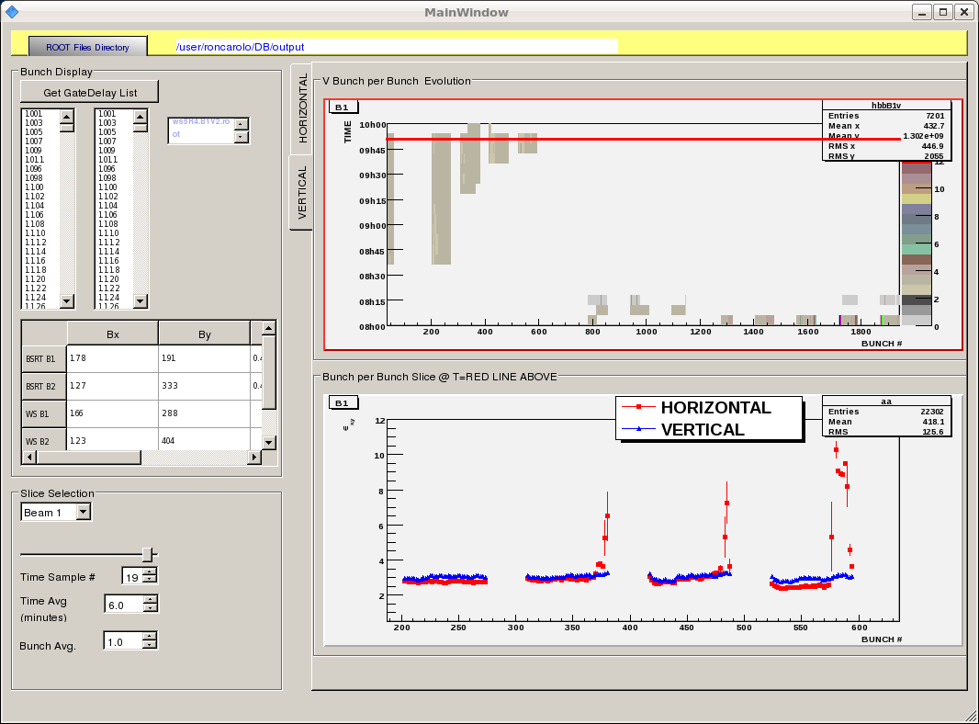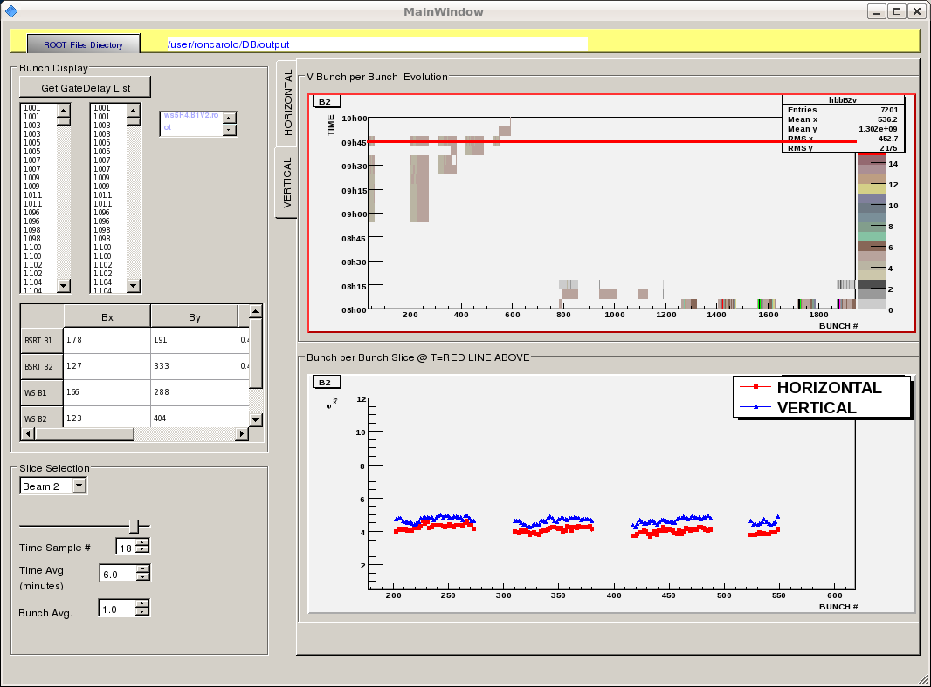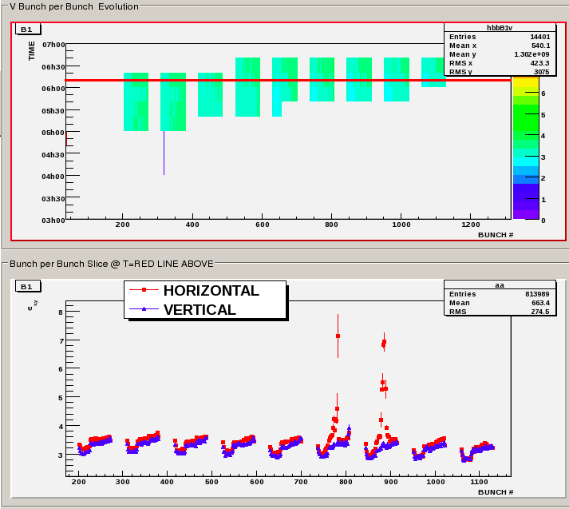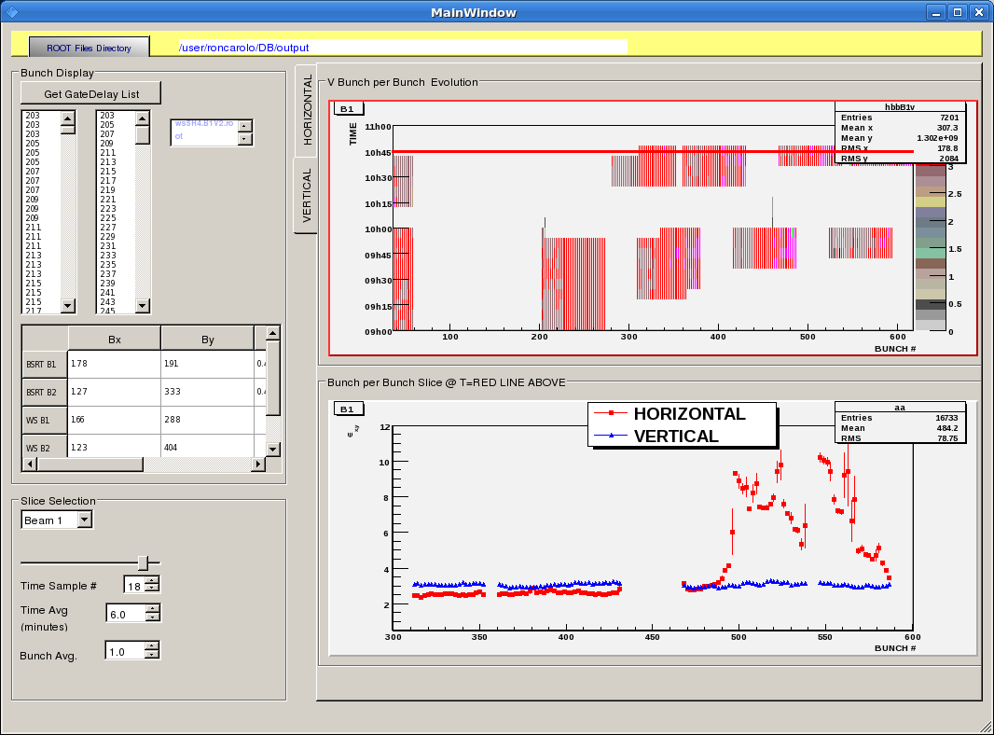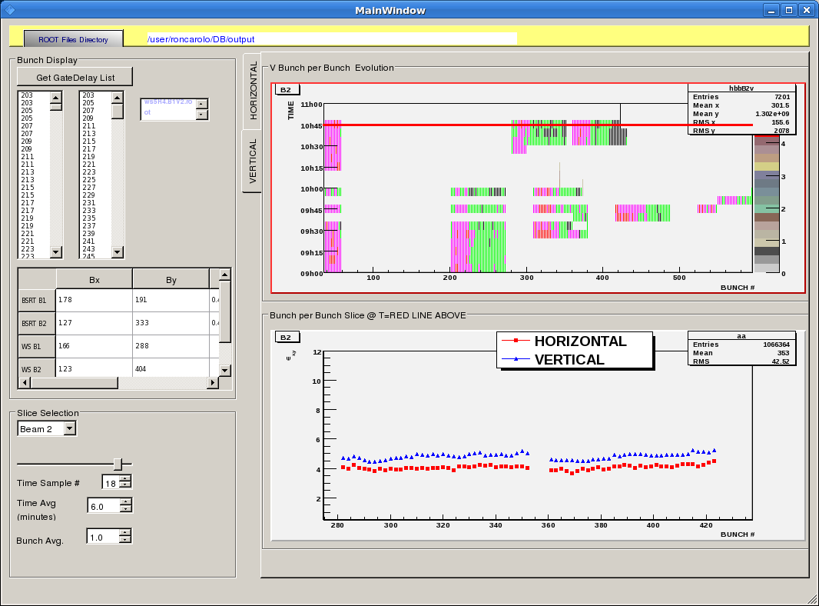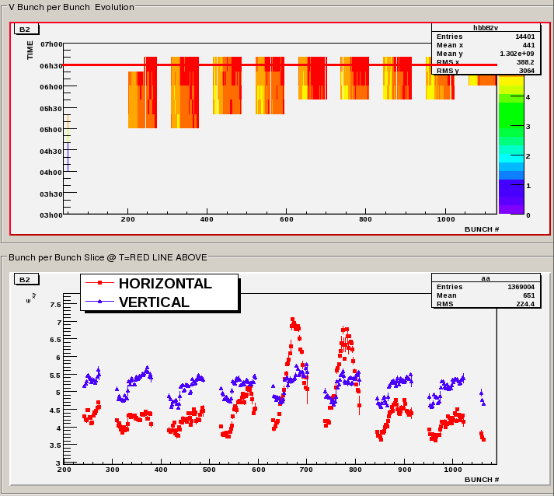
Timber How To:
- Open Timber: LHC Control -> LHC Logging -> Timber or download from a browser: cern.ch/timber (needs java)
- Choose Local Time
- Choose the Variable Lists tab
- Filter for BSRT: Name % BSRT
- Select BSRT
- Under the List Variables tab: Add ALL and Add Selected
- Go to the Query tab
- Select e.g. all DELAY and SIGMA Variables
- Check the Use Sub-Selection square
- Choose the time window: Under the Window tab choose Start time and End time
- Check Statistics or Chart
- Query
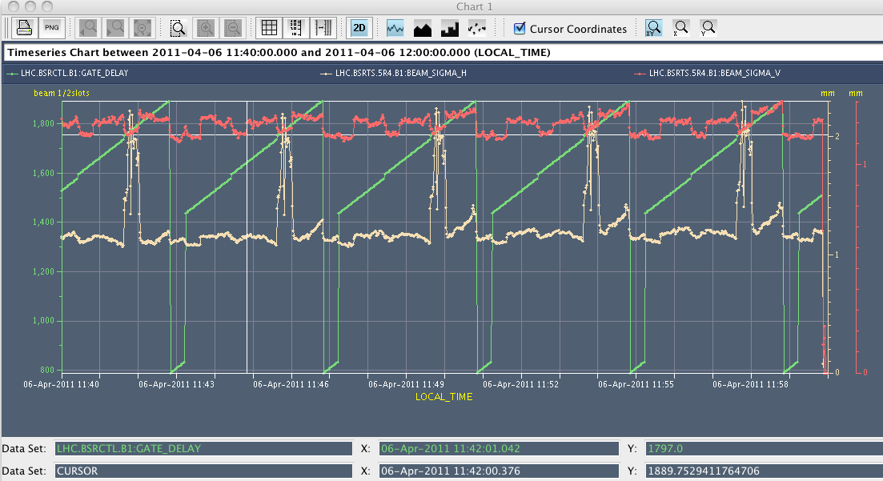
Hint:
- You could save some hours of sleep if you know that they sometimes announce in Page 1 of Vistar if the beam will be gone for many hours.

