* The beam intensity in the PS was 1.5 * 10-5 protons.
* The beam intensity in the SPS was 1.2 * 10-5 protons (<http://elogbook.cern.ch/eLogbook/attach_viewer.jsp?attach_id=1184370> )
* The intensity in the TT20 was 0.86 * 10-5 protons (<http://elogbook.cern.ch/eLogbook/attach_viewer.jsp?attach_id=1184398> )

The beam consisted of one batch.

**Sequence of MD (3 August 2011):**

<http://elogbook.cern.ch/eLogbook/eLogbook.jsp?shiftId=1037294>

**Implement proton optics: SPS.USER.SFTLONG1 (SFT_LONG_L9690_2010_MD_V1)**

21.15 : Picture of scan of T2 target :

<http://elogbook.cern.ch/eLogbook/attach_viewer.jsp?attach_id=1184372>

21.15 : Pictures of BSGV and BSGH at splitters + another:

<http://elogbook.cern.ch/eLogbook/attach_viewer.jsp?attach_id=1184371>

21.30 : Photos of TV screens in the TT20 line:

\\cern.ch\dfs\Users\b\berrig\Public\TT20_NA61_optics\MD_3Aug_2011\2103_3Aug_9.35_mightBeproblem.JPG

\\cern.ch\dfs\Users\b\berrig\Public\TT20_NA61_optics\MD_3Aug_2011\2116_3Aug_9.30.JPG

\\cern.ch\dfs\Users\b\berrig\Public\TT20_NA61_optics\MD_3Aug_2011\2116_3Aug_10.20_inrealityabit bigger.JPG 🡨 Splitter_1

\\cern.ch\dfs\Users\b\berrig\Public\TT20_NA61_optics\MD_3Aug_2011\2117_3Aug_9.40.JPG

\\cern.ch\dfs\Users\b\berrig\Public\TT20_NA61_optics\MD_3Aug_2011\2204_3Aug_9.45.JPG 🡨Splitter_2

\\cern.ch\dfs\Users\b\berrig\Public\TT20_NA61_optics\MD_3Aug_2011\2204_3Aug_9.45.JPG

\\cern.ch\dfs\Users\b\berrig\Public\TT20_NA61_optics\MD_3Aug_2011\2301_3Aug_9.50.JPG

\\cern.ch\dfs\Users\b\berrig\Public\TT20_NA61_optics\MD_3Aug_2011\2309_3Aug_9.55.JPG

21.55 : All photos of TV screens in the TT20 line made.

With these photos we can verify the general correctness of the model of the TT20 line.

**Measure dispersion by changing radial steering**

22.11 : Starting dispersion measurements by changing the energy of the SPS with the RF frequency (radial steering)

starting dispersion measurement   
We first calibrate radial steering at 4200   
Original situation:   
Radial steering at flat-top = -6mm   
Dp measured @ 4200 = -0.12E-3   
  
-3mm => +0.52E-3   
-9mm => -0.75E-3   
or Dp=0.213E-3/mm   
  
Note: size of steps need to be much smaller for the extraction to still work (~DR=1mm or Dp=2E-4 maximum)

22.30 : Changed dP/P to -2E-4 below original value

<http://elogbook.cern.ch/eLogbook/attach_viewer.jsp?attach_id=1184374>

<http://elogbook.cern.ch/eLogbook/attach_viewer.jsp?attach_id=1184376>

22.52 : Changed dP/P to +2E-4 obove original value

<http://elogbook.cern.ch/eLogbook/attach_viewer.jsp?attach_id=1184378>

<http://elogbook.cern.ch/eLogbook/attach_viewer.jsp?attach_id=1184379>

22.53 : Number of [mm] per dP/P is equal to

<http://elogbook.cern.ch/eLogbook/attach_viewer.jsp?attach_id=1184375>

22:57 : Emittance of the SPS measured with the wire scanner BSW.41677 to Eh=0.71 and Ev=0.76

<http://elogbook.cern.ch/eLogbook/attach_viewer.jsp?attach_id=1184384>

From the photos of the TV screens we can calculate the emittances in TT20, and compare them with these values.

**Implement Lead ion optics with the knob T2BEAM/T2-P2ION**

00.35 : Starting to implement the Lead ion optics (that was tested in 2010):

<http://project-ps-optics.web.cern.ch/project-PS-optics/cps/TransLines/TT20/2011/strength/tt20_pb_lowenergy_NA61.str>

The lead ion optics was implemented with the knob: T2BEAM/T2-P2ION

**KQTLD2101       -0.00368673**

**KQTLF2102        0.00096001**

**KQTLD2103       -0.00216824**

**KQNLF2104       -0.00067221**

**KQNLD2105M      -0.00019103**

**KQNLF2106M       0.00019103**

**KQNL2112M        0.00198458**

**KQTS2112M        0.00198458**

**KQNL2113M        0.00104965**

**KQTL2114M       -0.00016357**

**KQNL2115M        0.00083735**

**KQTL2116M       -0.00141554**

**KQTS2116M       -0.00141554**

**KQM2117         -0.00004902**

**KQSLD2201       -0.00013306**

**KQTAF2202M       0.00104891**

**KQTAD2204       -0.00093986**

**KQTAD2302       -0.00388356**

**KQTAF2303        0.00873940**

**KQTAF2304M      -0.00472372**

**KQTAD2306M       0.00283187**

**KQTAF2308M      -0.00194561**

The strength of KQNLF2104 is 0.00489537532 in the proton optics:

<http://project-ps-optics.web.cern.ch/project-PS-optics/cps/TransLines/TT20/2011/strength/tt20_protons_SE_noqsplit.str>

while in the lead ion optics, the strength of KQNLF2104 is 0.0042223161669597:

<http://project-ps-optics.web.cern.ch/project-PS-optics/cps/TransLines/TT20/2011/strength/tt20_pb_lowenergy_NA61.str>

Somehow, this change was not implemented correctly, so it was done manually.

The knob T2BEAM/T2-P2ION had an error, the strength for KQNLF2104 was missing.

01.10 : Lead ion optics implemented:

<http://elogbook.cern.ch/eLogbook/attach_viewer.jsp?attach_id=1184387>

<http://elogbook.cern.ch/eLogbook/attach_viewer.jsp?attach_id=1184388>

<http://elogbook.cern.ch/eLogbook/attach_viewer.jsp?attach_id=1184389>

<http://elogbook.cern.ch/eLogbook/attach_viewer.jsp?attach_id=1184390>

Photos of the TV screens for lead ion optics:

\\cern.ch\dfs\Users\b\berrig\Public\TT20_NA61_optics\MD_3Aug_2011\2103_4Aug_1.35.JPG

\\cern.ch\dfs\Users\b\berrig\Public\TT20_NA61_optics\MD_3Aug_2011\2116_4Aug_1.20.JPG 🡨Splitter_1

\\cern.ch\dfs\Users\b\berrig\Public\TT20_NA61_optics\MD_3Aug_2011\2117__4Aug_1.40.JPG

\\cern.ch\dfs\Users\b\berrig\Public\TT20_NA61_optics\MD_3Aug_2011\2204_4Aug_1.25.JPG 🡨Splitter_2

\\cern.ch\dfs\Users\b\berrig\Public\TT20_NA61_optics\MD_3Aug_2011\2301_4Aug_1.45.JPG

\\cern.ch\dfs\Users\b\berrig\Public\TT20_NA61_optics\MD_3Aug_2011\2309_4Aug_1.47.JPG

**Test the effect of moving the focus point down-stream**

01.48 : Test of knob “TARGET-LONG.DISPLACEMENT“. Adding a factor = 0.1:

<http://elogbook.cern.ch/eLogbook/attach_viewer.jsp?attach_id=1184391>

The value of the strengths before implementing the knob were:

KQTAD2306M := -0.007608134744198 ;

KQTAF2308M := 0.007954386023063 ;

After implementing the knob, they were:

KQTAD2306M := -0.0076072088

KQTAF2308M := 0.0079517507

The knob contains the values:

kqtad2306m =  0.921246 * 10^-5

kqtaf2308m = -2.639321 * 10^-5

The knob “TARGET-LONG.DISPLACEMENT“ is implemented perfectly!

02.01 : Another read out of the strength:

<http://elogbook.cern.ch/eLogbook/attach_viewer.jsp?attach_id=1184392>

New strengths are still:

KQTAD2306M := -0.0076072088 ;

KQTAF2308M := 0.0079517507 ;

Vertical profile after factor 0.1 (which corresponds to 1 cm):

<http://elogbook.cern.ch/eLogbook/attach_viewer.jsp?attach_id=1184392>

02.08 : Adding another factor 0.9 to the knob “TARGET-LONG.DISPLACEMENT“. Total factor is now 1.0.

Strengths are now:

KQTAD2306M := -0.0076989176 ;

KQTAF2308M := 0.0079279968 ;

The knob “TARGET-LONG.DISPLACEMENT“ is implemented perfectly. The focus point is moved 10cm down-stream.

T2 vertical target scan:

<http://elogbook.cern.ch/eLogbook/attach_viewer.jsp?attach_id=1184395>

02.16 : Factor for the knob “TARGET-LONG.DISPLACEMENT“.

Total factor is now -1.0, i.e. the focus is now 10cm up-stream. Strengths:

<http://elogbook.cern.ch/eLogbook/attach_viewer.jsp?attach_id=1184396>

KQTAD2306M := -0.0076173425 ;

KQTAF2308M := 0.0079807832 ;

The knob “TARGET-LONG.DISPLACEMENT“ is implemented perfectly. The focus point is moved 10cm up-stream.

02.30 : T2 target scan 10cm up-stream:

<http://elogbook.cern.ch/eLogbook/attach_viewer.jsp?attach_id=1184397>

02.31 : T2 target scan, with focus moved 20cm down-stream. Strengths:

KQTAD2306M := -0.0075897051 ;

KQTAF2308M := 0.0079016036 ;

<http://elogbook.cern.ch/eLogbook/attach_viewer.jsp?attach_id=1184399>

The knob “TARGET-LONG.DISPLACEMENT“ is implemented perfectly. The focus point is moved 20cm down-stream. T2 target scan:

<http://elogbook.cern.ch/eLogbook/attach_viewer.jsp?attach_id=1184401>

02.42 : Another verification of the strength (for 20cm down-stream):

<http://elogbook.cern.ch/eLogbook/attach_viewer.jsp?attach_id=1184400>

02.44 : Scan with focus 5cm down-stream.

Strengts are OK: <http://elogbook.cern.ch/eLogbook/attach_viewer.jsp?attach_id=1184402>

Scan: <http://elogbook.cern.ch/eLogbook/attach_viewer.jsp?attach_id=1184406>

02.55 : Another check of the strengths for 5cm downstream:

<http://elogbook.cern.ch/eLogbook/attach_viewer.jsp?attach_id=1184407>

02.56 : Scan with focus 15cm down-stream.

Strengths are OK: <http://elogbook.cern.ch/eLogbook/attach_viewer.jsp?attach_id=1184412>

Scan with 15cm down-stream: <http://elogbook.cern.ch/eLogbook/attach_viewer.jsp?attach_id=1184415>

03.12 : Scan with focus 10cm down-stream.

strengths: <http://elogbook.cern.ch/eLogbook/attach_viewer.jsp?attach_id=1184417>

Strengths are OK: <http://elogbook.cern.ch/eLogbook/attach_viewer.jsp?attach_id=1184418>

Scan_1: <http://elogbook.cern.ch/eLogbook/attach_viewer.jsp?attach_id=1184419>

Scan_2: <http://elogbook.cern.ch/eLogbook/attach_viewer.jsp?attach_id=1184420>

03.35 : Back to focus at 0cm:

Strengths: <http://elogbook.cern.ch/eLogbook/attach_viewer.jsp?attach_id=1184421>

<http://elogbook.cern.ch/eLogbook/attach_viewer.jsp?attach_id=1184422>

<http://elogbook.cern.ch/eLogbook/attach_viewer.jsp?attach_id=1184423>

<http://elogbook.cern.ch/eLogbook/attach_viewer.jsp?attach_id=1184424>

<http://elogbook.cern.ch/eLogbook/attach_viewer.jsp?attach_id=1184425>

Strengths are NOT OK!! The QTLD2103 is set to -0.0078690011 where it should have been -0.009365027133332.

This knob should have been corrected, but was not! All further measurements should be compared with theoretical values, where the strength of The QTLD2103 is set to -0.0078690011.

Scan: <http://elogbook.cern.ch/eLogbook/attach_viewer.jsp?attach_id=1184426>

**Measure dispersion by changing the strength of all the quadrupoles and dipoles in the TT20 line**

03.44 : Change the energy by 0.1 GeV (which is 0.25%). The change was done with the trim: **T2BEAM/MOMENTUM**:

<http://elogbook.cern.ch/eLogbook/attach_viewer.jsp?attach_id=1184427>

<http://elogbook.cern.ch/eLogbook/attach_viewer.jsp?attach_id=1185801>

<http://elogbook.cern.ch/eLogbook/attach_viewer.jsp?attach_id=1185798>

<http://elogbook.cern.ch/eLogbook/attach_viewer.jsp?attach_id=1185799>

Scan of T2 target, after changing energy by 0.1 GeV:

<http://elogbook.cern.ch/eLogbook/attach_viewer.jsp?attach_id=1184428>

04.13 : Change of energy to 1 GeV (with T2BEAM/MOMENTUM ).

Beam positions measured: <http://elogbook.cern.ch/eLogbook/attach_viewer.jsp?attach_id=1184429>

Scan at T2 target: <http://elogbook.cern.ch/eLogbook/attach_viewer.jsp?attach_id=1184431>

04.13 : Improved symmetry at T2 target from 61% to 91%.

Scan at T2 target: <http://elogbook.cern.ch/eLogbook/attach_viewer.jsp?attach_id=1184432>

04.23 : Back to 0 GeV trim.

Beam positions: <http://elogbook.cern.ch/eLogbook/attach_viewer.jsp?attach_id=1184433>

04.25 : -1 GeV trim. The beam was lost!!

Beam positions: <http://elogbook.cern.ch/eLogbook/attach_viewer.jsp?attach_id=1184434>

04.32 : -0.5 GeV trim.

Beam positions: <http://elogbook.cern.ch/eLogbook/attach_viewer.jsp?attach_id=1184436>

T2 target scan: <http://elogbook.cern.ch/eLogbook/attach_viewer.jsp?attach_id=1184437>

04.56 : We notice that there's a big difference on QTLD2103 (trim=-0.0078690011 optics=-0.009365027133332).

-> reset optics value.

Strengths:

<http://elogbook.cern.ch/eLogbook/attach_viewer.jsp?attach_id=1184438>

<http://elogbook.cern.ch/eLogbook/attach_viewer.jsp?attach_id=1184439>

<http://elogbook.cern.ch/eLogbook/attach_viewer.jsp?attach_id=1184440>

<http://elogbook.cern.ch/eLogbook/attach_viewer.jsp?attach_id=1184441>

T2 target scan: <http://elogbook.cern.ch/eLogbook/attach_viewer.jsp?attach_id=1184442>

**Implement the reduced dispersion optics**

05.16 : Implemented the RED.DISPERSION knob (with factor 1.0). Strengths:

<http://elogbook.cern.ch/eLogbook/attach_viewer.jsp?attach_id=1184443>

<http://elogbook.cern.ch/eLogbook/attach_viewer.jsp?attach_id=1184444>

<http://elogbook.cern.ch/eLogbook/attach_viewer.jsp?attach_id=1184445>   
05.22 : It was not possible to implement the RED.BETA knob (no make rules !)

05.29 : RED.DISPERSION knob implemented (factor = 0.1).

06.15 : RED.DISPERSION knob implemented (factor = 1.0).

<http://project-ps-optics.web.cern.ch/project-PS-optics/cps/TransLines/TT20/2011/strength/tt20_pb_lowenergy_NA61_3august_test5.str>

Strengths: (there are some accuracy problems – probably not serious)

<http://elogbook.cern.ch/eLogbook/attach_viewer.jsp?attach_id=1184448>

<http://elogbook.cern.ch/eLogbook/attach_viewer.jsp?attach_id=1184449>

<http://elogbook.cern.ch/eLogbook/attach_viewer.jsp?attach_id=1184450>

<http://elogbook.cern.ch/eLogbook/attach_viewer.jsp?attach_id=1184451>

Scan at T2 target:

<http://elogbook.cern.ch/eLogbook/attach_viewer.jsp?attach_id=1184452>

<http://elogbook.cern.ch/eLogbook/attach_viewer.jsp?attach_id=1184453>

**Analysis**

**(Success is not hocus-pocus, but a question of focus)**



BEAM SIZE:

The measured **vertical** emittance (norm) in the SPS is: 0.76 10-6 m

SPLITTER_1, Proton optics:

NAME BETX ALFX DX DPX BETY ALFY DY DPY

MIDSPLIT1 11.65324 -0.00541 0.18402 -0.04138 23373.82364 0.00265 0.50726 -0.00115

From 34.9 mm = 4 sigma, I get physical emittance = 0.00325 10-6 m or normalized emittance = 1.30 10-6 m (If, on the other hand, I believe that I see ~ 5 sigma; I will get a normalized emittance of 0. 58 10-6 m)

SPLITTER_2; Proton optics:

NAME BETX ALFX DX DPX BETY ALFY DY DPY

MIDSPLIT2 10.85553 0.26684 -0.44828 0.03122 23621.78931 -1.76603 0.38749 -0.00111

From 42.3 mm = 4 sigma, I get a physical emittance = 0.00473 10-6 m or normalized emittance = 1.89 10-6 m (If, on the other hand, I believe that I see ~ 6 sigma; I will get a normalized emittance of 0.84 10-6 m)

SPLITTER_1, Lead Ion optics:

NAME BETX ALFX DX DPX BETY ALFY DY DPY

MIDSPLIT1 52.52377 -2.04089 0.86890 -0.01406 4153.06916 -2.50046 0.06276 -0.00023 From 19.3 mm = 4 sigma, I get physical emittance = 0.00558 10-6 m or normalized emittance = 2.23 10-6 m (If, on the other hand, I believe that I see ~ 6 sigma; I will get a normalized emittance of 0. 99 10-6 m)

SPLITTER_2; Lead Ion optics:

NAME BETX ALFX DX DPX BETY ALFY DY DPY

MIDSPLIT2 91.75191 -7.17881-0.81328 -0.02638 5246.96123 -2.83907 0.04146 -0.00022

From 23.8 mm = 4 sigma, I get a physical emittance = 0.000310 10-6 m or normalized emittance = 0.124 10-6 m (If, on the other hand, I believe that I see ~ 6 sigma; I will get a normalized emittance of 0. 055 10-6 m) 🡨 **outlier**

Average emittance – assuming 4 sigma : (1.30 10-6 m + 1.89 10-6 m + 2.23 10-6 m)/3 = 1.81 10-6 m

Average emittance – assuming 6 sigma : (0.58 10-6 m + 0.84 10-6 m + 0.99 10-6 m)/3 = 0.80 10-6 m

Assuming a normalized emittance of 0.76 10-6 m, will on the T2 target give a 4 sigma size = 2.88 mm and this is what we get from visual inspection (to be calculated ):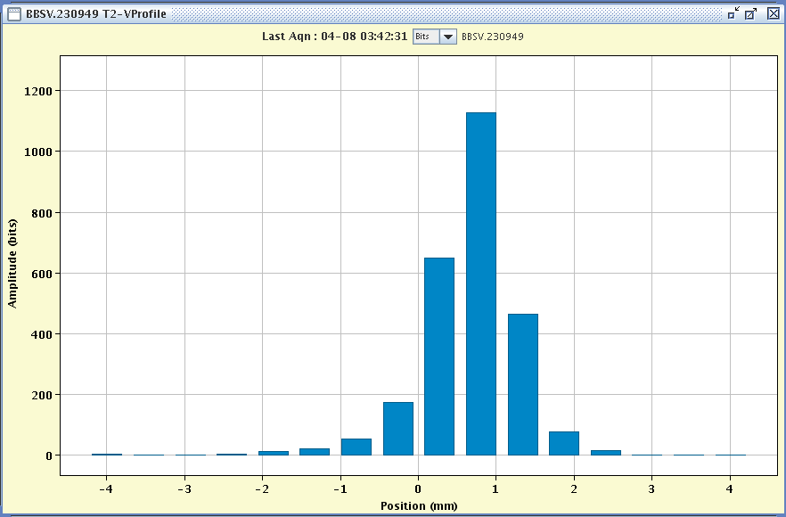

Using the optics with extremely low dispersion function, does NOT reduce the beam size:

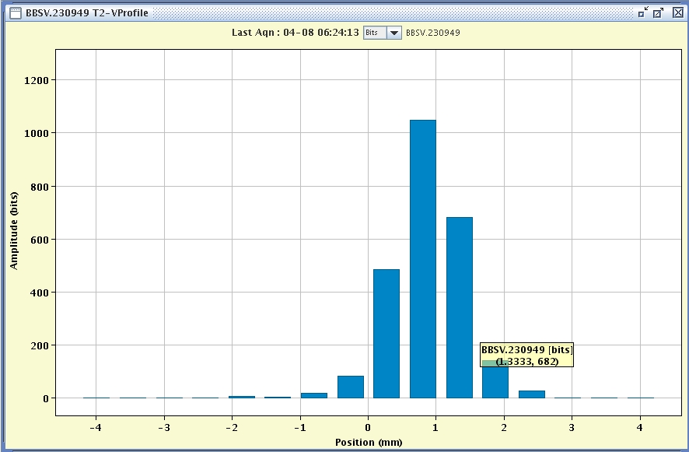

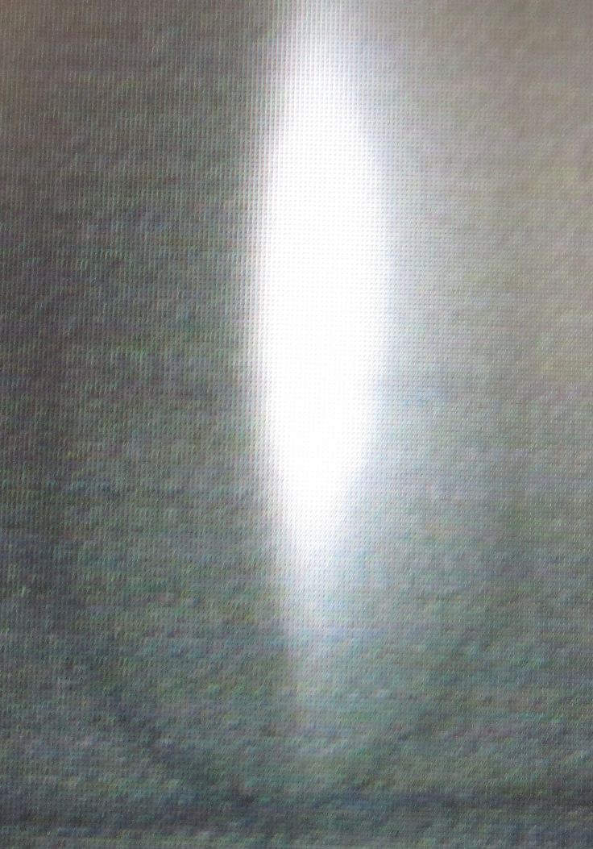

**First SPLITTER (proton optics)**

Spot size (4? sigma):

HOR = 8.5 mm

VER = 34.9 mm

**26 mm**

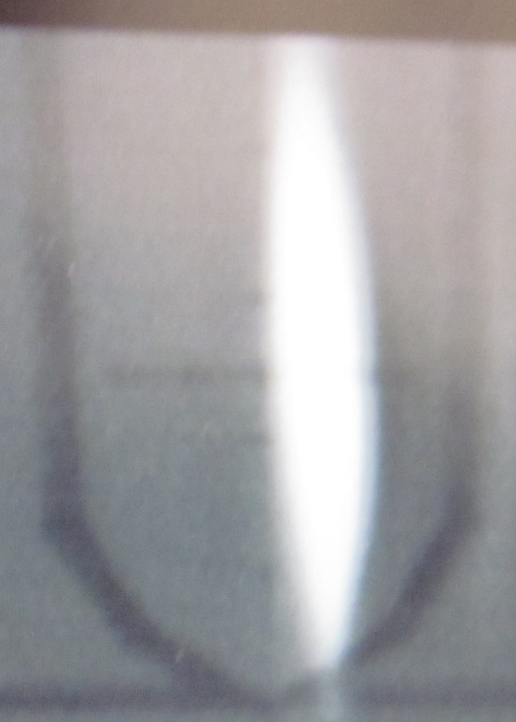

**Second SPLITTER (proton optics)**

Spot size (4? sigma):

HOR = 9.1 mm

VER = 42.3 mm

**26 mm**

**26 mm**

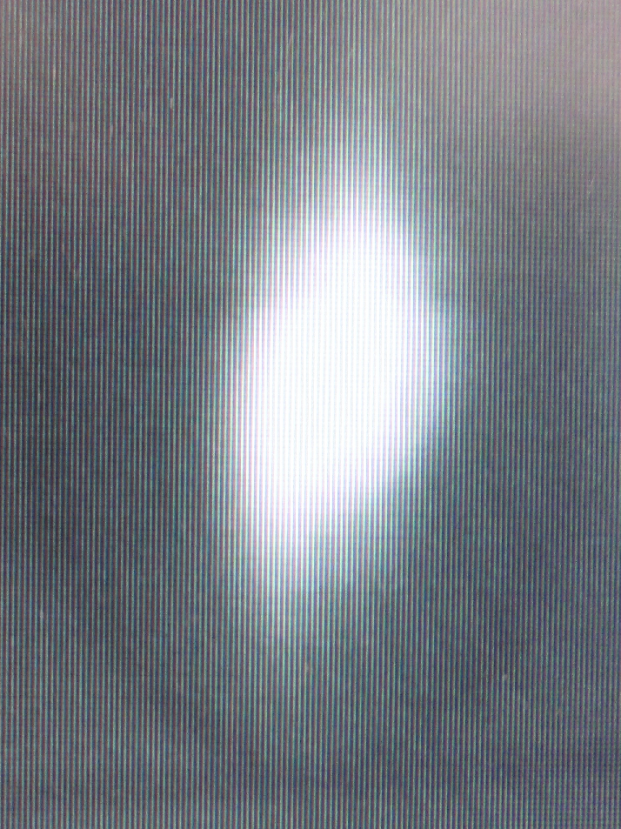

**First SPLITTER**

**(Lead Ion optics)**

Spot size (4? sigma):

HOR = 11.4 mm

VER = 19.3 mm

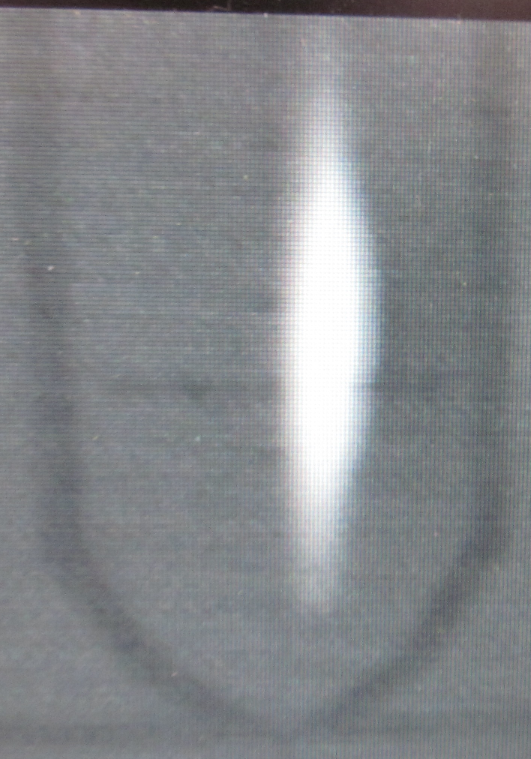

**Second SPLITTER**

**( Lead Ion optics)**

Spot size (4? sigma):

HOR = 5.1 mm

VER = 23.8 mm

**26 mm**

