2011 LHC Scrubbing run

- Started on Tuesday 05/04/11 night ~ 24:00. The idea was to change almost no settings during the scrubbing, i.e. keep chromaticities to ~ 4 units, octupoles OFF and transverse dampers ON.
- WE 06/04:
- 00:22: We are getting the same problem as this afternoon to inject the first 36 bunches just after the 12 bunches injection. We are shifting the filling scheme by 500 buckets, as we are anyway not using the last injection of 72, to see if we can manage.
- 01:04: We finally manage to edit end save a filling scheme with the 36 bunch injection shifted to suit the requirements of the Ecloud MD studies. 8x1batch36bunches (plus pilot and 1x12bunches).
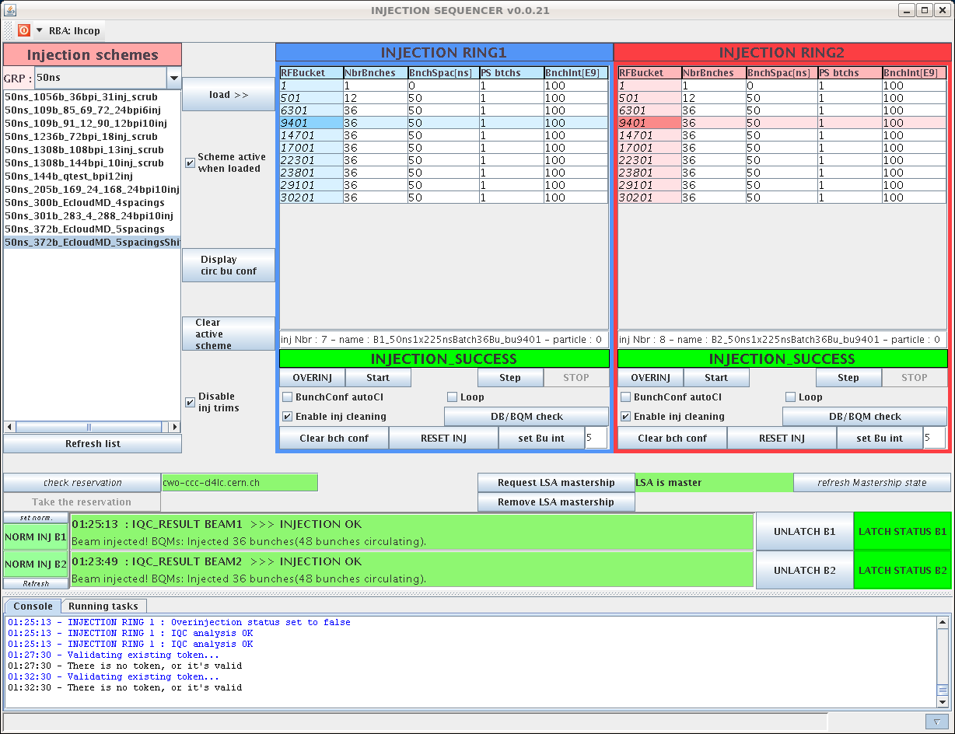
- 01:33: Vacuum peak at the injection of the 36 bunches for beam 1, with 36 bunches IN for beam2.
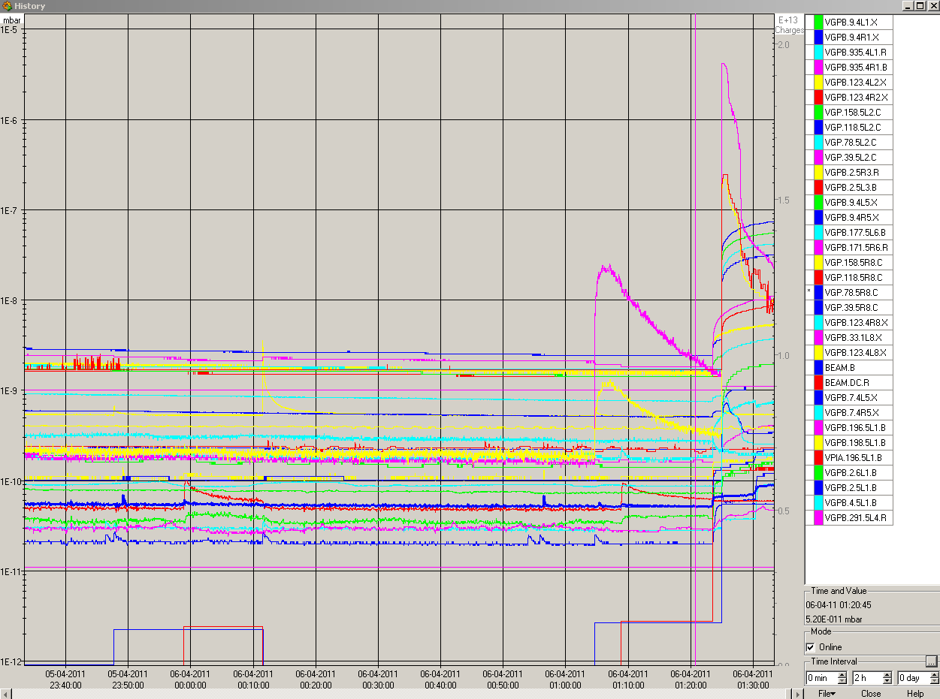
- 01:56: ADT pickups: we start to see the horizontal tune in the horizontal spectrum for the last bunches of the 3rd 36-bunch-train. Nothing special (no tune peak) seen on the two first batches.
- 02:37: ADT pickups: for beam1, the tune peak for the 4th and 5th 36-bunch-batches seem to be more in the middle of the batch than at the end.
- 02:42: loss pattern with 192 bunches in beam 1 and 120 in beam 2. We start to see losses in point 6.
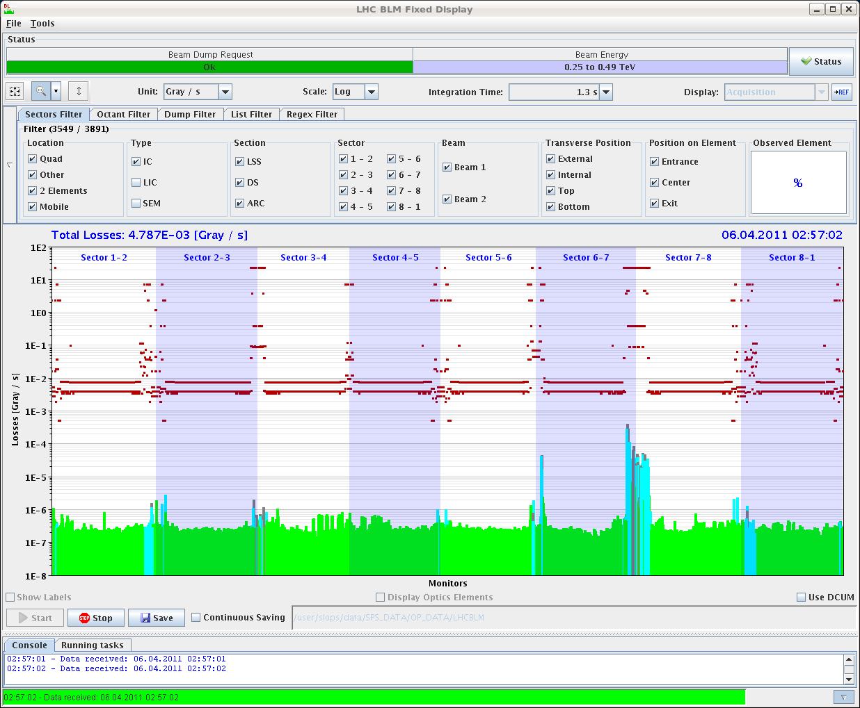
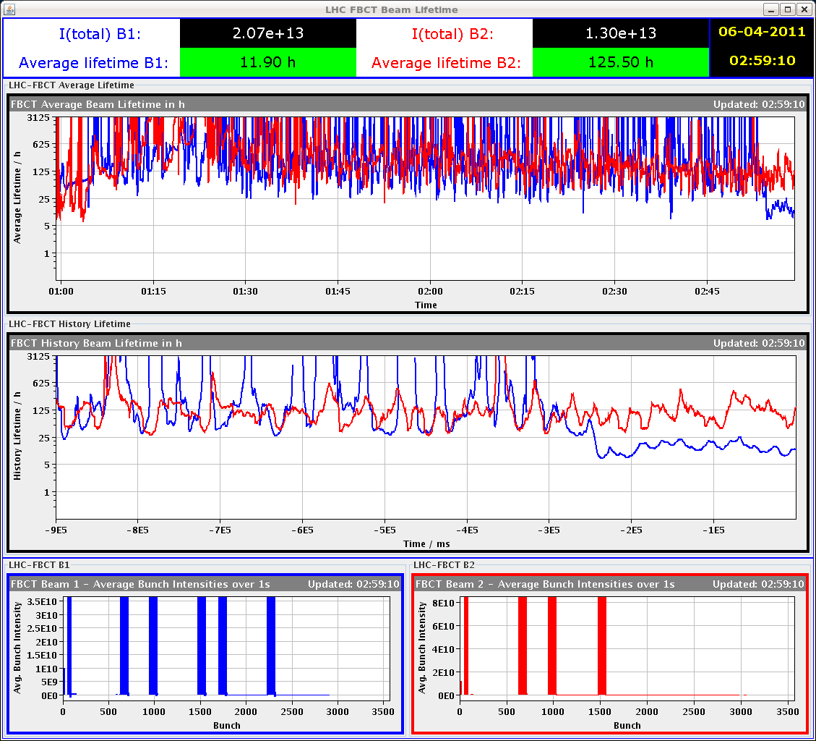
- 03:07: Losses on B1 seem to be localized at the end of the 4th 36-bunch-batch.
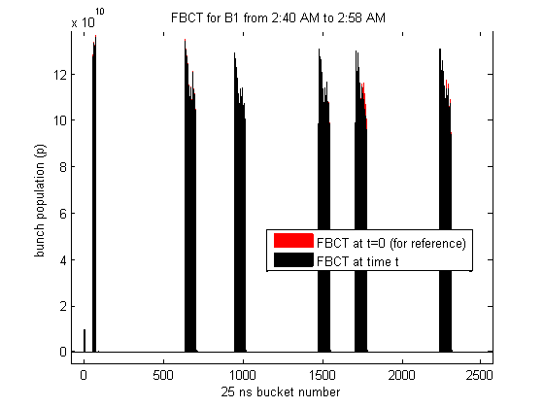
- 03:43: We are stopped here because of the injection interlock from the BIS-PRE-OPS checks.
- Transverse emittances at ~4h:10
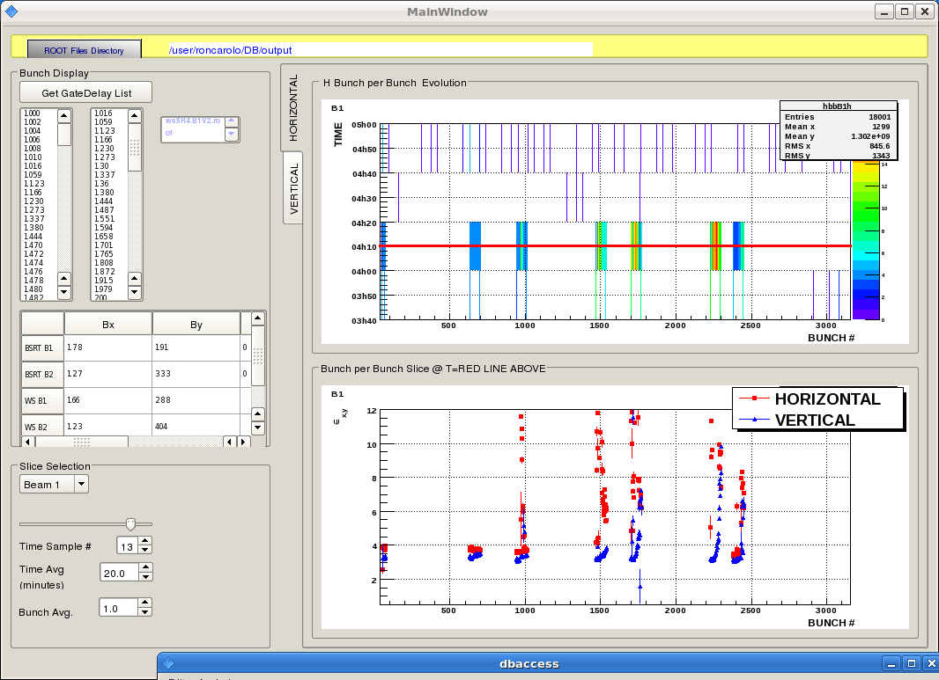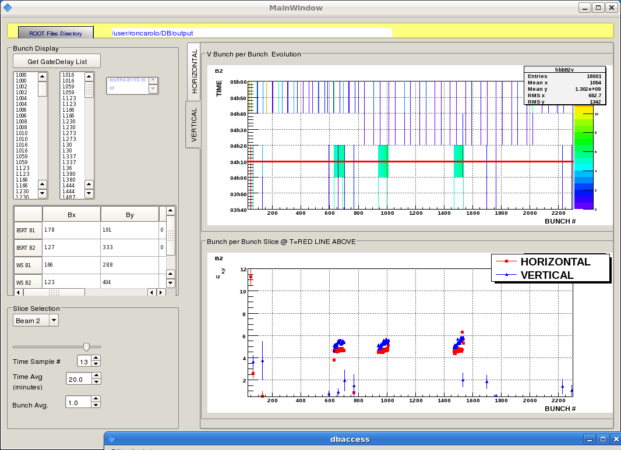
- 04:13: Vacuum peak when switching ON solenoid in LSS1.L with 220 bunches IN for beam 1.
- 04:55: Dump after injection of 36 bunches after another train of 36 bunches, spaced by 1000 RF bucket.
- 05:44: Again dump at injection when putting the second train of 36 with a spacing of 1000 buckets.
- 06:05: We suspect that the trains are too close? So we are trying a filling scheme with 2 us between the 2 trains as it worked earlier in the night.
- 06:23: New scheme "50ns_1056b_EcloudMDtest" with extra spacing (first few batches).
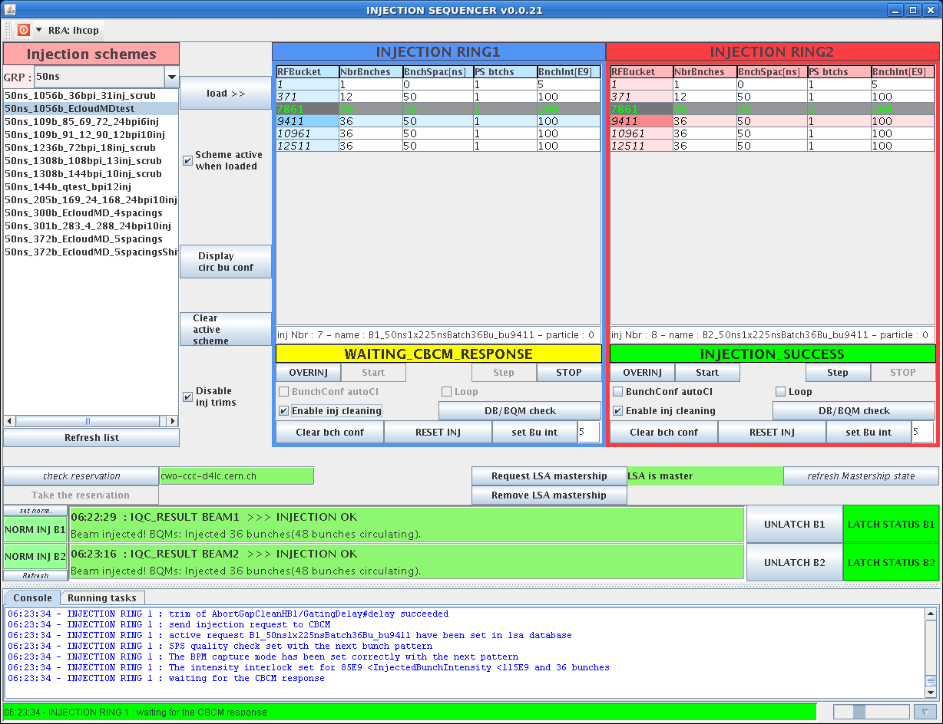
- 06:35: ADT pickups: 3rd 36-bunch-batch for beam1 shows increased activity along the batch (horizontal tune+synchrotron side bands on both H and V spectra). Same observations for beam 2. Same observations for 4th batch. And the tune peak do not seem to damp much with time.
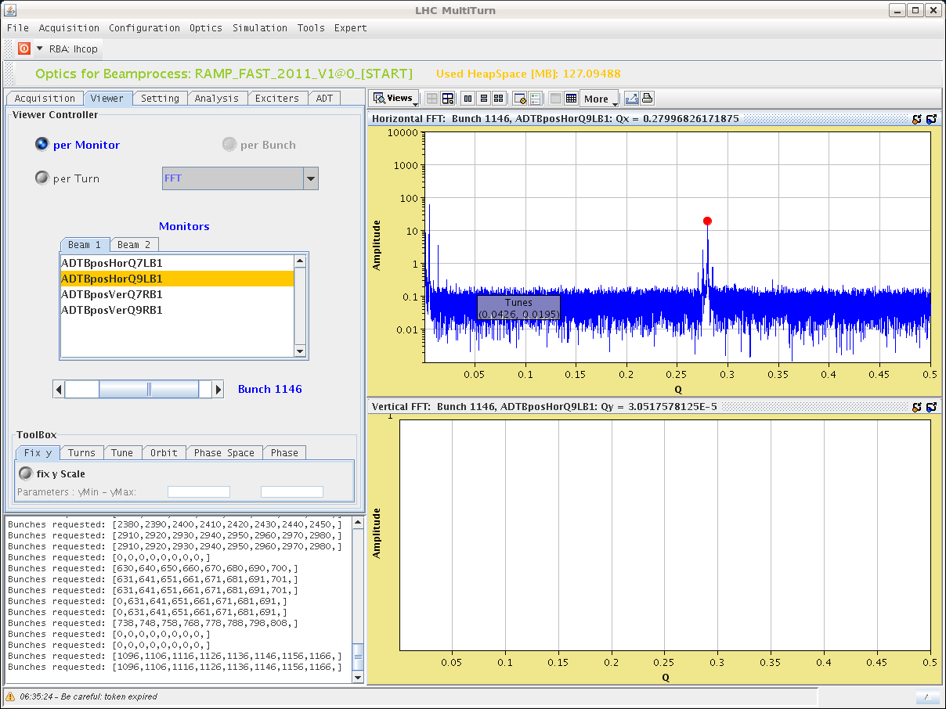
- 06:41: Scheme with extra spacing "50ns_1056b_EcloudMDtest" completed.
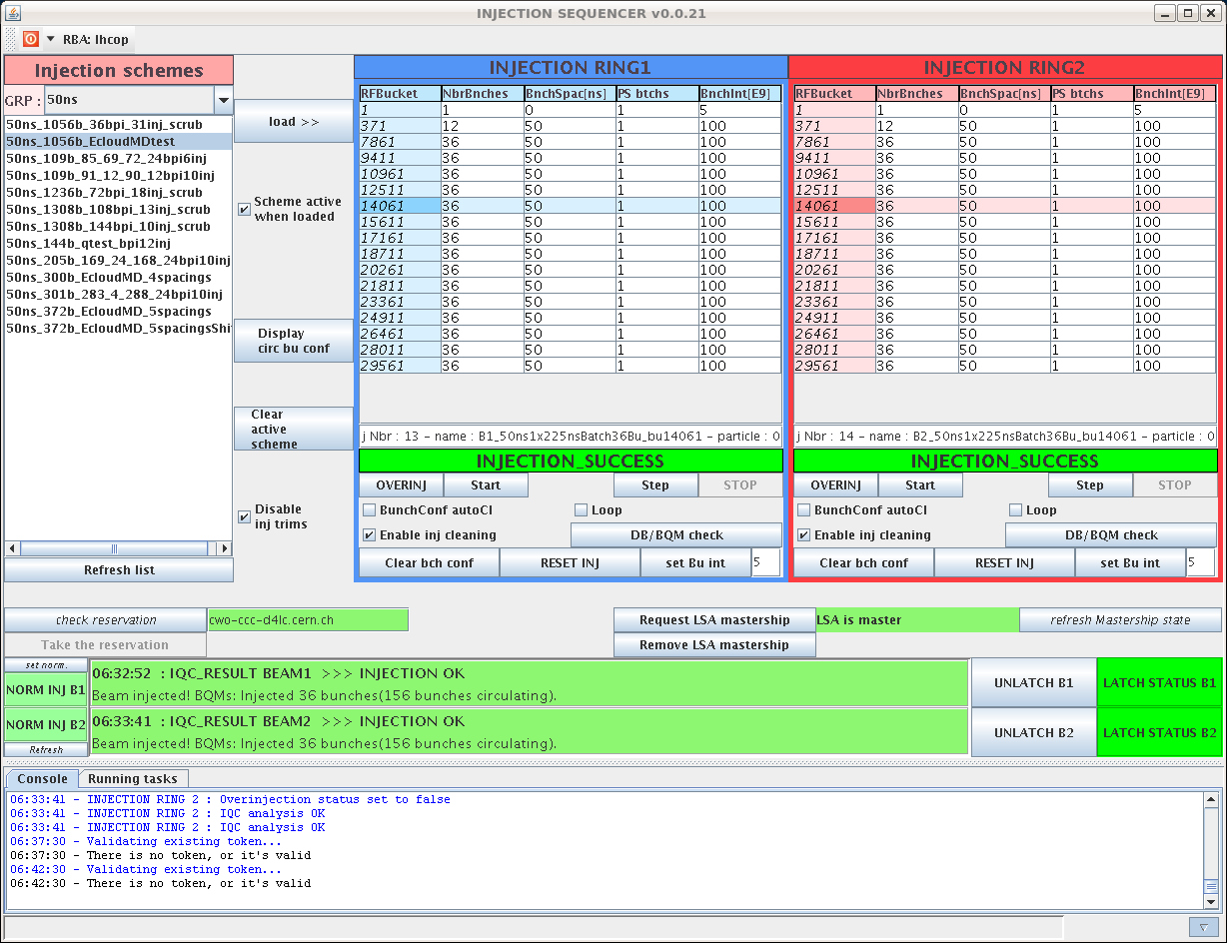
- 06:55: Shift summary:
- we started the shift with the E-cloud MD with the planned filling scheme 50ns_372b_EcloudMD_5spacings. We had an issue to inject the first 36 bunches in bucket 1301 as it was too close from the 12 bunches injection. So on request of the MD users, we edited a new filling scheme (50ns_372b_EcloudMD_5spacingsShift) with the 36 bunches all shifted by 5000 buckets.
- we were stopped in beam 2 because of a pressure rise in point 2 very close to the interlock limit after 3 injections.
- we have been stopped on beam 1 because of an injection interlock due to BIC sanity checks not performed in the last 25 hours.
- we observed an increase of the losses several minutes after the 4th train was in. We increased the ADT normalized gain to 0.2 (max allowed in LSA), situation improved.
- we then move to the filling scheme with 925 ns spacing between trains. We managed to inject the first 36 bunches in bucket 6301 (we skipped the firts ones to be sure to avoid the problem with the satellite of the 12 bunches).
- we had a bem dump at each injection of the second train of 36 bunches in bucket 7381. We tried to increase the scraping in SPS, check the injection oscillation, emittances, but all looks the same as for the first 36 bunches.
So we decided to try with a larger spacing of 2 us between trains,
- We then manage to fill 300 bunches per beam.
- 07:08: ADT pickups: horizontal tune peak increase along the batch is now smaller for newly injected batches, but is still there.
- 07:18: loss pattern with 300 bunches in beam 1.
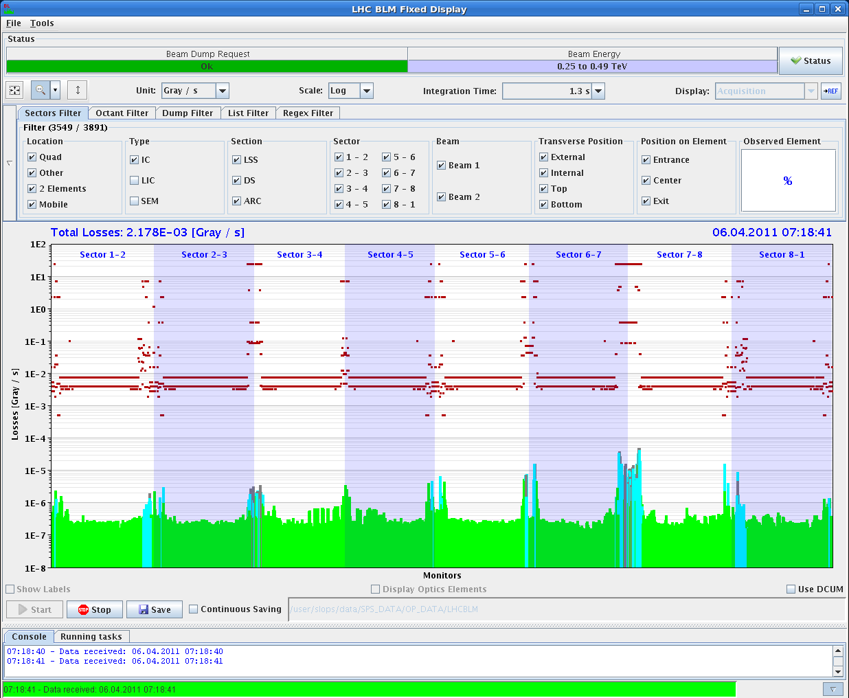
- 07:23: 300b + 300b IN. While staying at injection, bunches lengthen (WCM peak goes down also) => For me it seems it is the opposite from the pictures below!
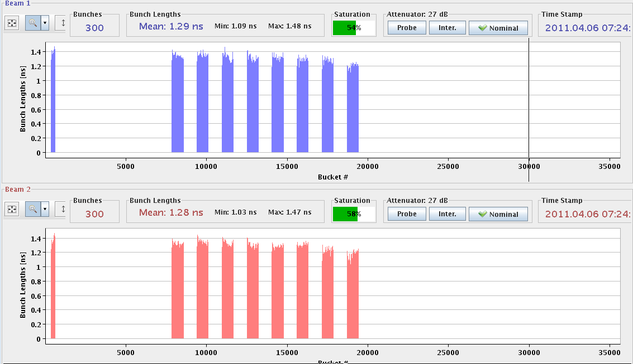
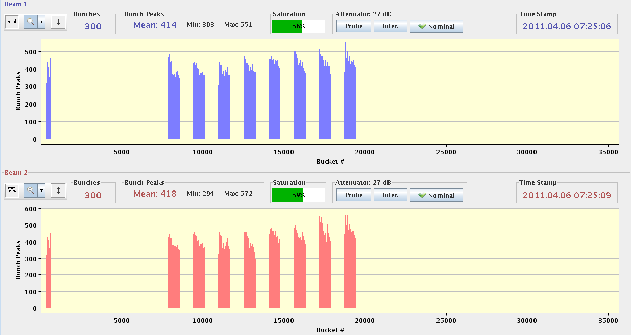
- 07:48: First night scrubbing run: Brief Summary
- The first filling scheme used was to test the dependence of the electron cloud wrt the batch spacing. The pressure rises were quite high from the beginning and it was necessary to wait a while for next injections. No more than 3 batches of 36 bunches could be injected in beam 2. In Beam 1, 6 batches of 36 bunches have been injected, i.e. the last two foreseen batches could not be injected.
- After dumping the beam a new filling scheme has been introduced. Problems with the injection of a second batch of 36 batches with a batch spacing of 875 ns lead us to increase this spacing to 2 us. With this scheme we injected 300 bunches in each beam (12+8*36). The machine was filled with 300 bunches in both beams around 1 hour.
- In brief, vacuum rise, coherent motion and emittance growth have been observed with several batches of 50 ns beam. More analysis is needed, but we can already say that the behaviour is very similar to what we observed last year (horizontal instability that affects the mid/last bunches of the batches and also seems to be correlated to a large emittance growth at the mid/end of the batches). The perturbation appears to build up with the number of batches until the motion and emittance grow really strong. Bunches and batches that are injected after these seem less affected and this should be understood.
- 08:10: Transverse emittances 8 trains just before the dump.
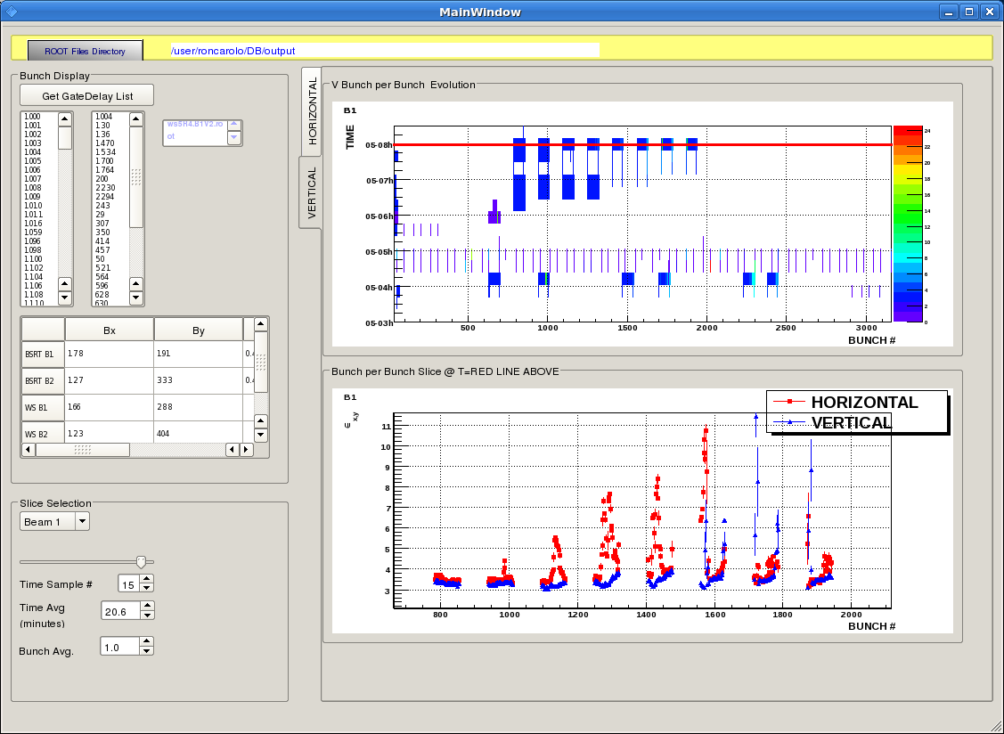
- 09:22: LDM observations: 12-bunch train has trailing satellites as well as satellites at 25ns spacing; 36-bunch train has no trailing satellites, a few small satellites between bunches.
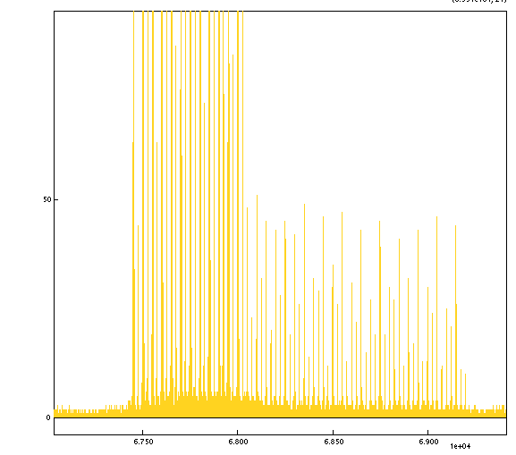
- 09:24: Stable phase measurement vs intensity.
- 09:33: B2 another 36: perfect.
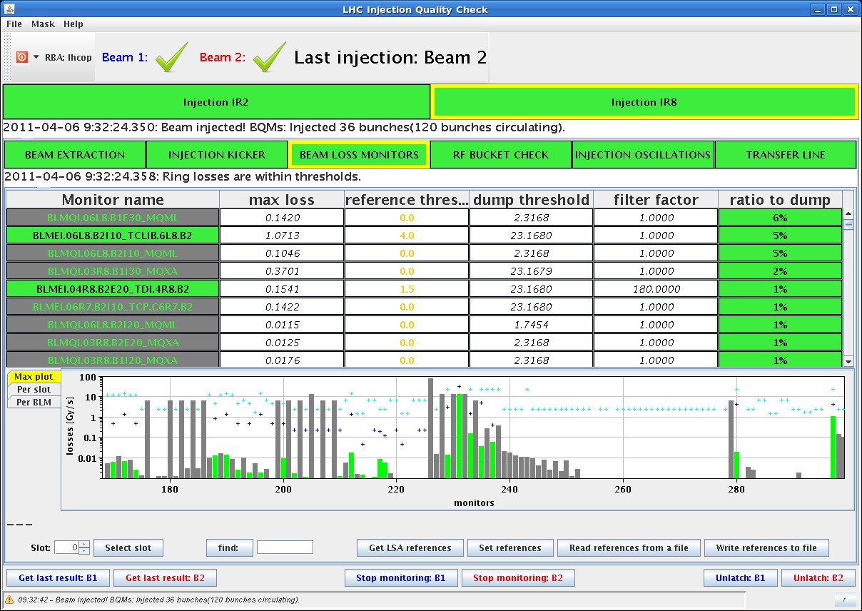
- 09:36: Waiting for vacuum pressure to go down before next injection. We have 120 bunches per ring.
- 09:52: Measured "Stable Phase" along the batch 9:43 AM. B1 left, B2 right. Pilot in bucket 0, then index in 25 ns slots. First batch 12 bunches, then 4 batches 36 bunches each. We observe an increasing spread in stable phase along the batches.
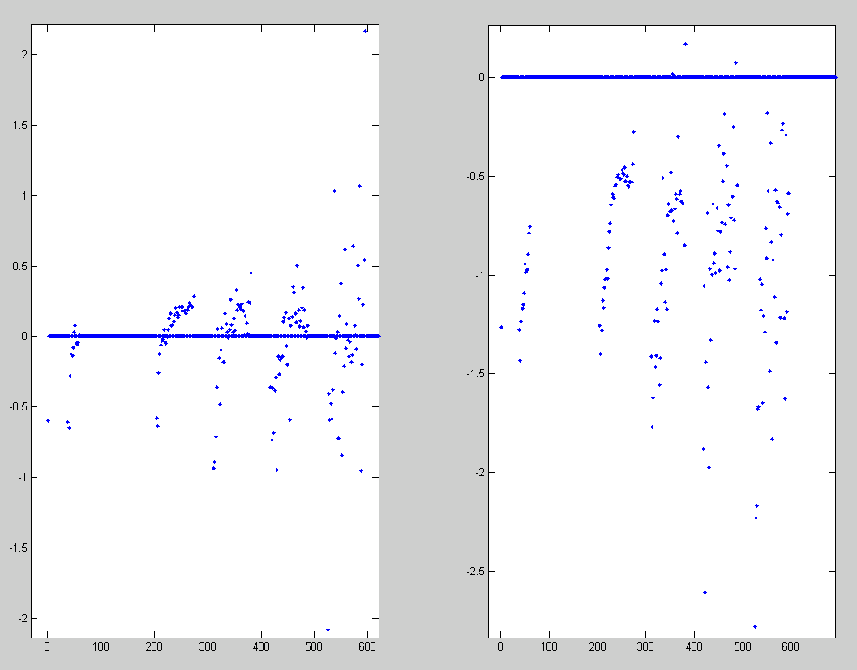
- 09:54: Transversal emittances of 4 trains.
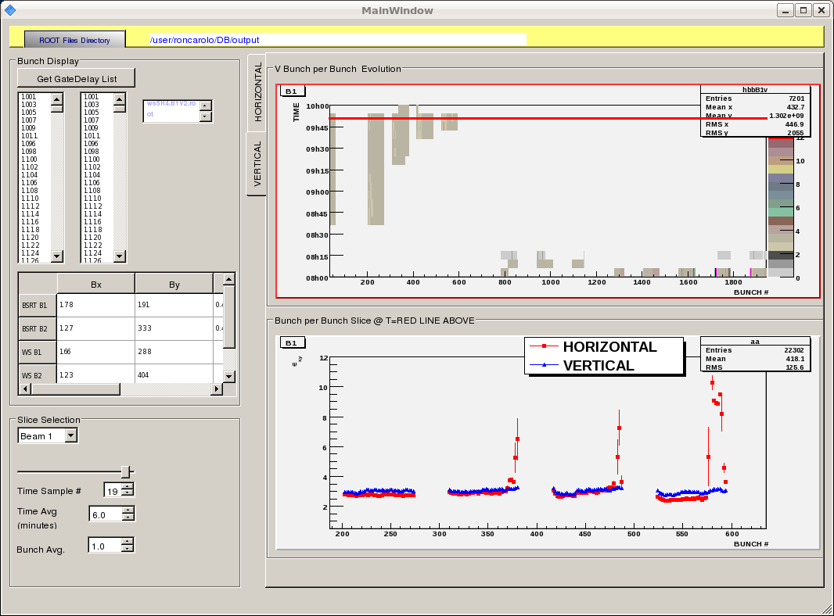
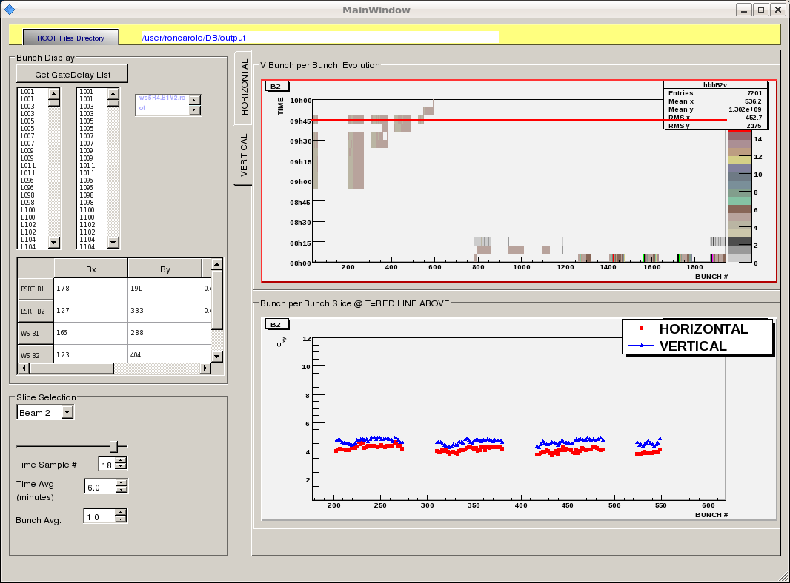
- 09:57: Dump due to BPM interlock test from ABT.
- 10:26: Beam 1 72 bunches 50 ns in. Perfectly clean. Below 1 % of dump threshold on the TCDIs. 7 % dump threshold from uncaptured beam. Note that similar good results were also obtained with Beam 2.
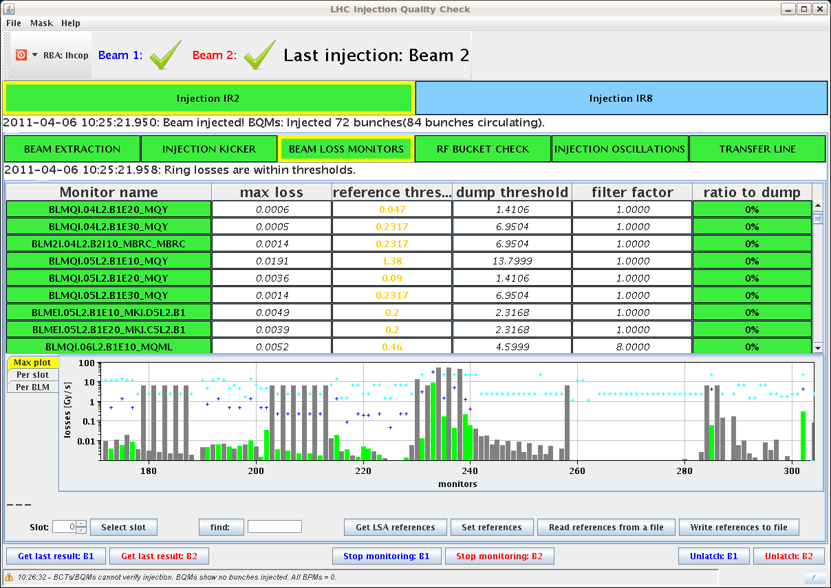
- 10:28: Intensities not very equal along our batch.
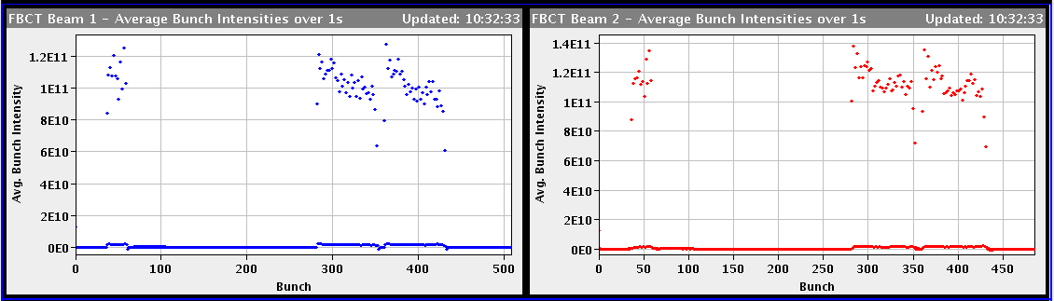
- 10:45: Dumped B1 with 'faulty' BPMSA.B4L6.B1. Reading 0.15 mm, dumped when moving threshold from 1.0 to 0.5 mm. OK, fucnctional, although not reading the correct number of bunches.
- 10:50: Transversal emittances of 2 trains with 72 bunches for each beam. Emittance growth in the last train of B1 but not emittance growth for B2, even though B2 was lost just after these plots.
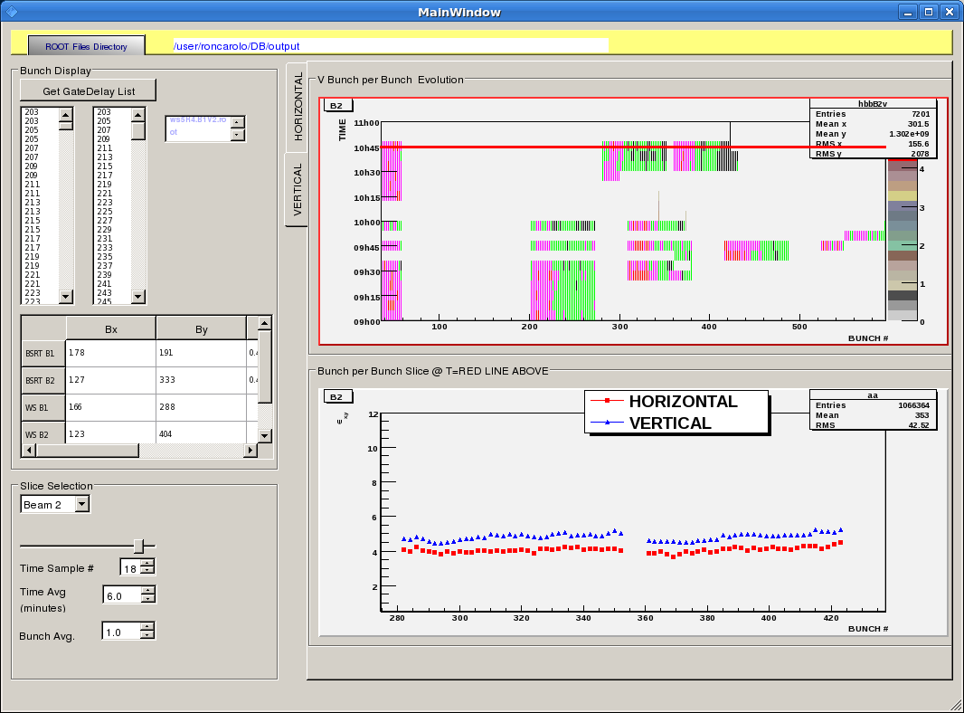
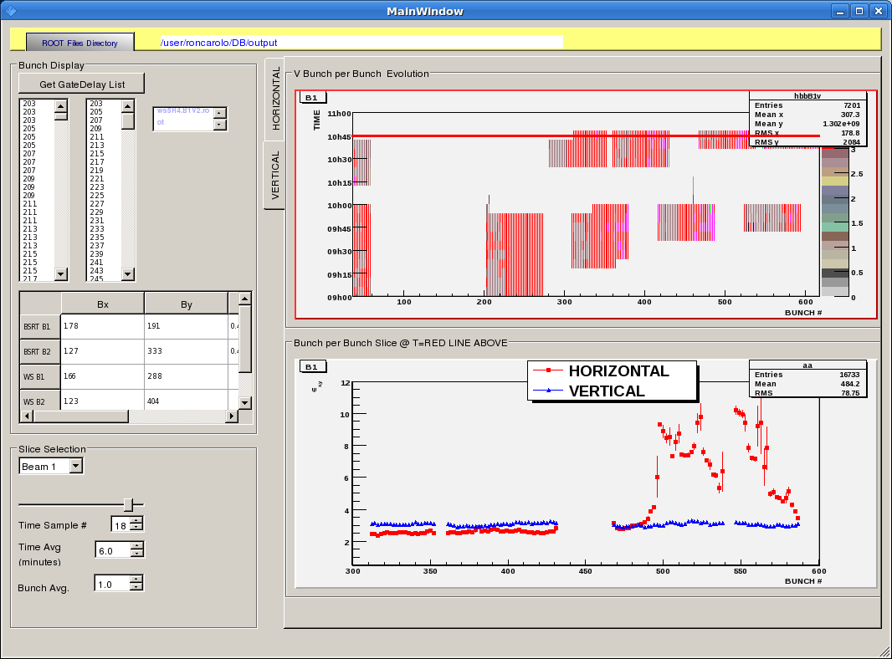
- 10:50: BPMS test B2, BPMSA.A4R6.B2 vertical. reading 0.29, dumped when moving threshold from 0.5 to 0.0 mm. OK.
- 11:13: 108 bunches came in at once.
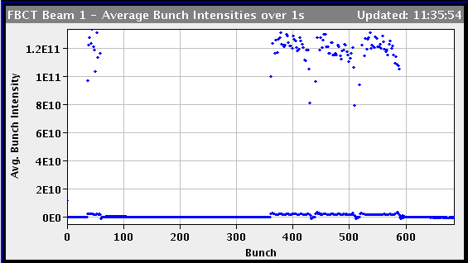
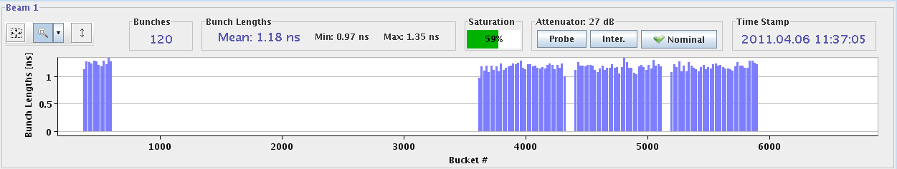
- 11:59: We had a trip of the ADT B1H, the power piquet is checking. For the ADT, it was a vacuum interlock.
- 12:17: Transversal emittances of trains with 216 bunches, just before B1 got lost.
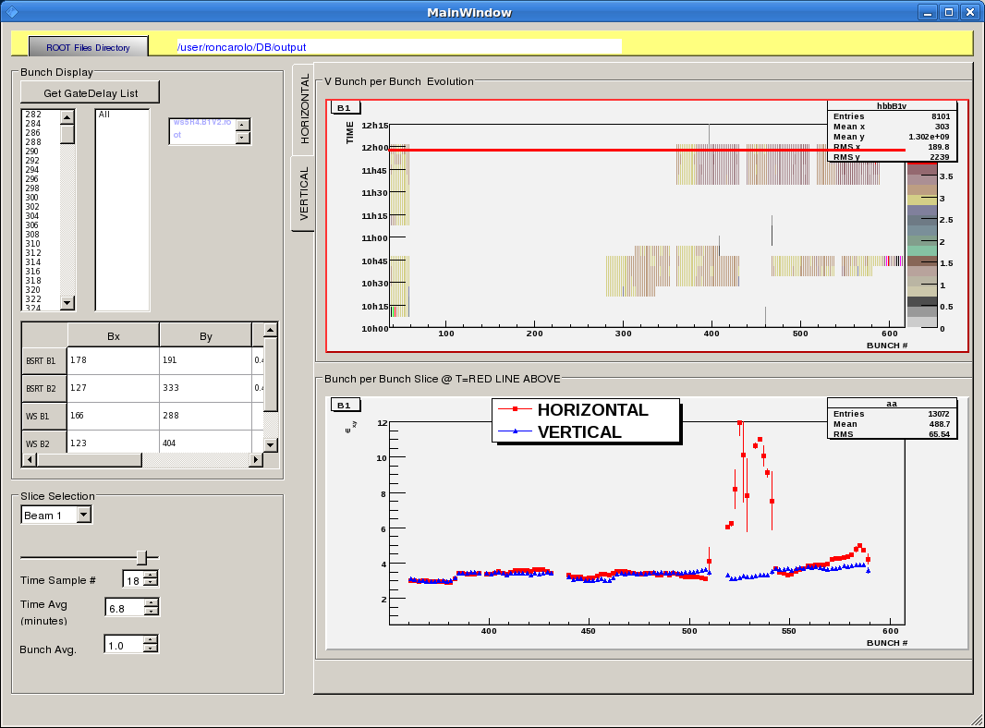
- 13:10: Had one not so clean injection with 36 bunches before. The LHC crew had changed the frequency by -8 Hz before the injection...the re-phasing maybe? The injections afterwards were good again.IQC result of the not so clean injection attached.
- 13:13: vacuum
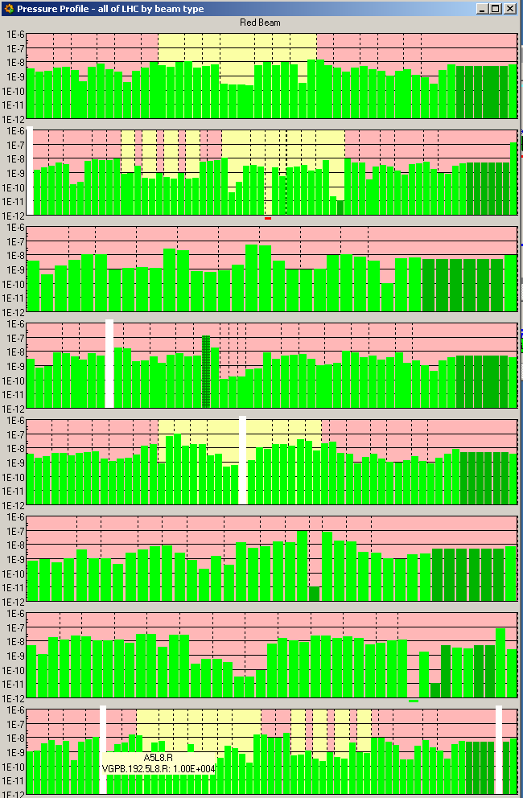
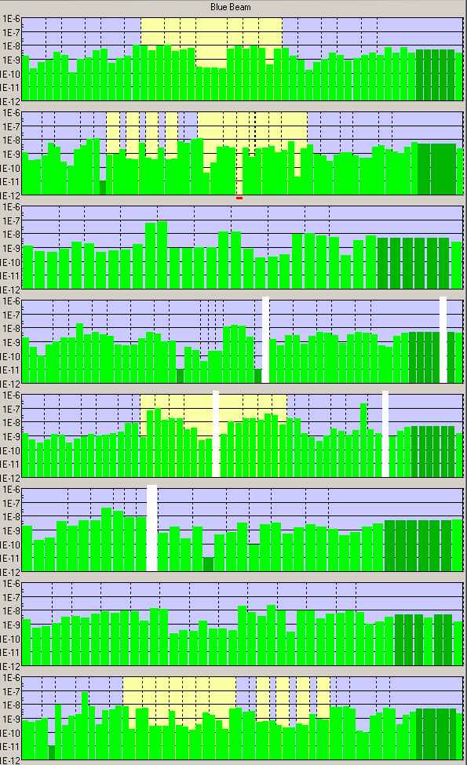
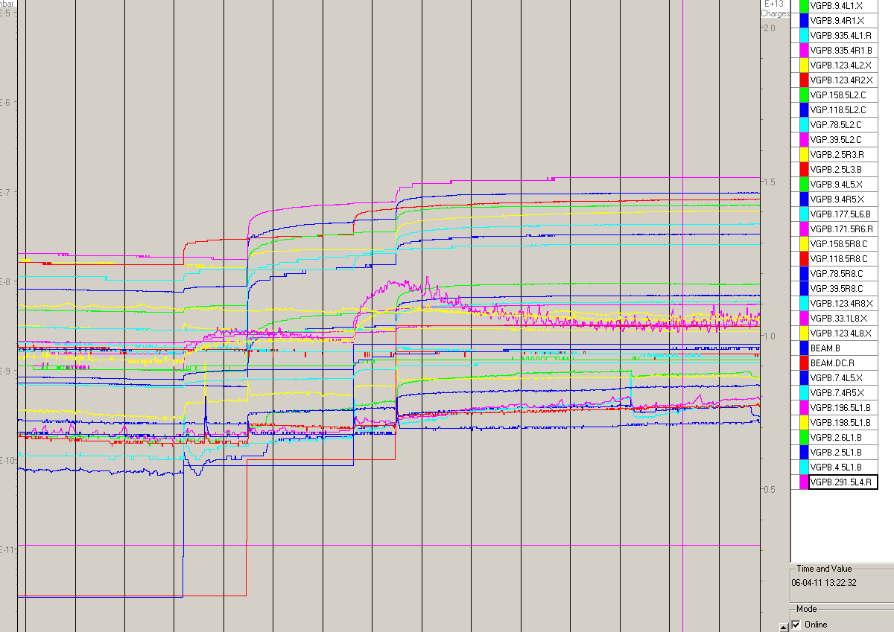
- 14:00: Pressure spike when no injection ongoing.
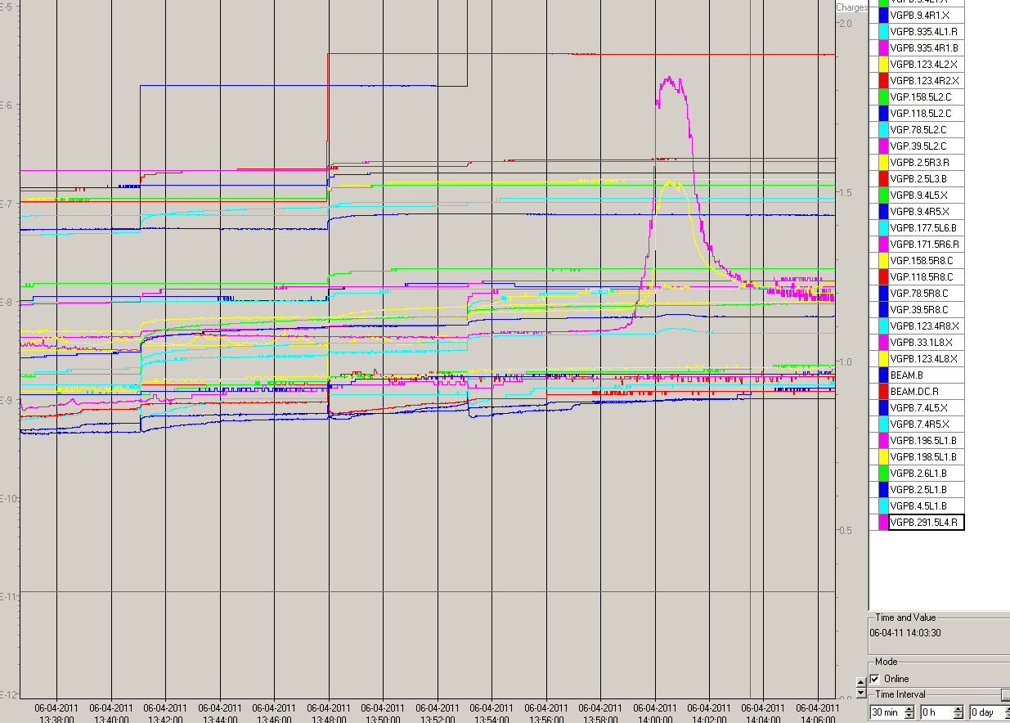
- 14:09: 5th injection Beam 2.
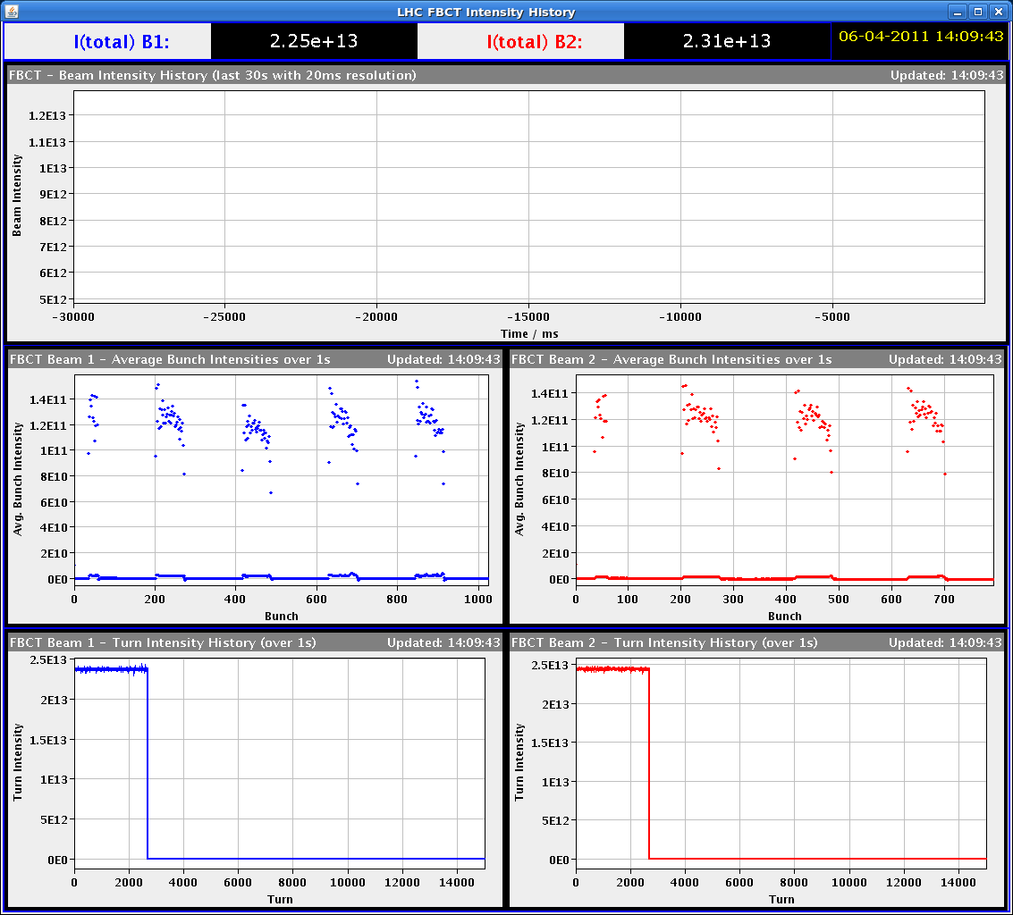
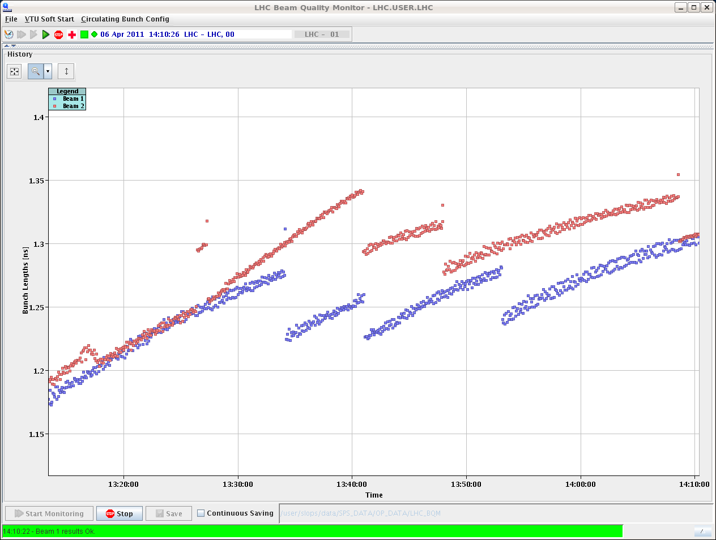
- 14:17: Paul from the vacuum has added the monitoring of the vacuum at the ADT since the trip we had this morning. We are now at 3e-7 and the interlock level is at 5e-7 (192 bunches per ring, in 36 bunch trains). Unfortunately the vacuum there does not seem to clean much, and additionally it seems to be going up with both beam injections.
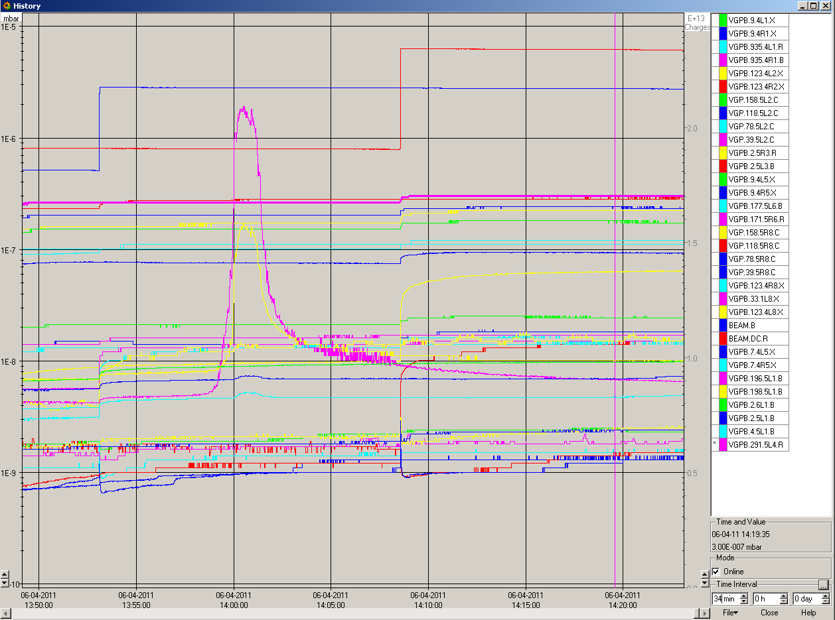
- 14:37: Transversal emittances for 6 trains (36 bunches each) for each beam.
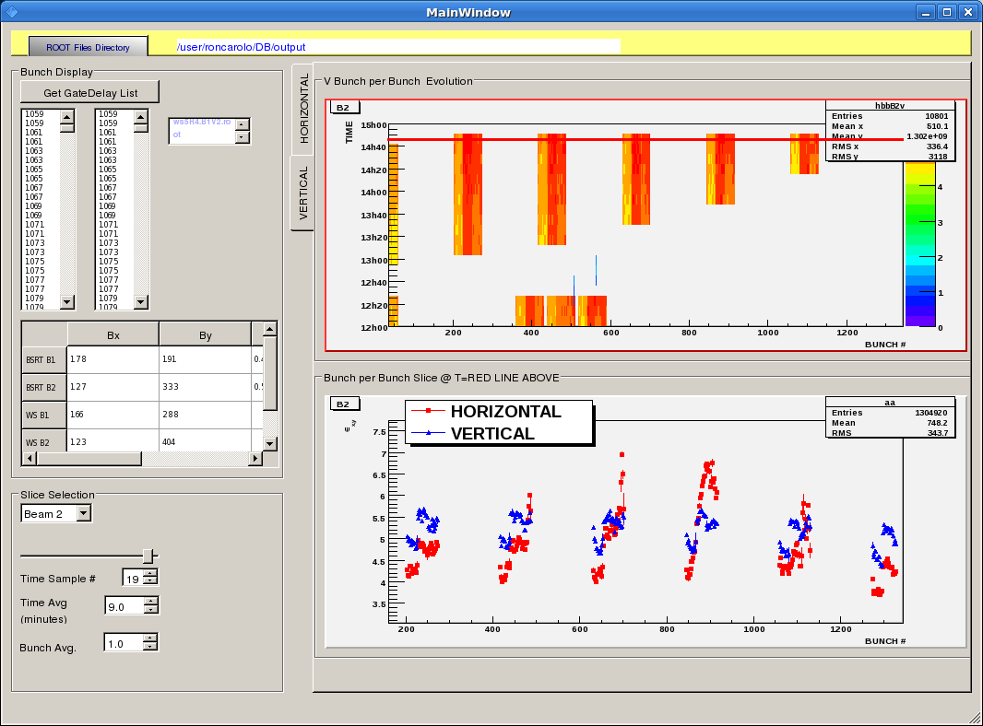
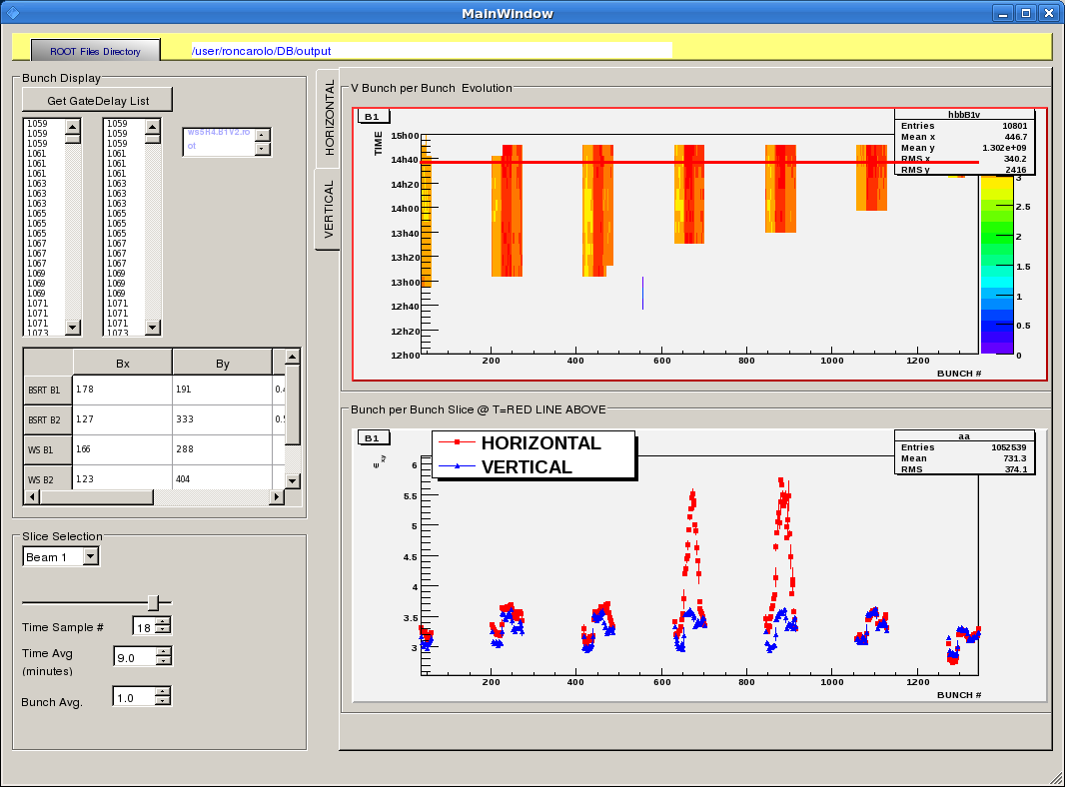
- 14:59: Shift summary:
- Got the machine with almost 300 bunches per train, and scrubbing ongoing with beam measurements from ABP colleagues. Then we dumped for injection studies. Verified 50 ns bunch injections:
- 36 bunches per injection were ok even when at minimum spacing (925 ns or 370 buckets), which was not the case during the past night shift.
- 2x36 bunches per injection were fine also. BPM interlock checked for both beams.
- 3x36 bunches per injection were more or less ok from the ABT point of view but brought the vacuum pressure close to the interlock levels. In particular an ADT gauge interlocked and we had a PM for beam 1 (not clear which came first, beam probably unstable on a few bunches). beam 2 was dumped with BPM interlock test.
- Given that the 108 bunch trains were too close to the vacuum interlock so we decided to scrub with 36 bunch trains equally spaced around the ring (to get a chance to get to about 400 for RF tests).
- Note that
- the U_RES of the undulator L4 needs to be reset;
- never injected the shot right after the intermediate intensity (in bucket 961);
- new XPOC to be released + work in PS and SPS for about 30 minutes with no beam.
- CONSIGNE:
- when pilot in, measure and document chroma;
- at every injection check vacuum and capture screenshots for fBCT, lifetime, bunch length, wires (1st and last bunch per batch, until intensity allows), vacuum behaviour;
- when intensity increase (total or per SPS train) capture screenshots for beam loss pattern, HOM power display, and check cryo / temperature increase.
- 15:54: Another B1 injection - now 300 bunches for both beams.
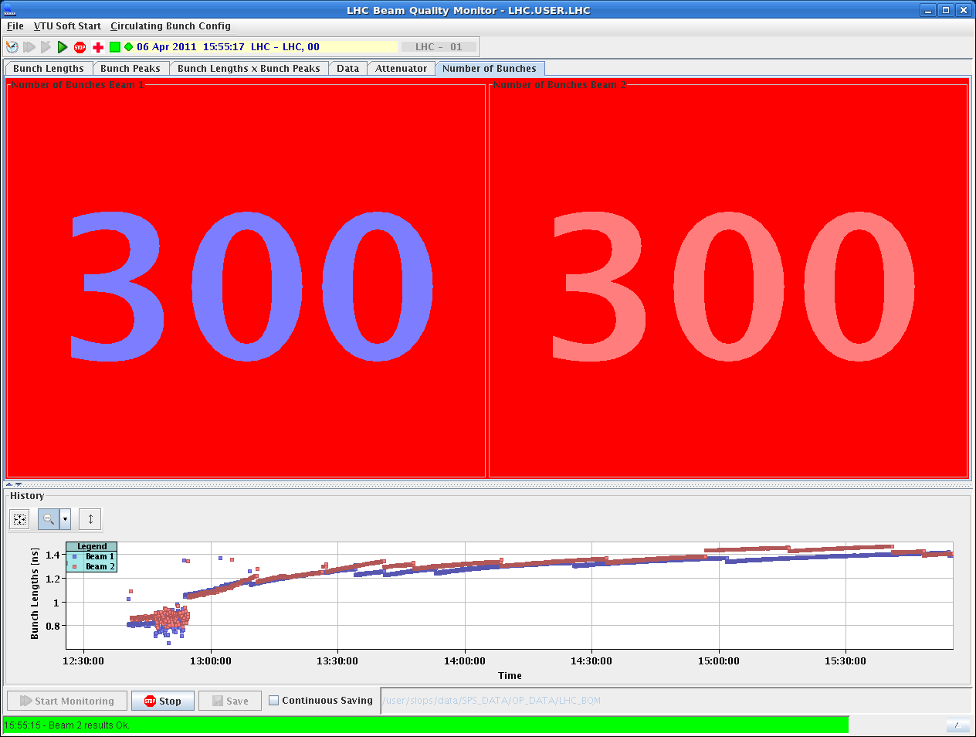
- 15:55: vacuum.
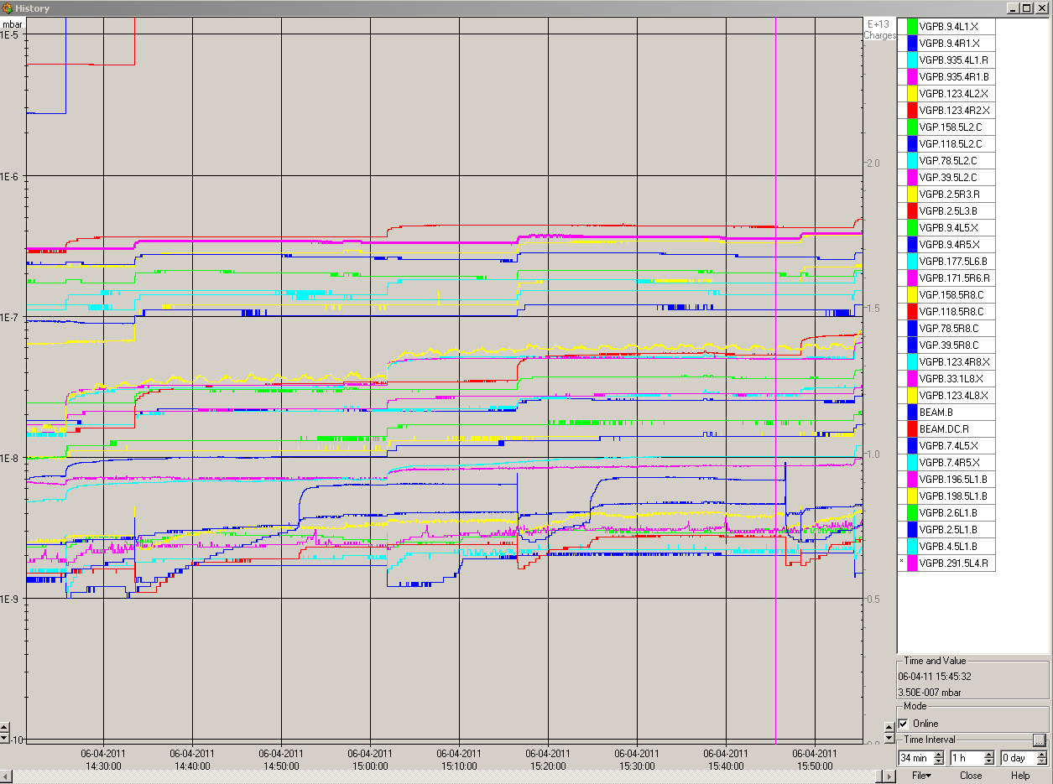
-16:18: BLM after ~20 min with 300 bunches.
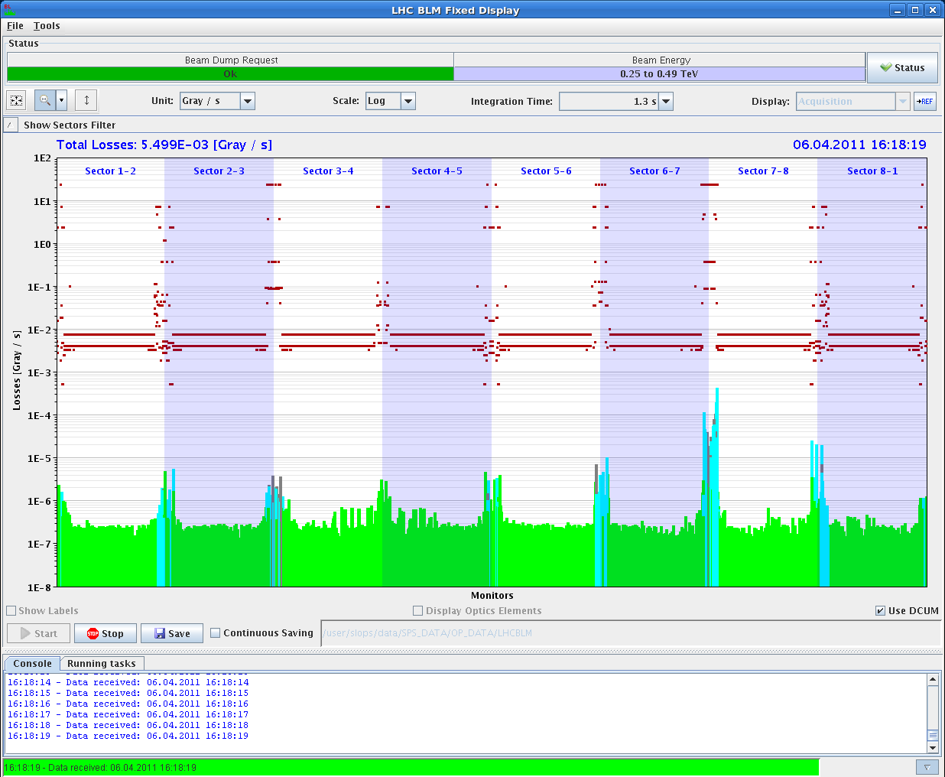
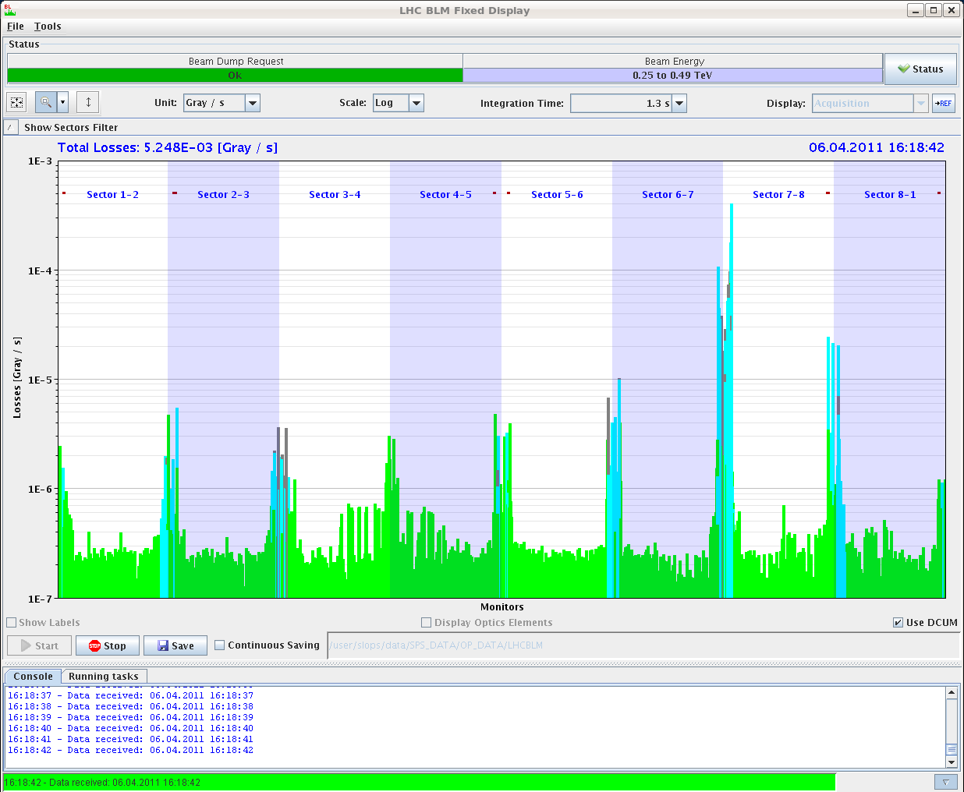
- 16:32:
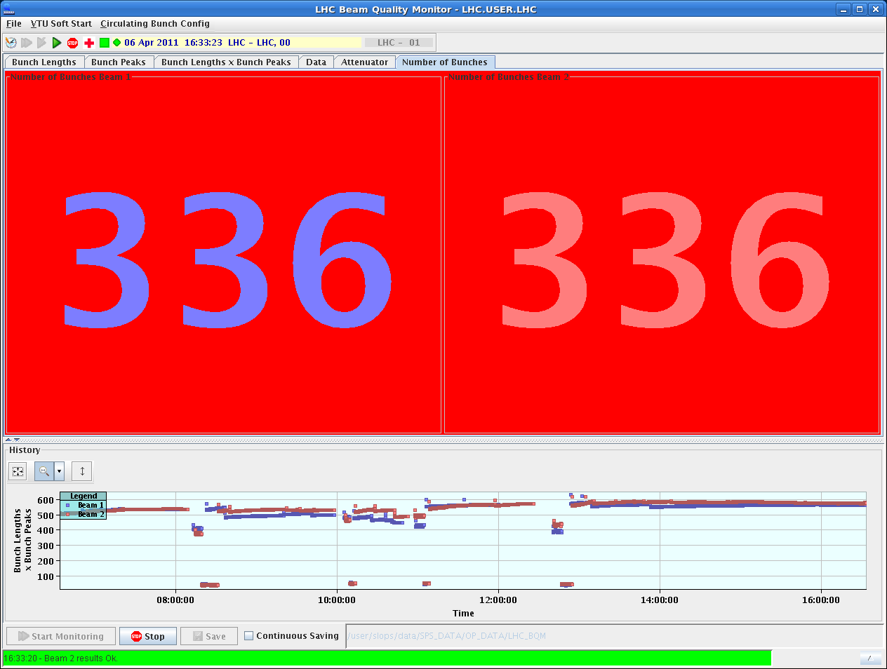
- 16:32: Transverse emittances along the trains.
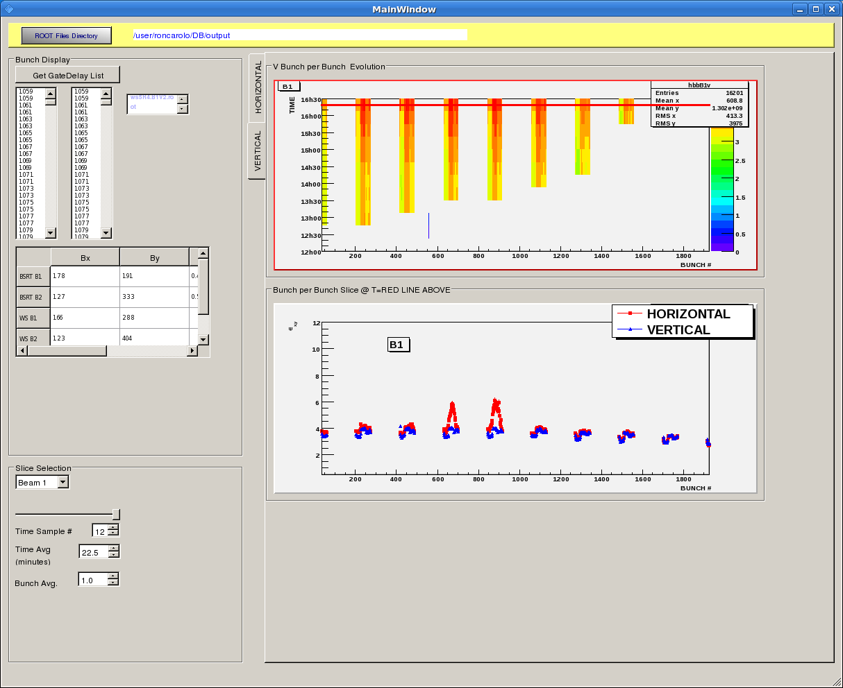
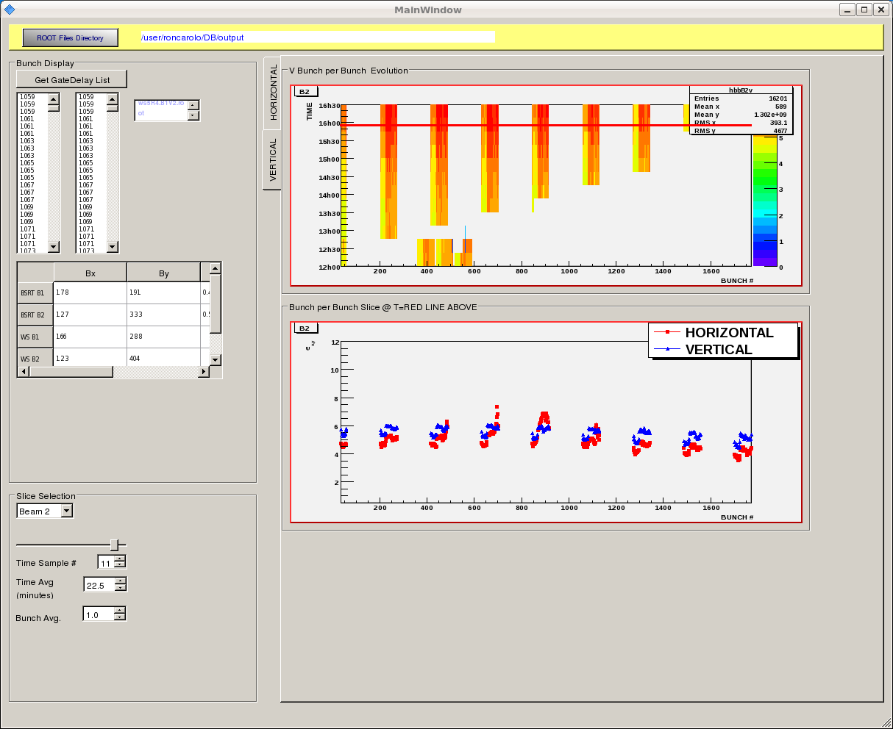
- 16:54: 372b + 372b.
- 17:17: 408b + 408b.
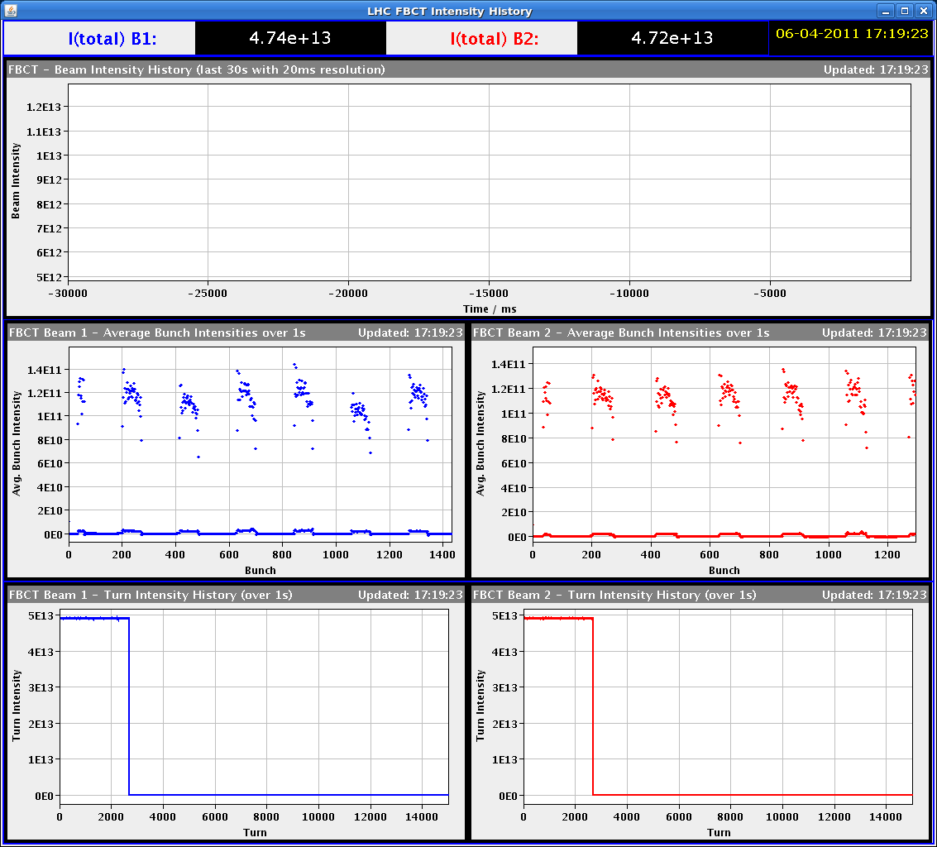
- 18:00: beams dumped => Short access for RF in point 4.
- 18:24:
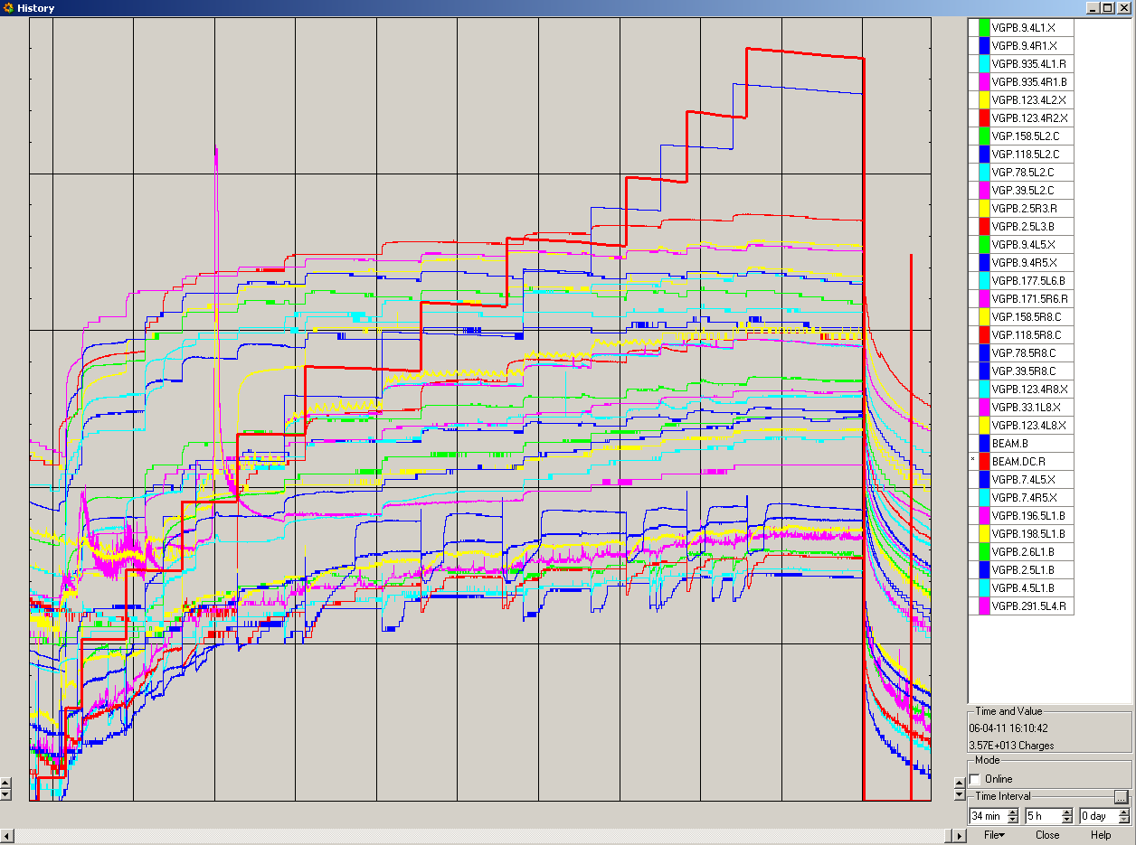
- 18:38: Single even upset found out by the QPS colleagues.
- 18:42: 2 persons enter PZ45 for a short acces for the damper interlocks.
- 19:25: Limits for the transverse damper gain increased to 0.357 to allow possible increase of the gain in case of instabilities (was 0.2 before).
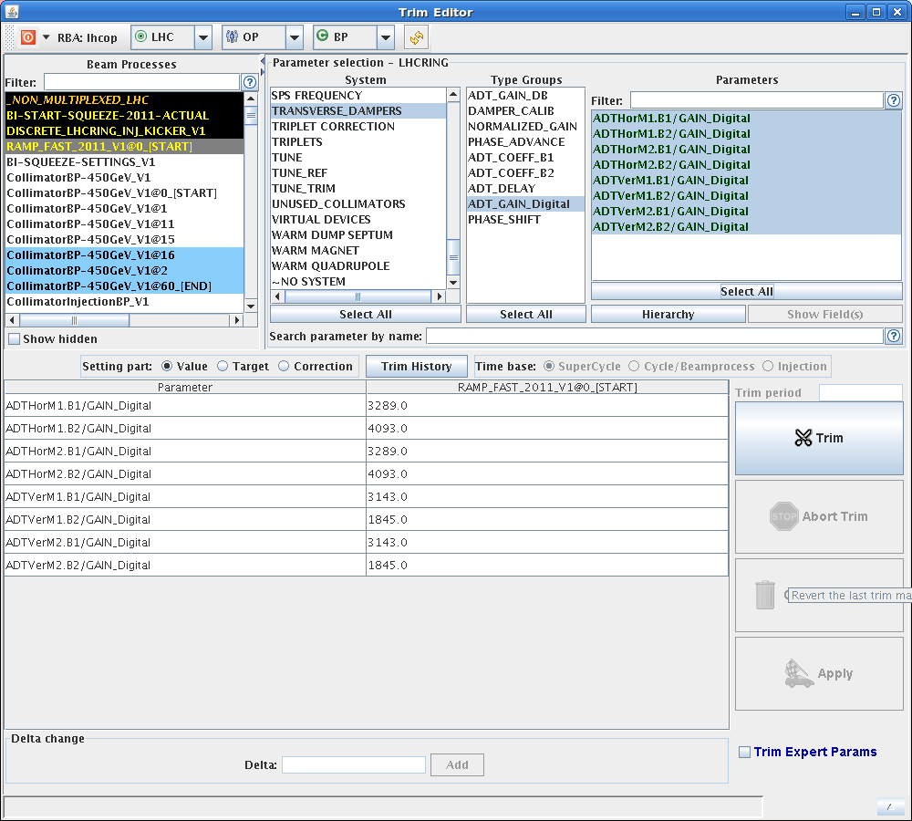
- 21:31: 156 bunches.
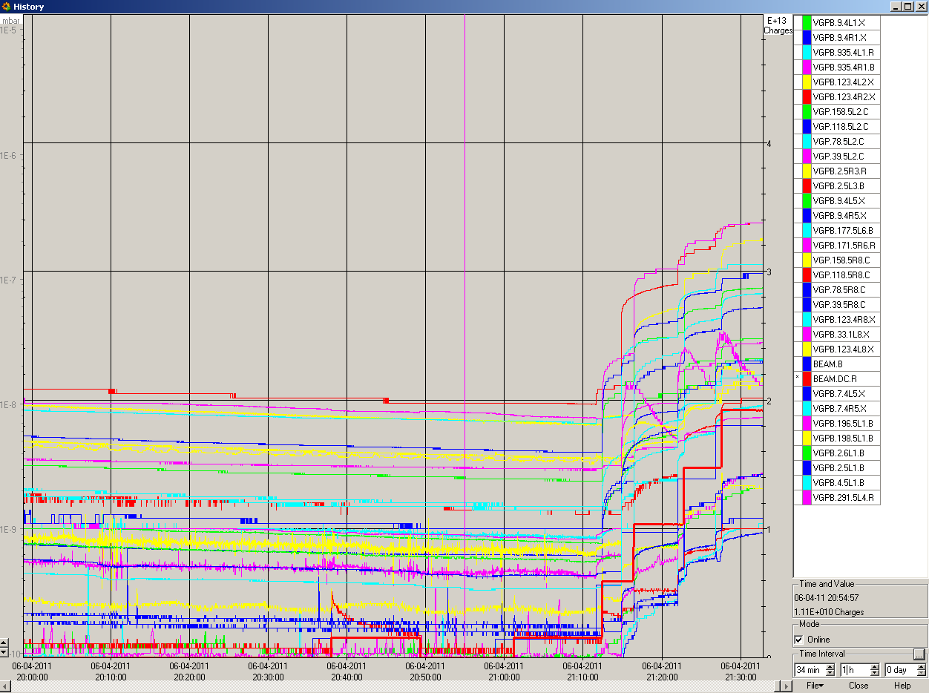
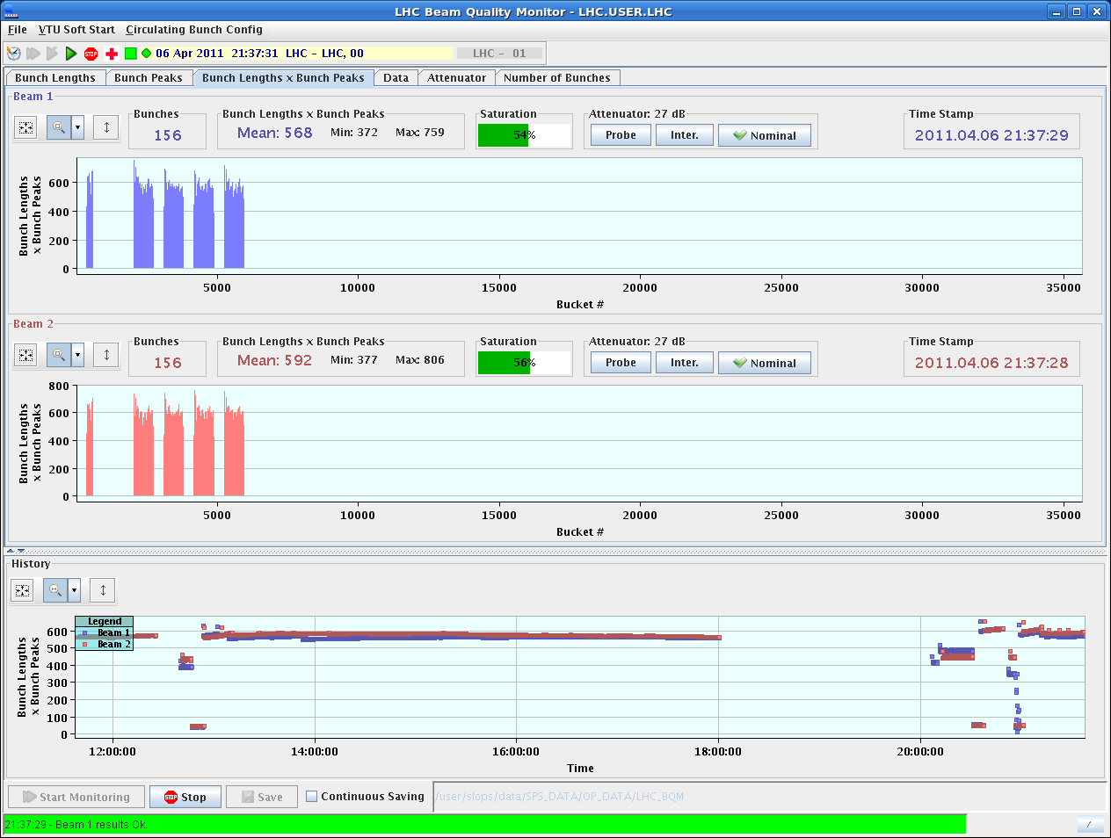
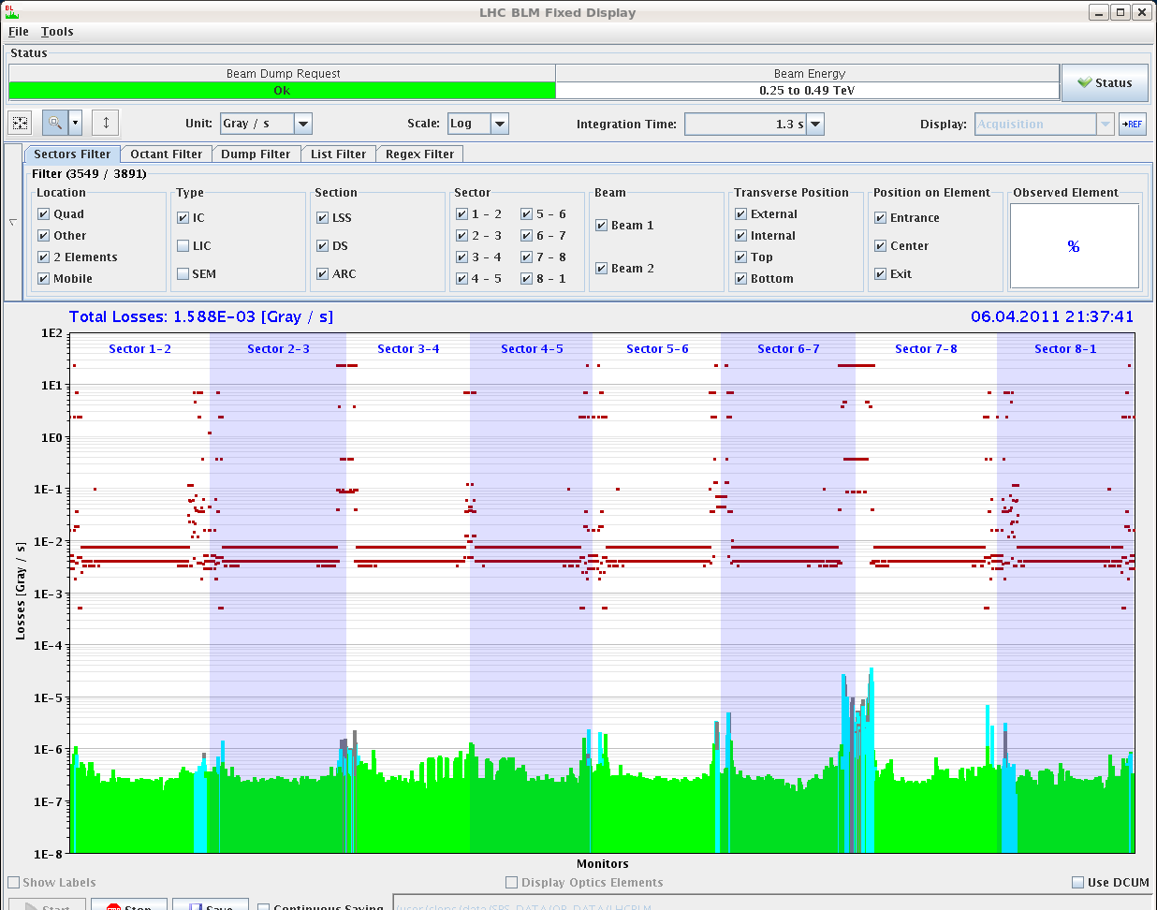
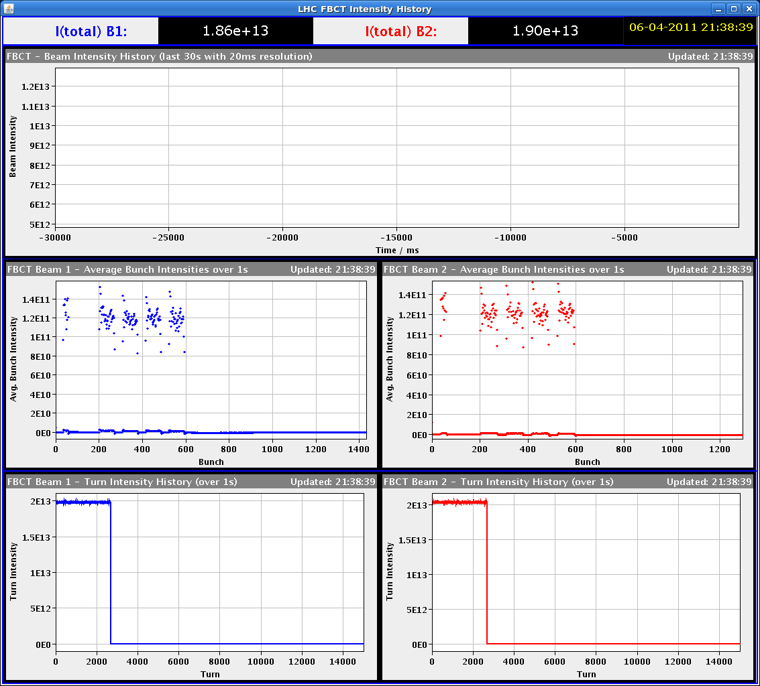
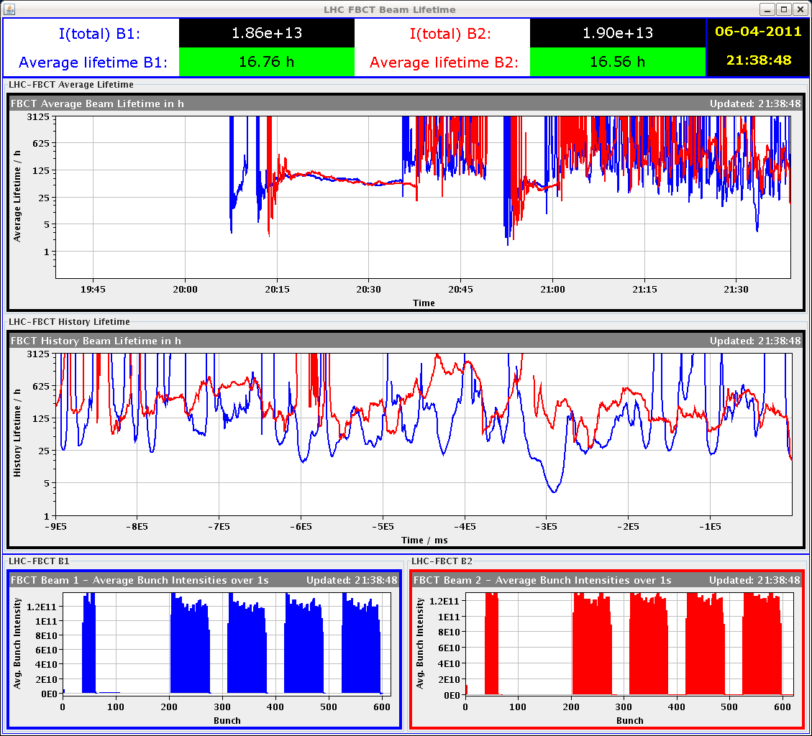
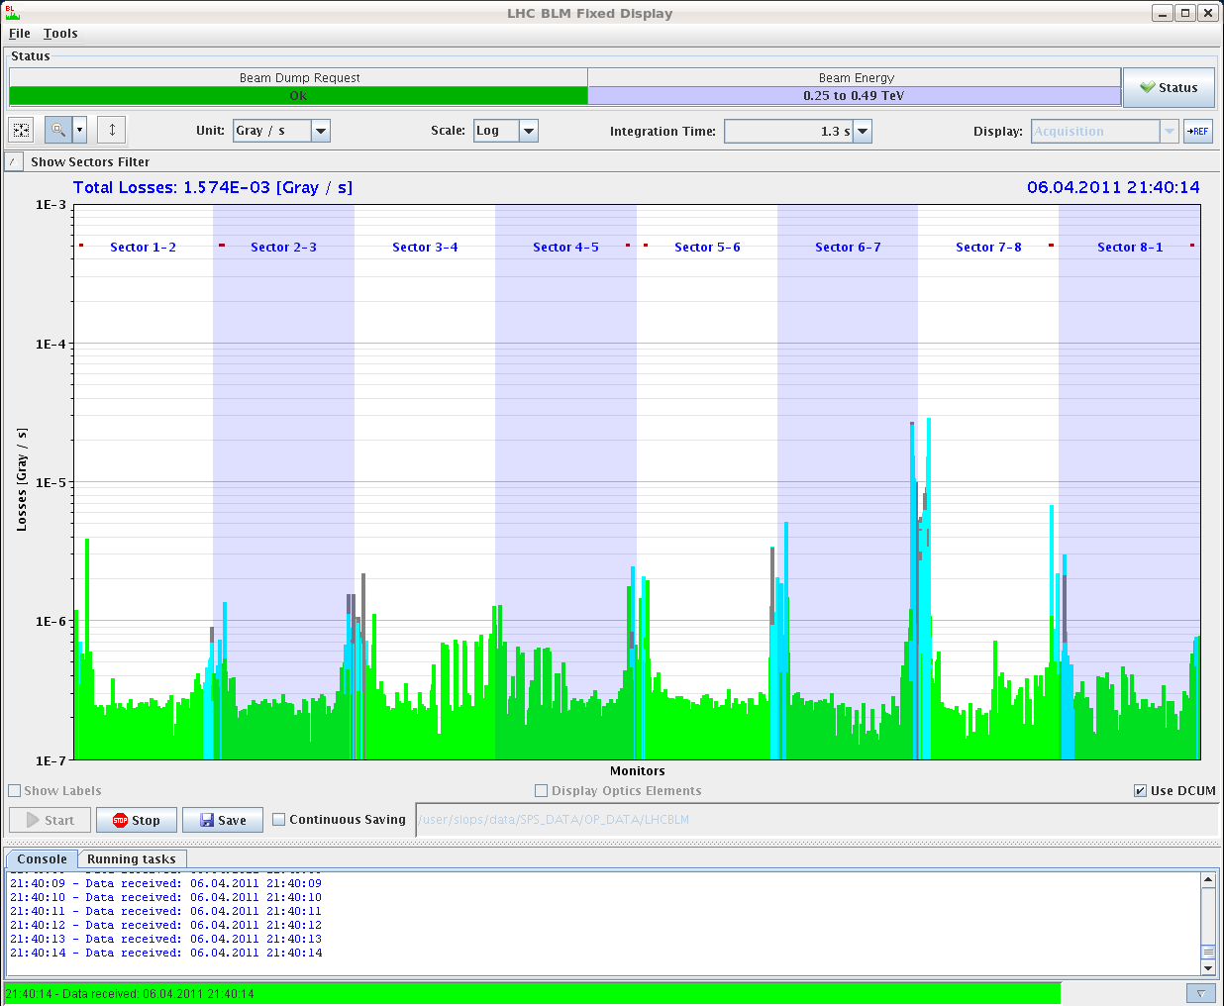
- 21:39: Emittances bunch by bunch since restart (from MDB).
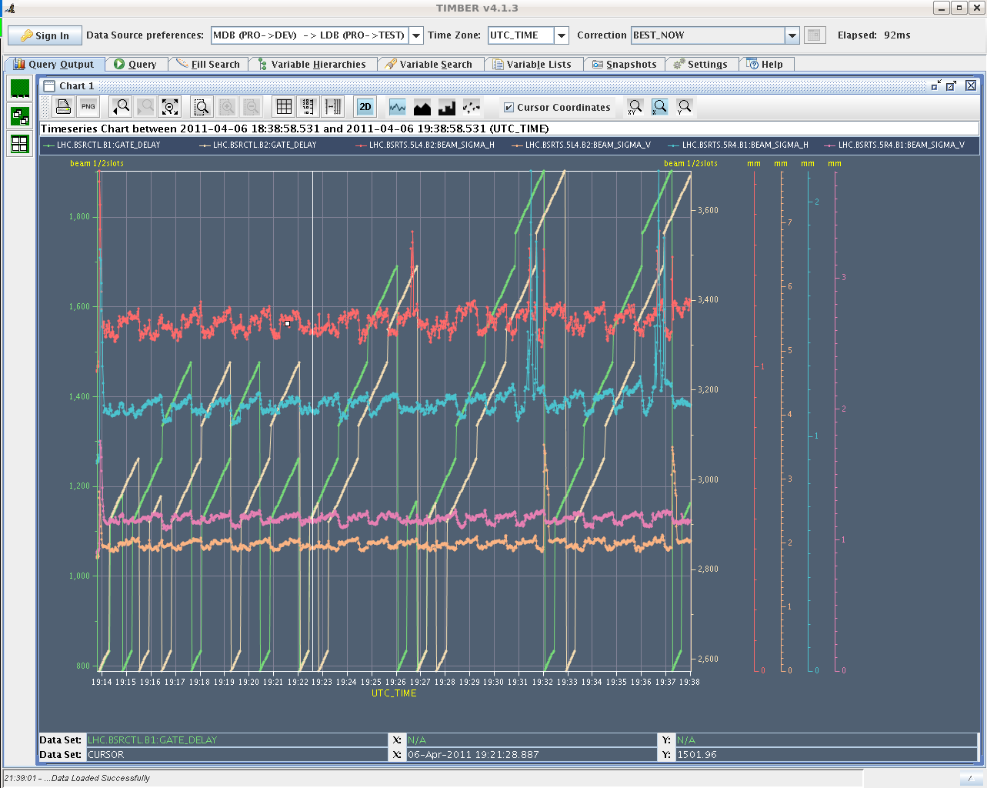
- 21:49: 192b + 192b.
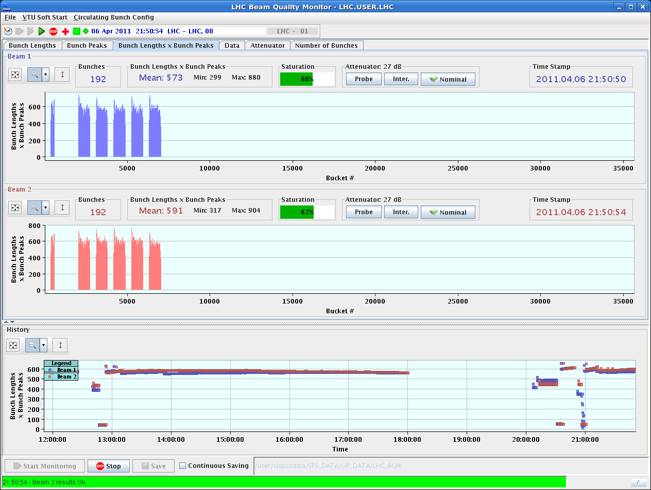
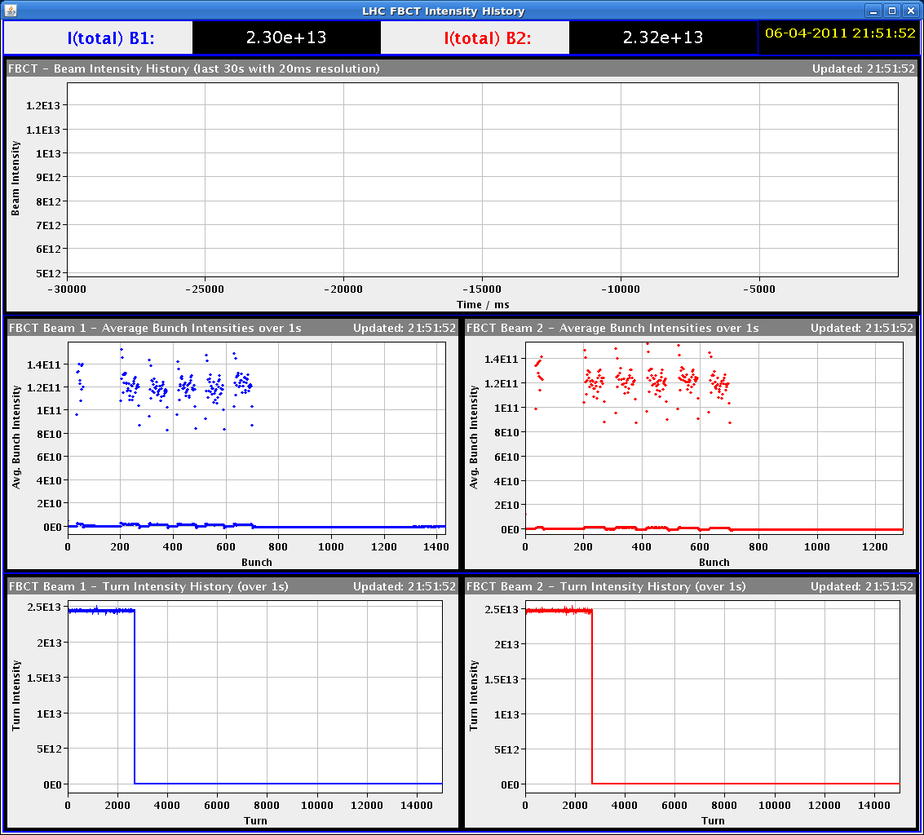
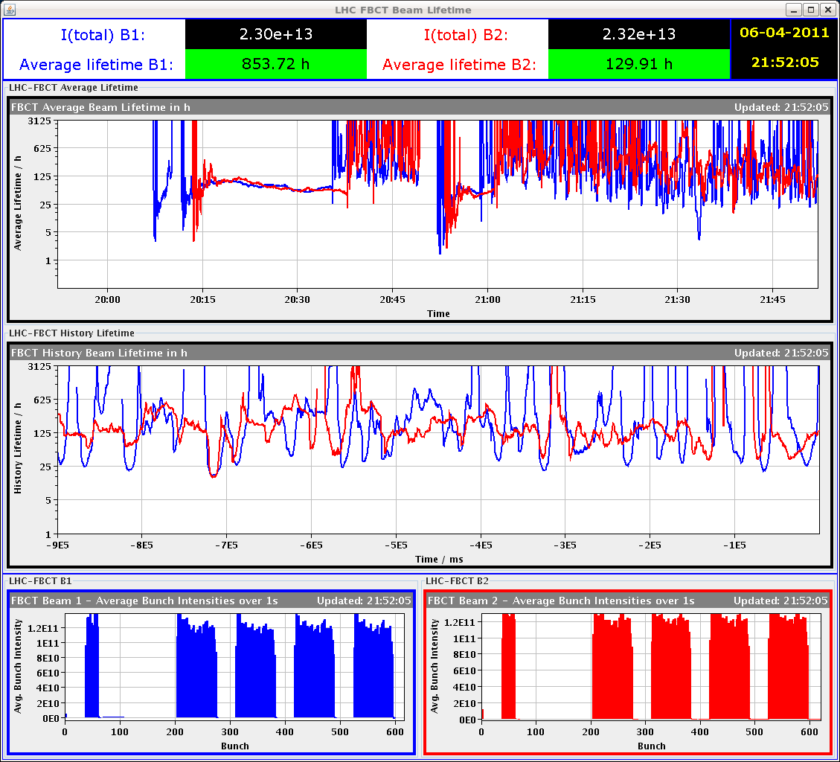
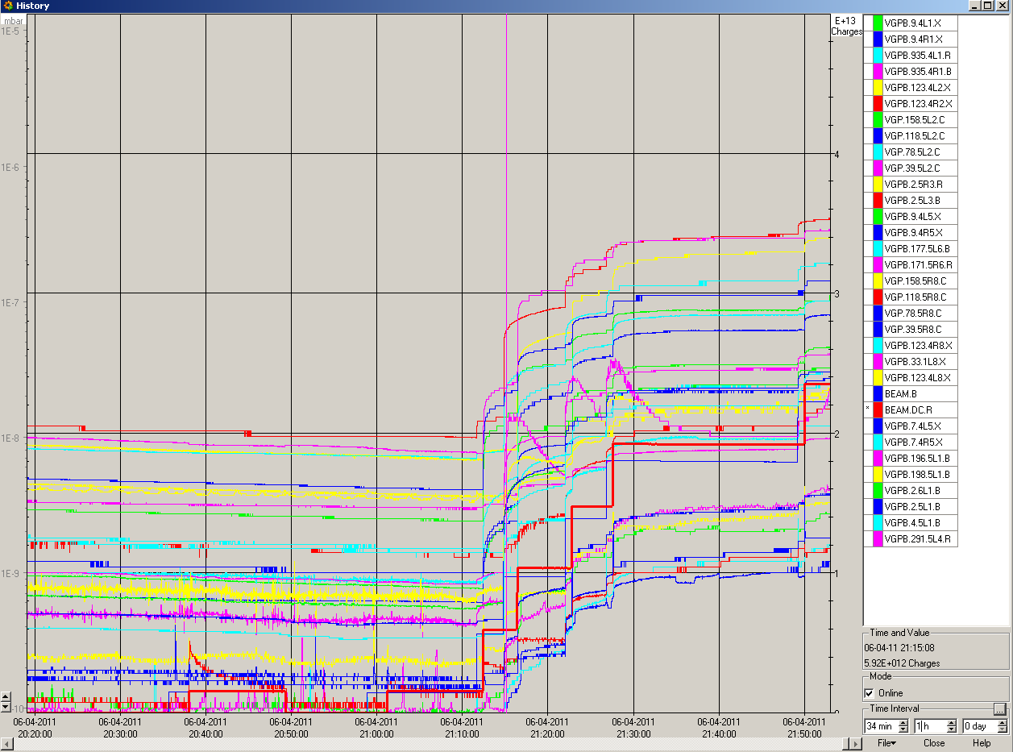
- 21:57: 228b + 228b.
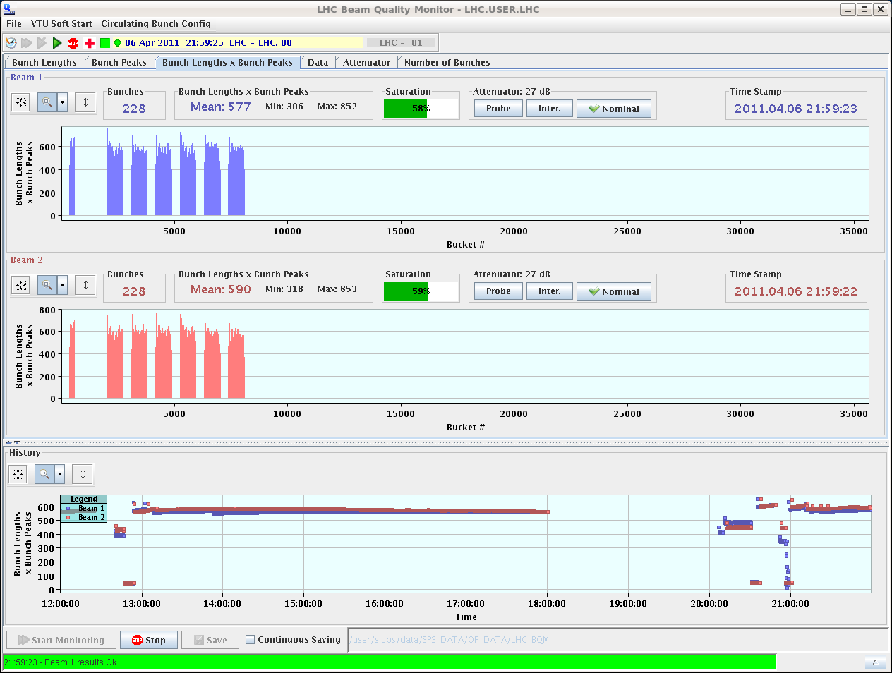
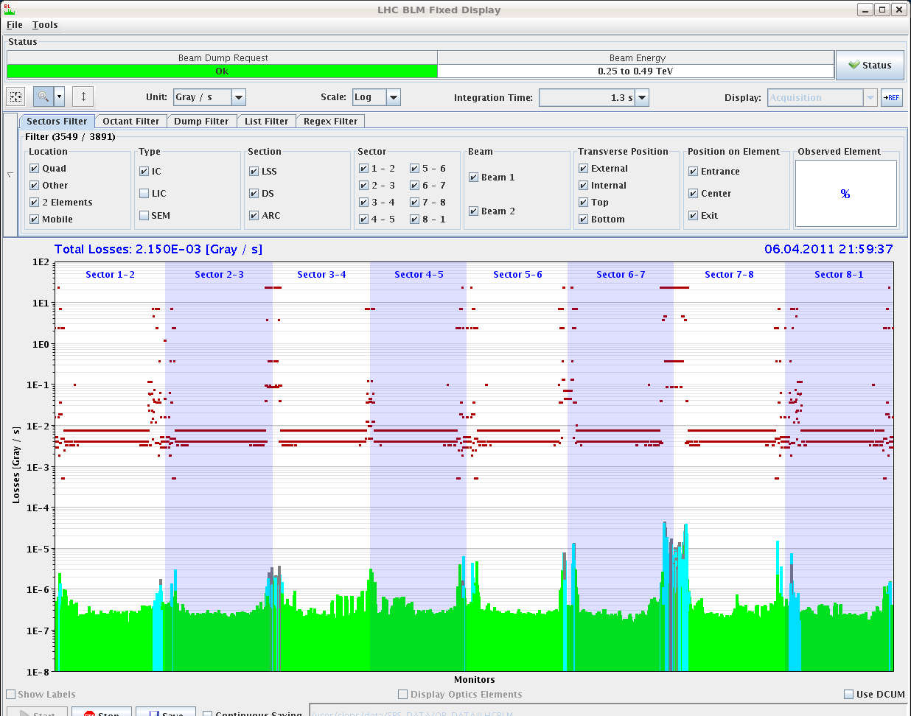
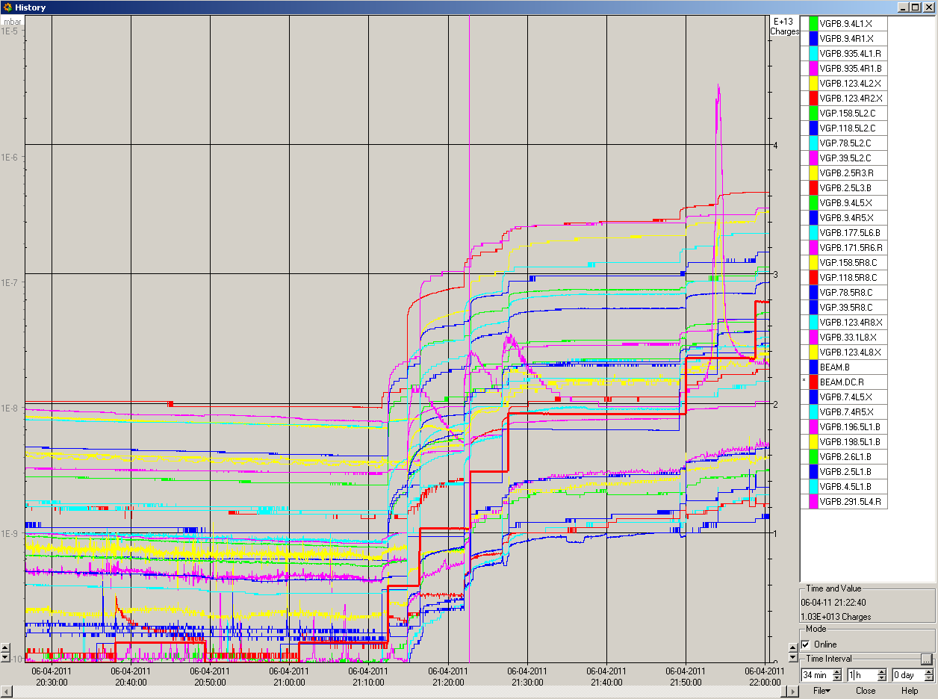
- 22:21: Loss pattern before next injection.
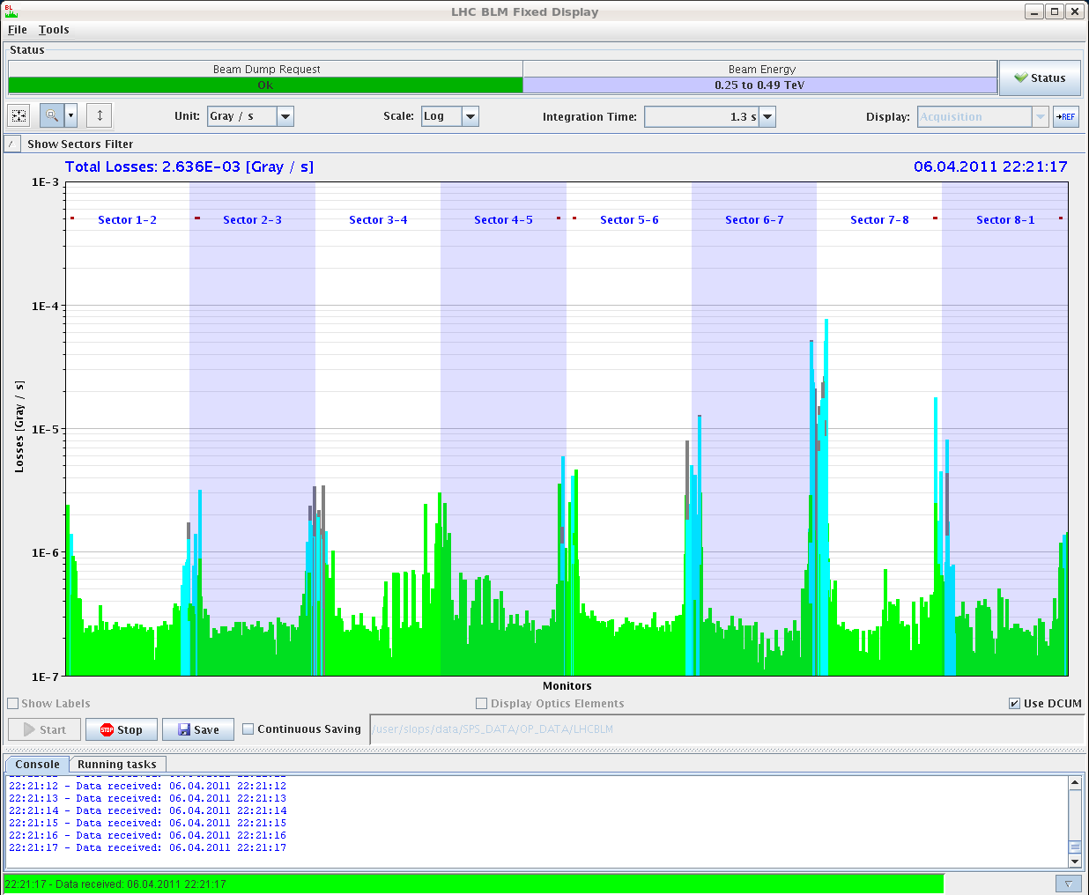
- 22:24: 264b + 264b.
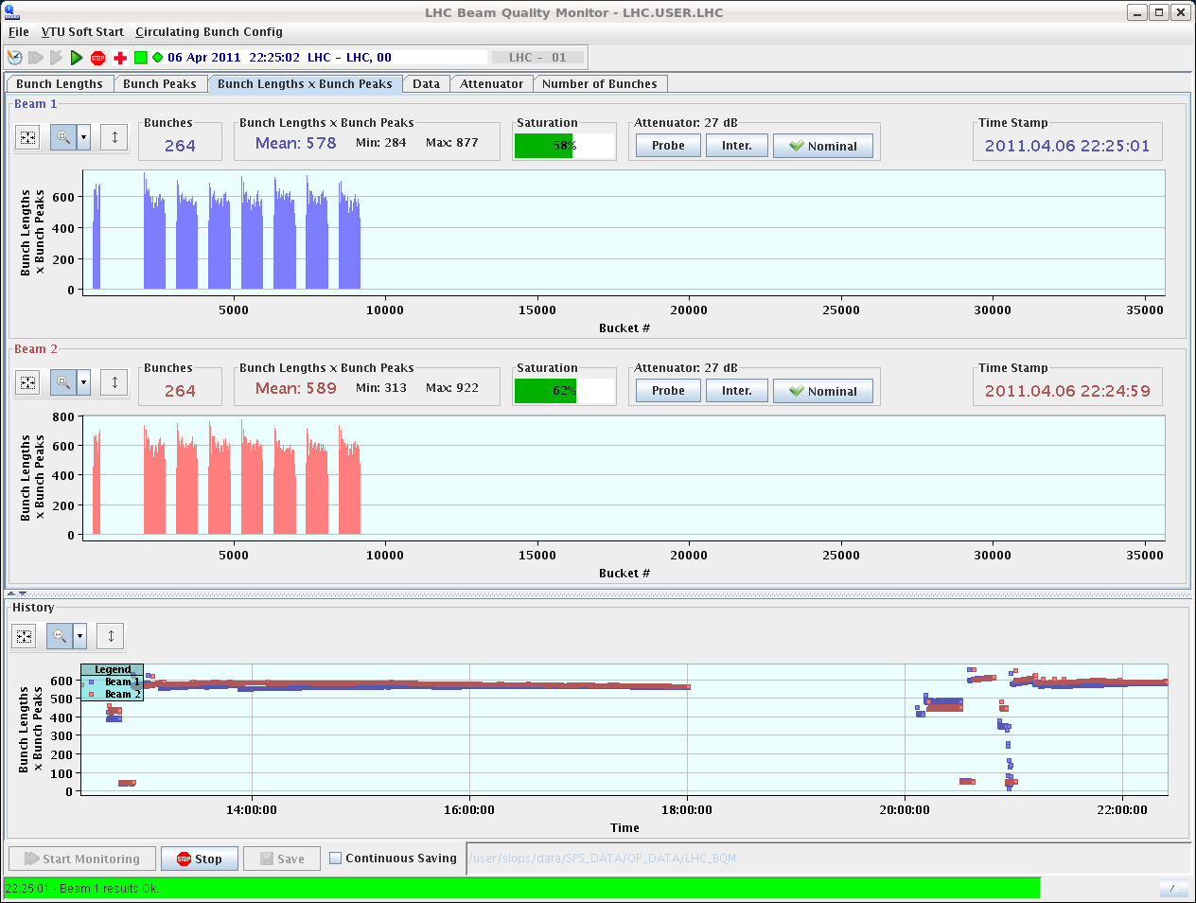
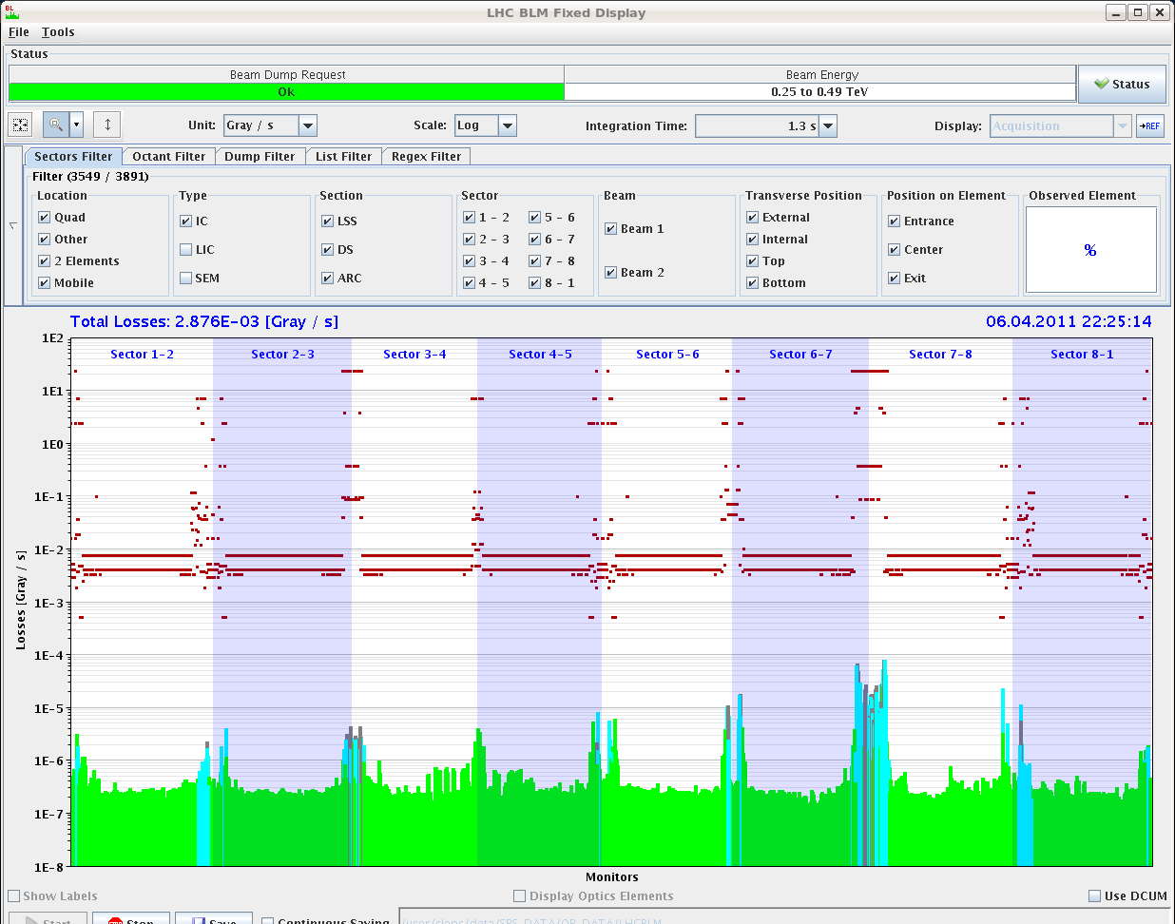
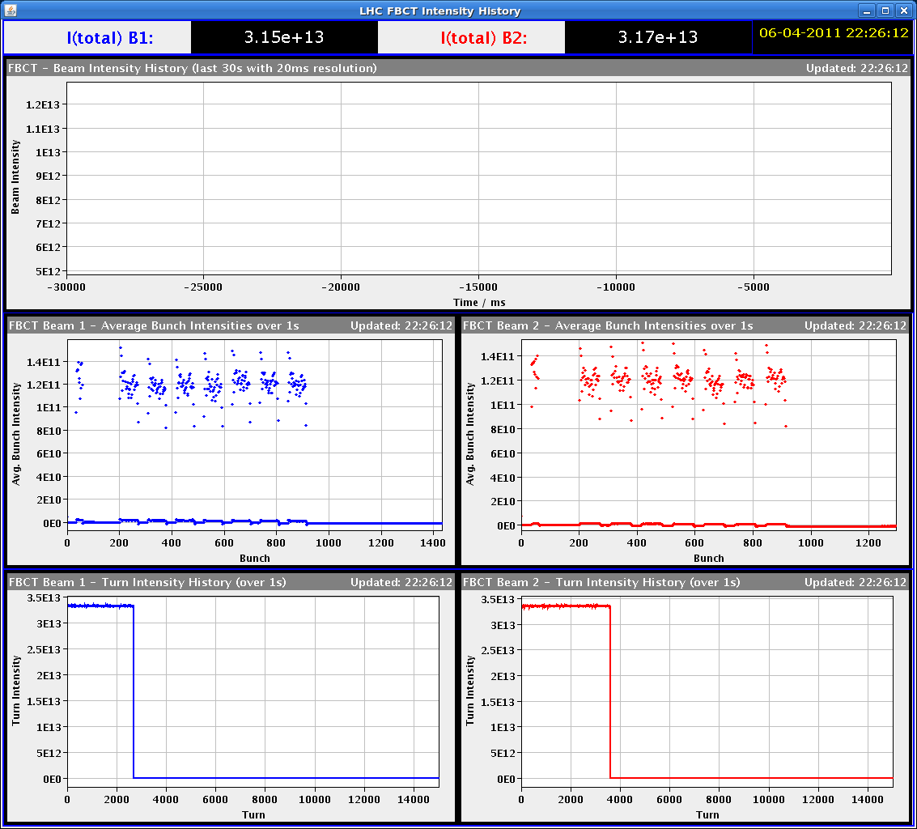
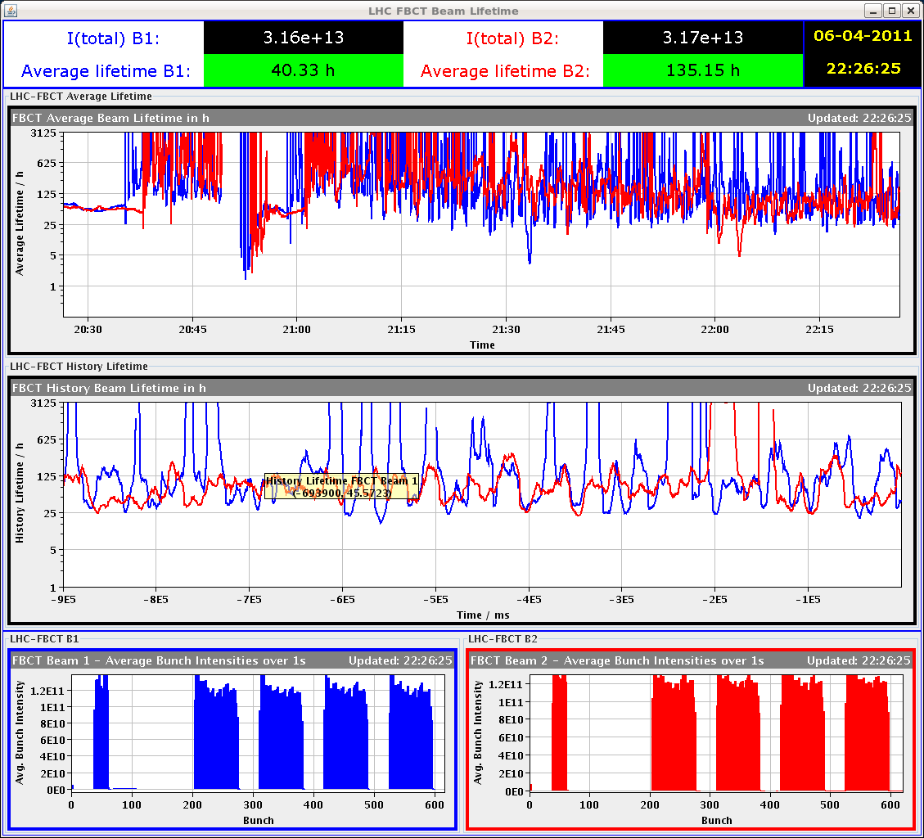
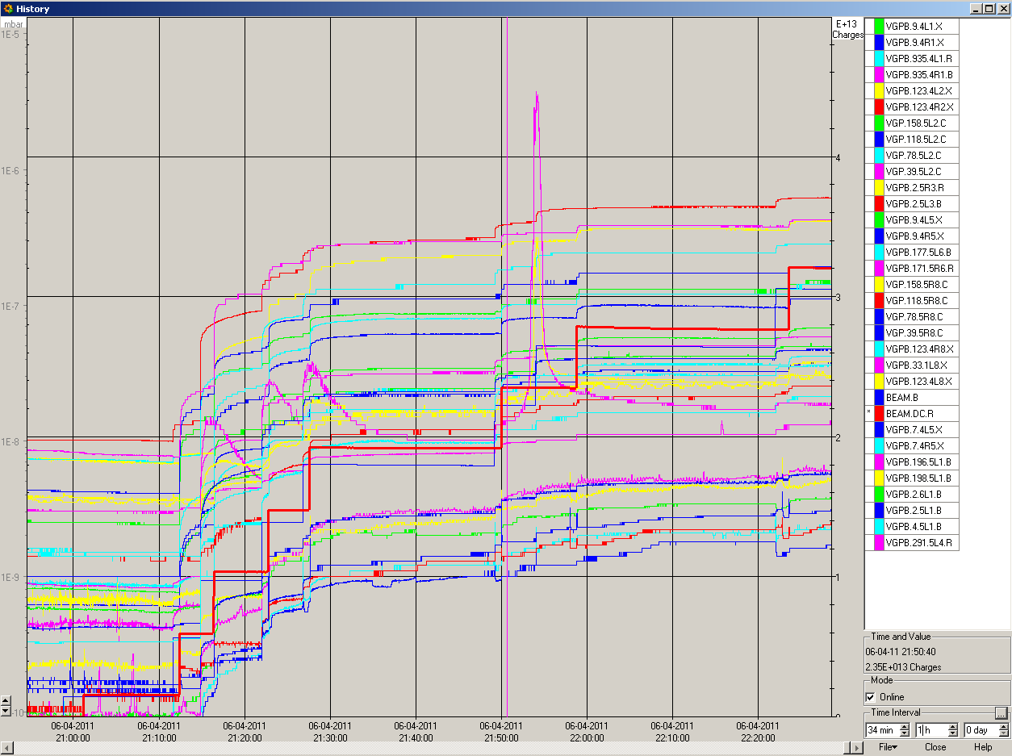
- 22:50: We are limited by VAC in the ADT region for B2. The vac colleagues have found out that there is a pump that is not connected. We will then continue only with B1 (faster) and proceed with B2 only if the vac permits. The issue with the pump will be followed up tomorrow.
- 22:50: 300b + 300b.
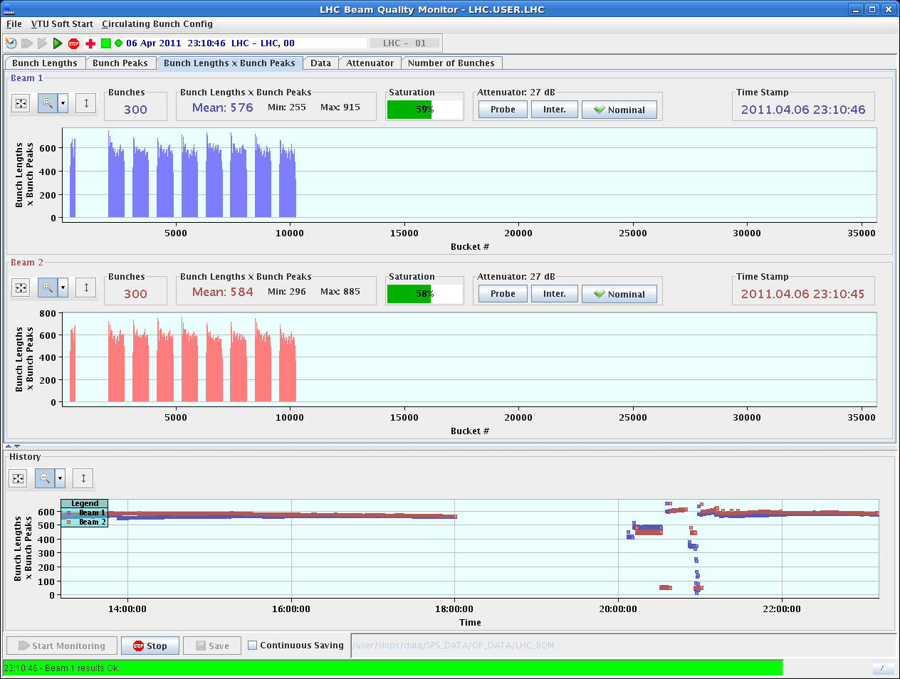
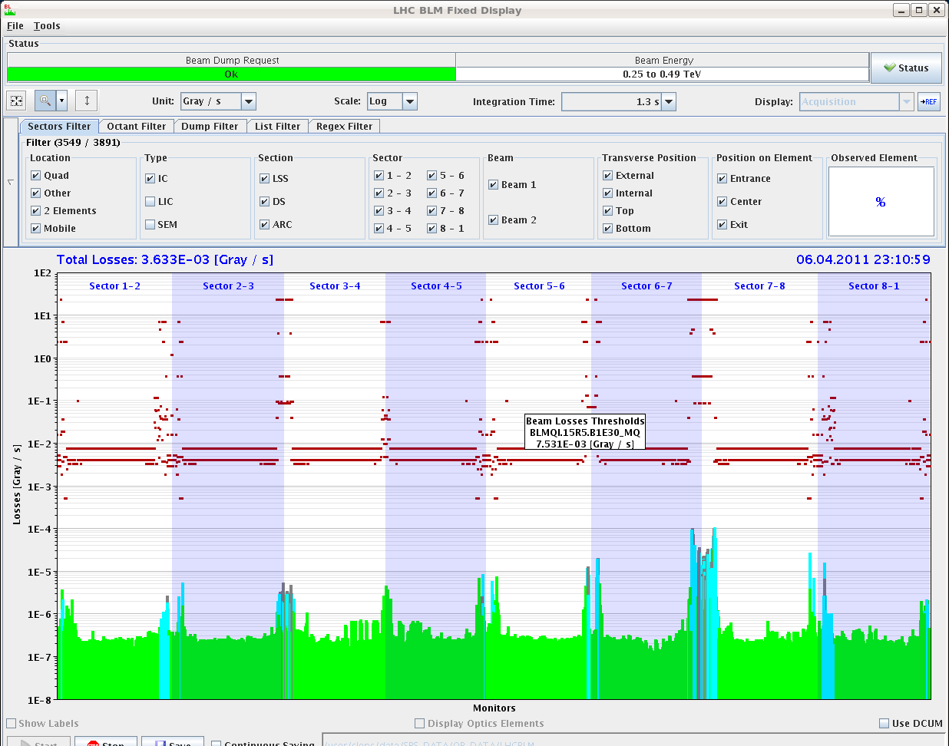
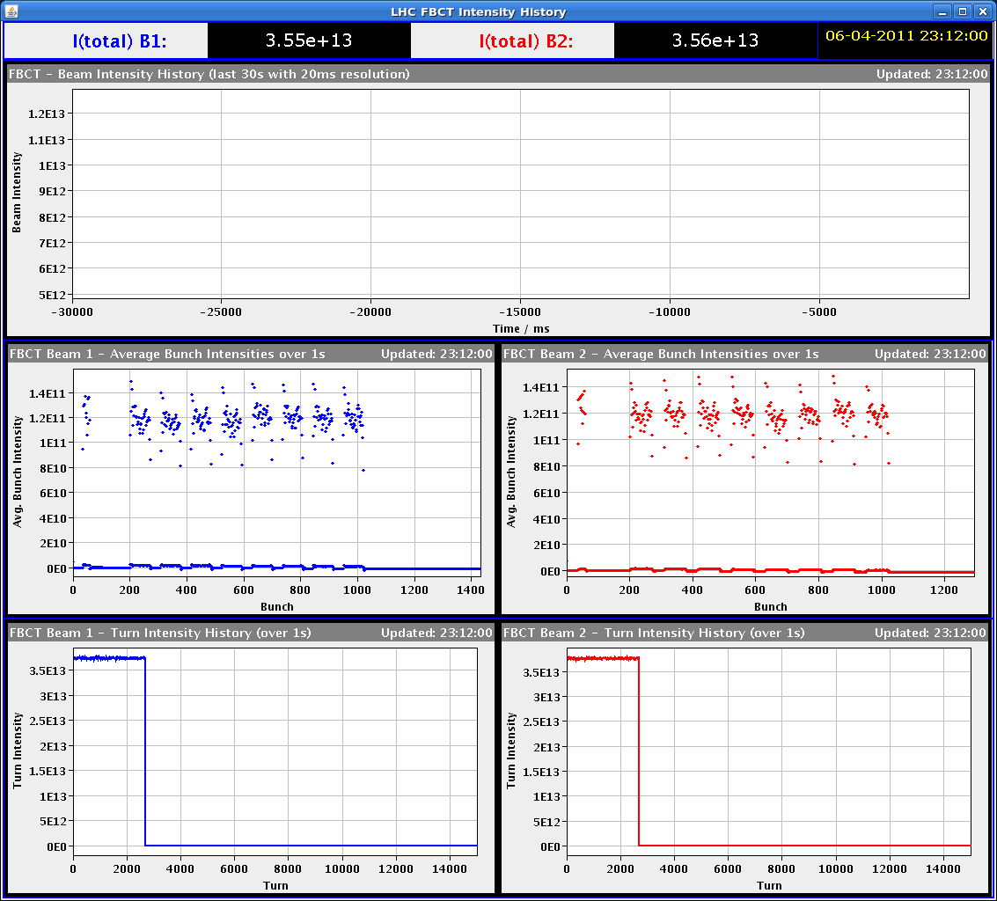
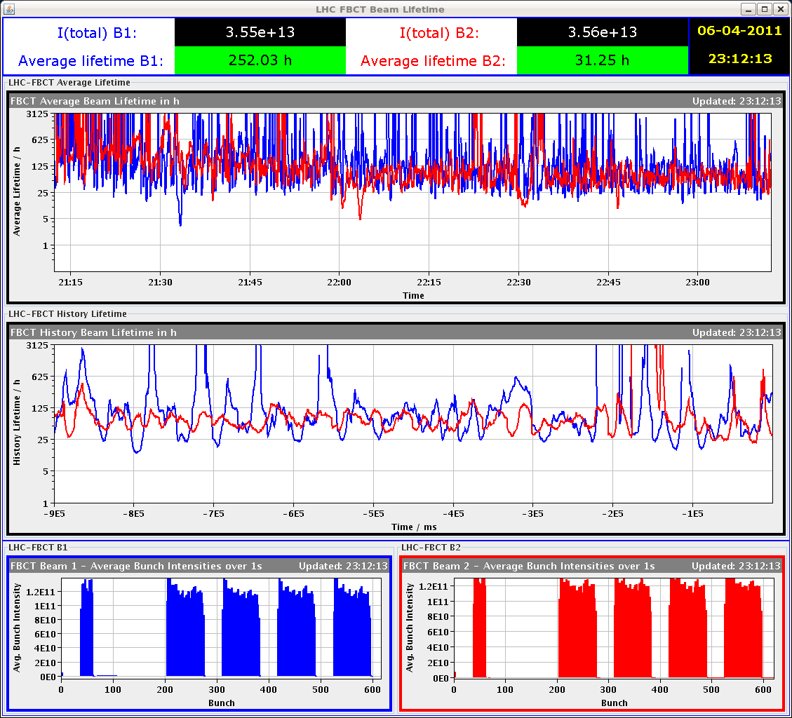
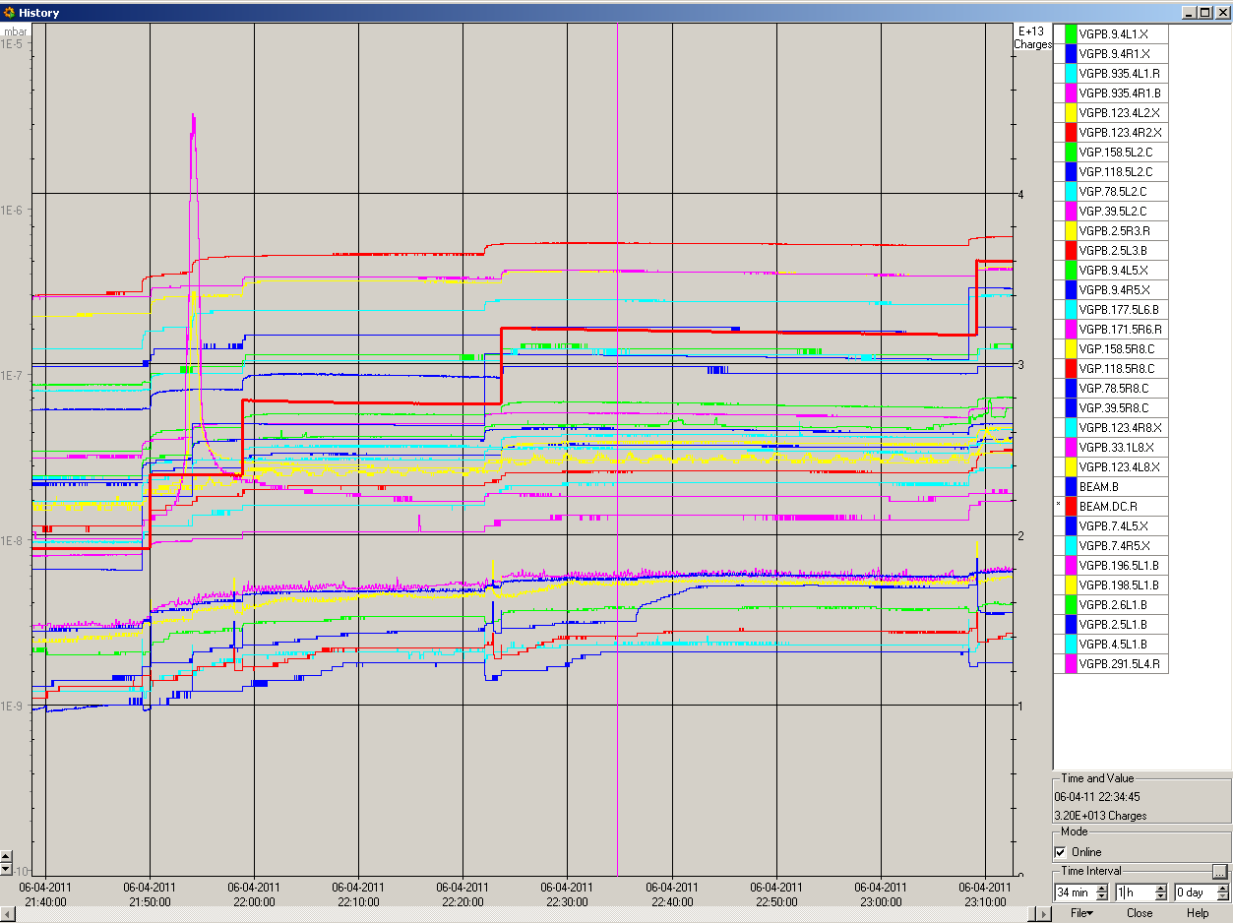

- 23:20: B1 = 372b + B2 = 300b.
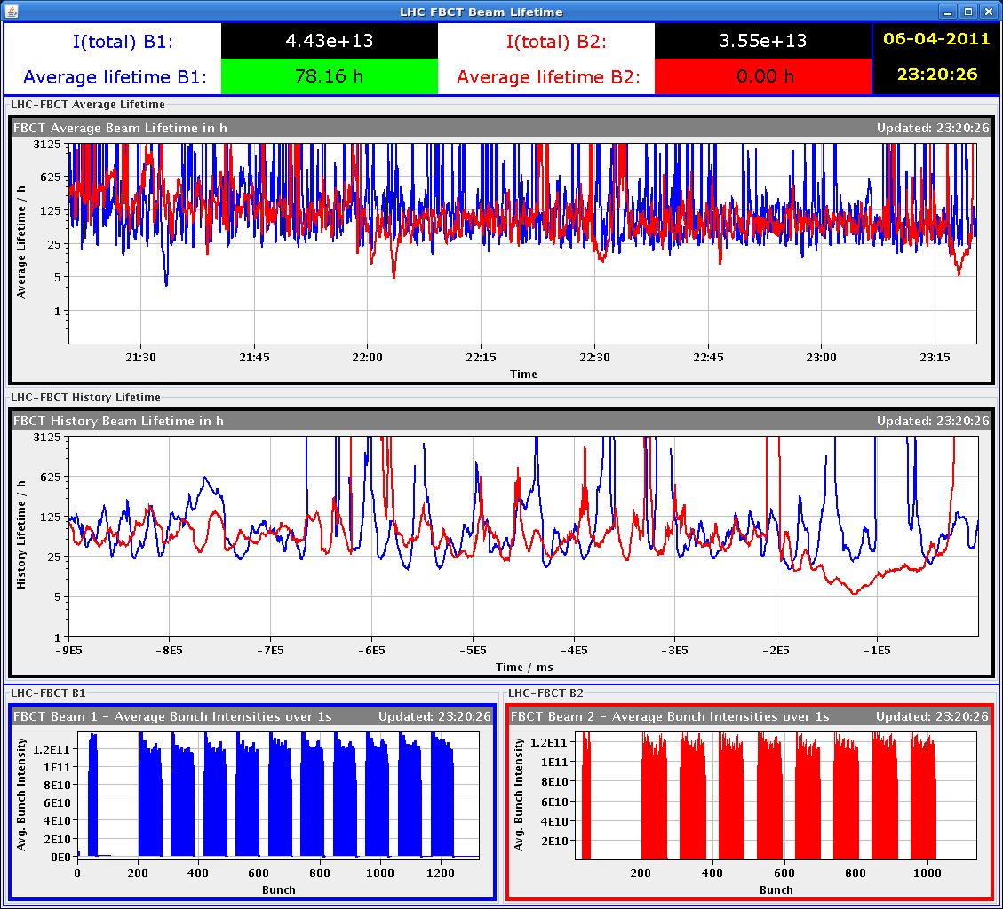
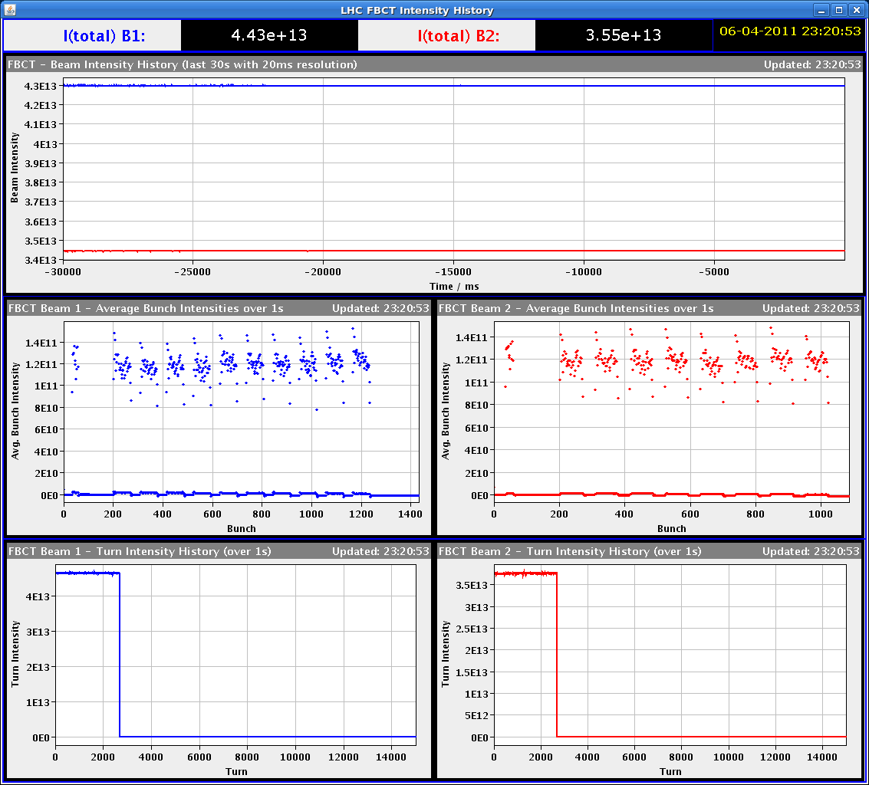
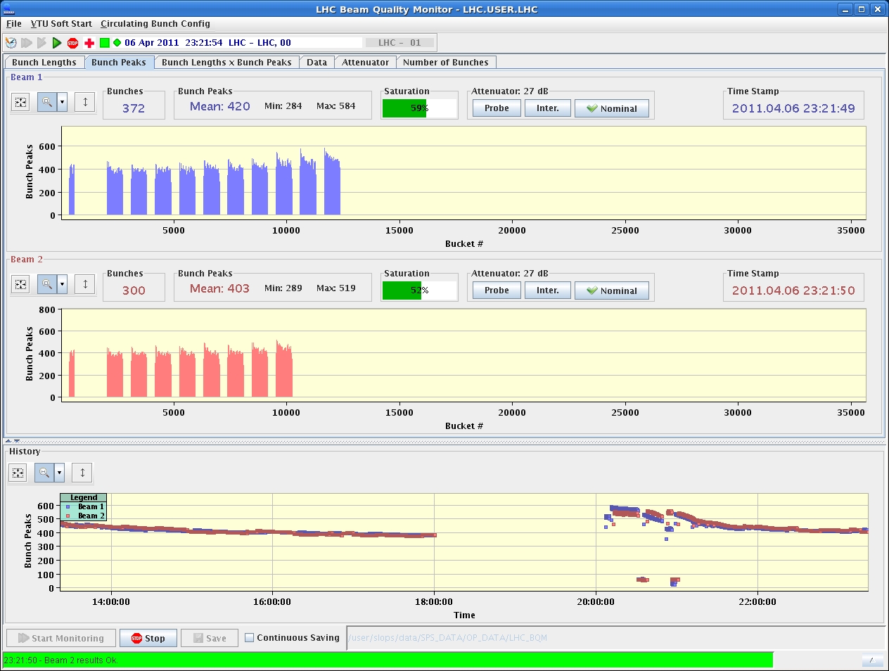
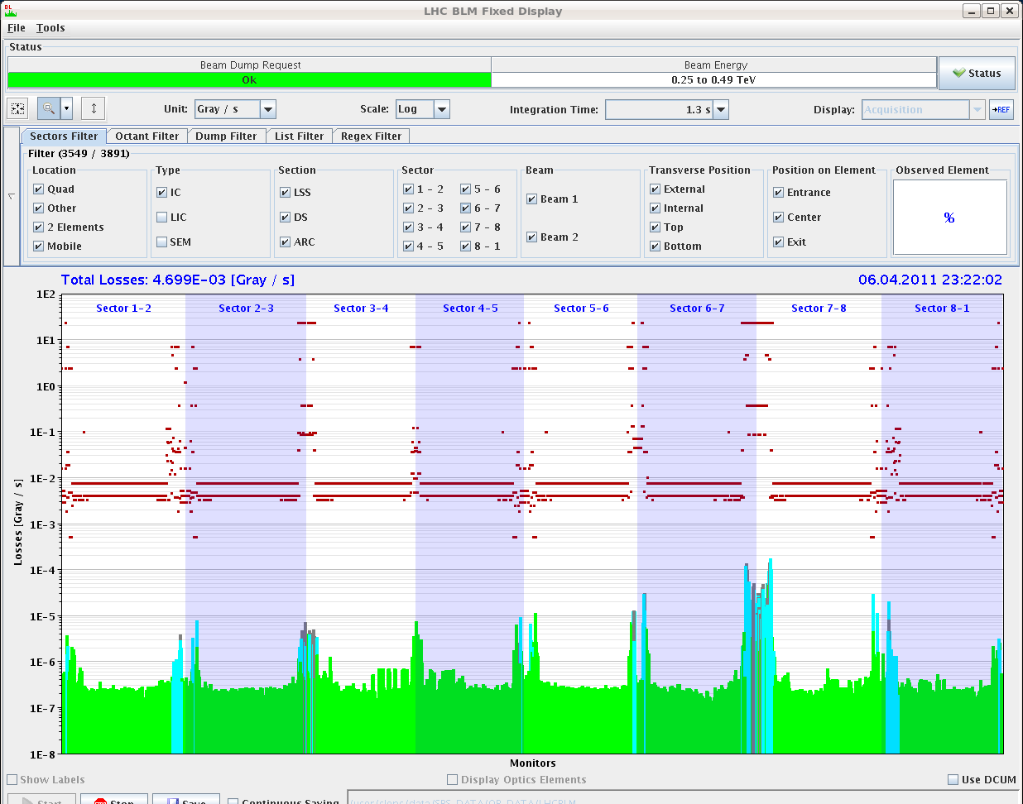
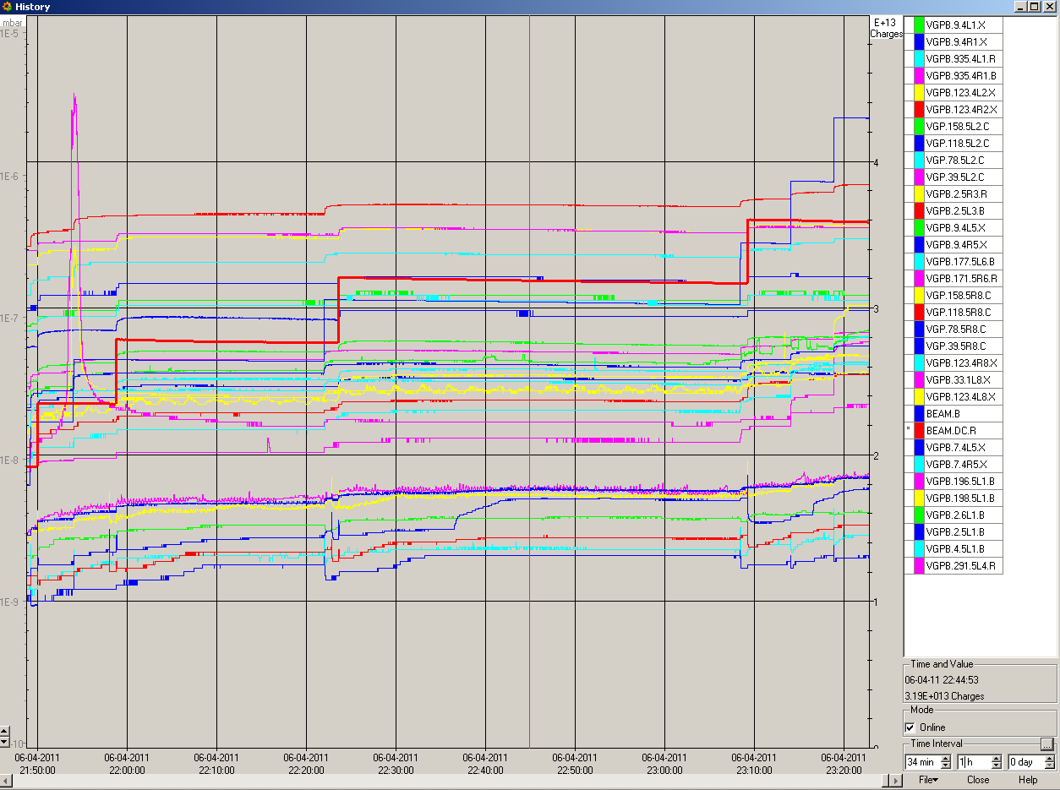
- 23:42: Transverse emittances fill 1677 so far.
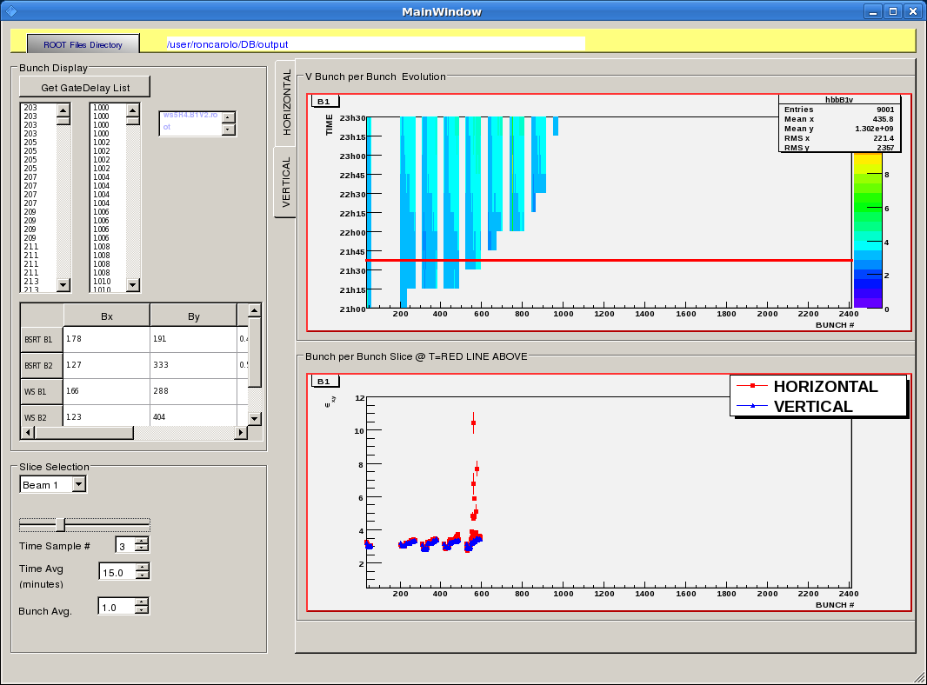
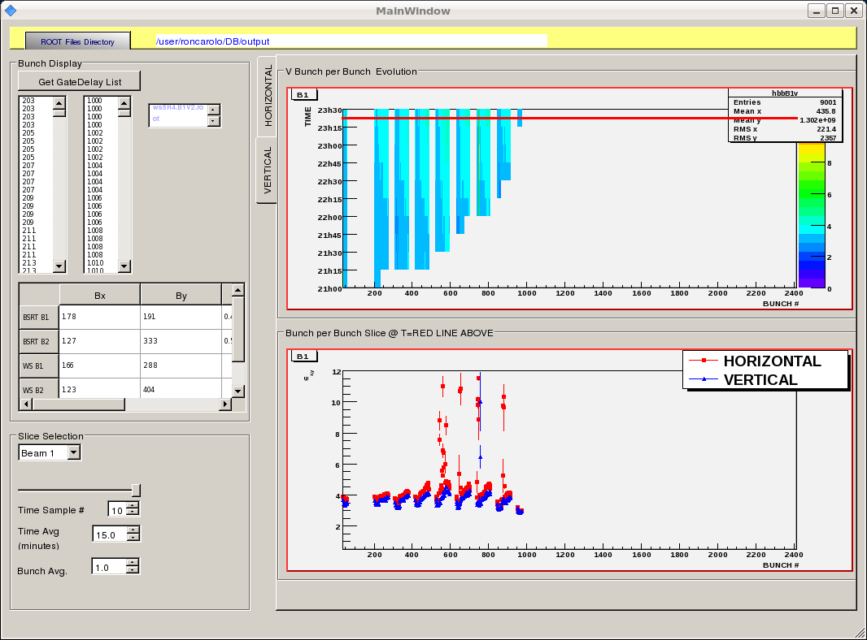
- 23:44: B1 = 408b + B2 = 300b.
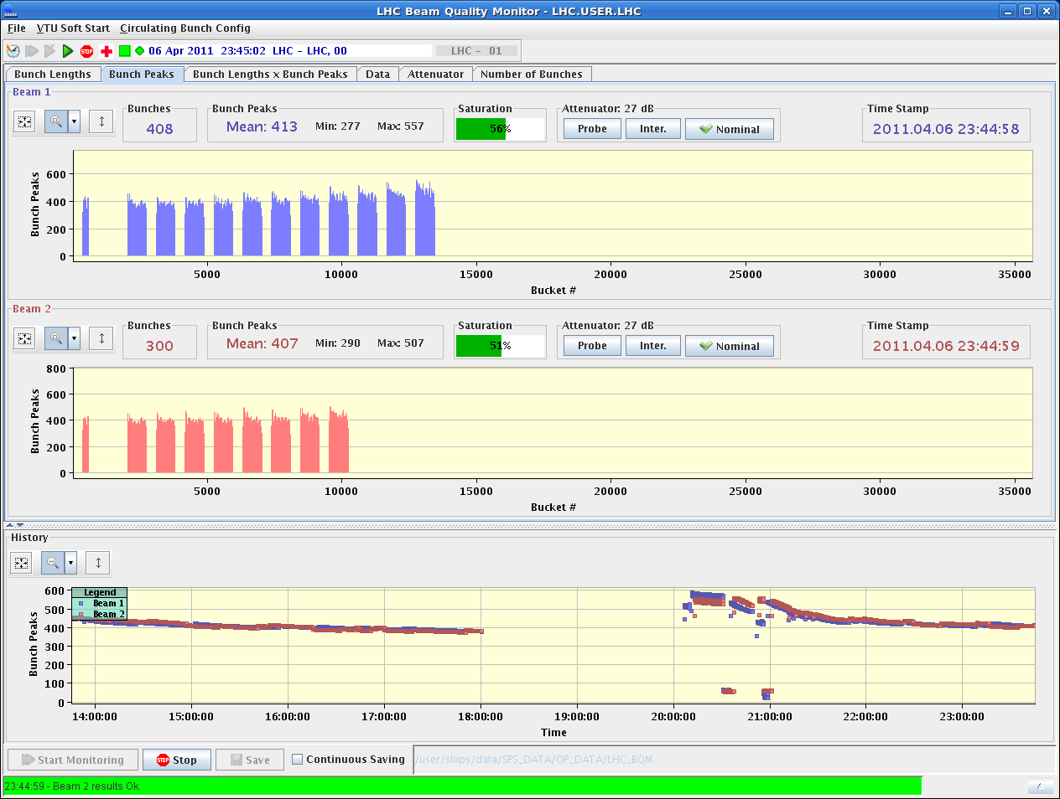
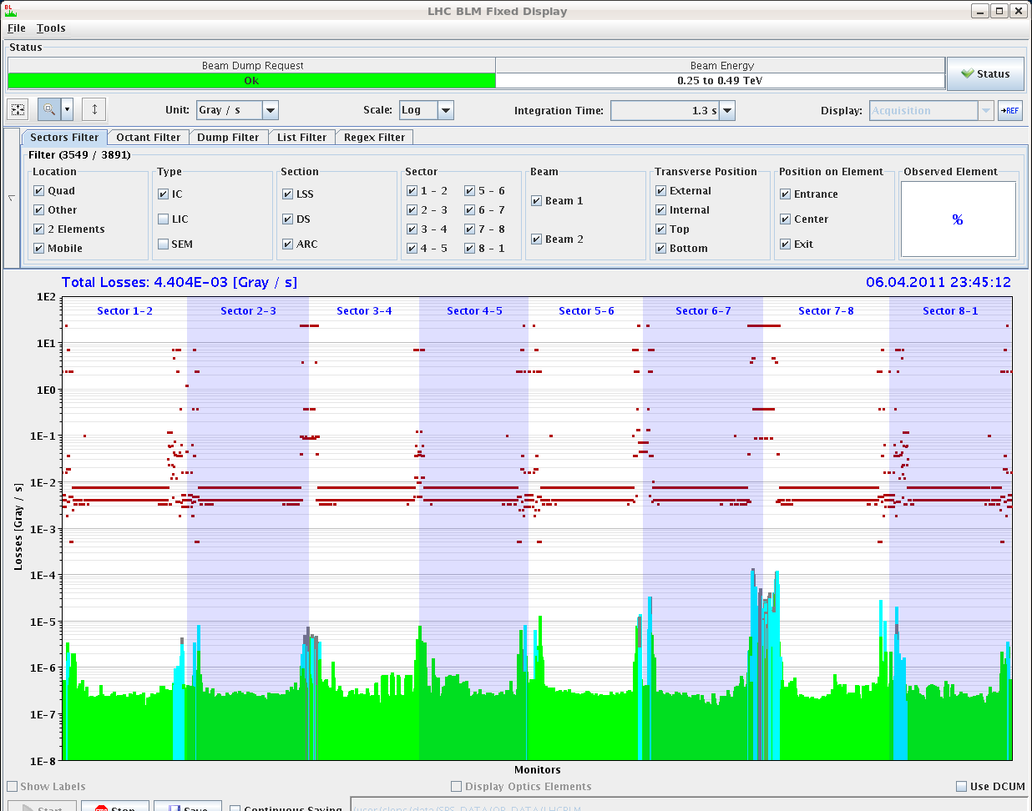
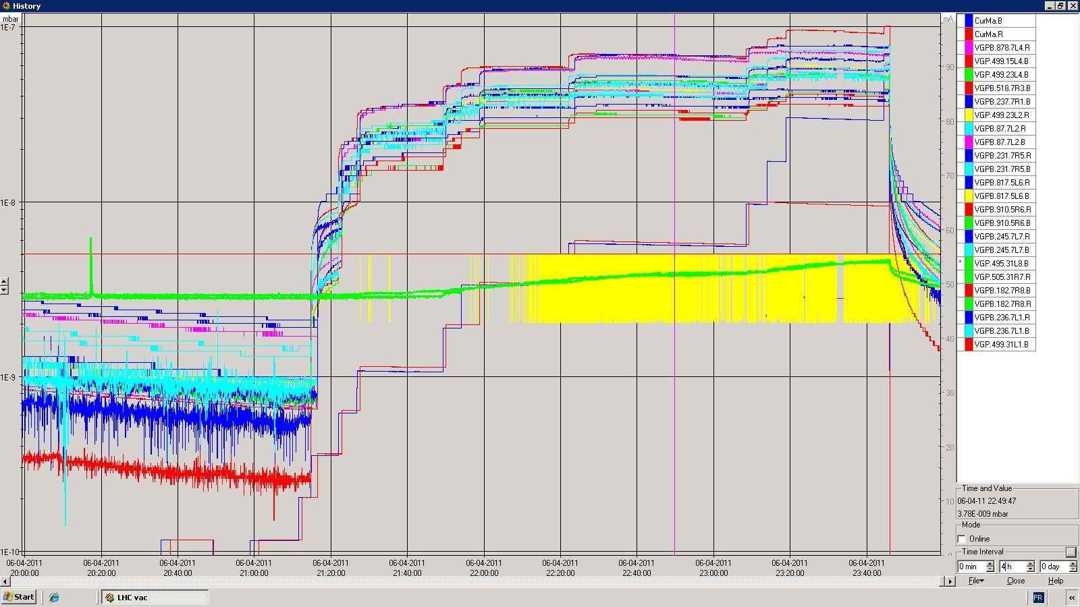
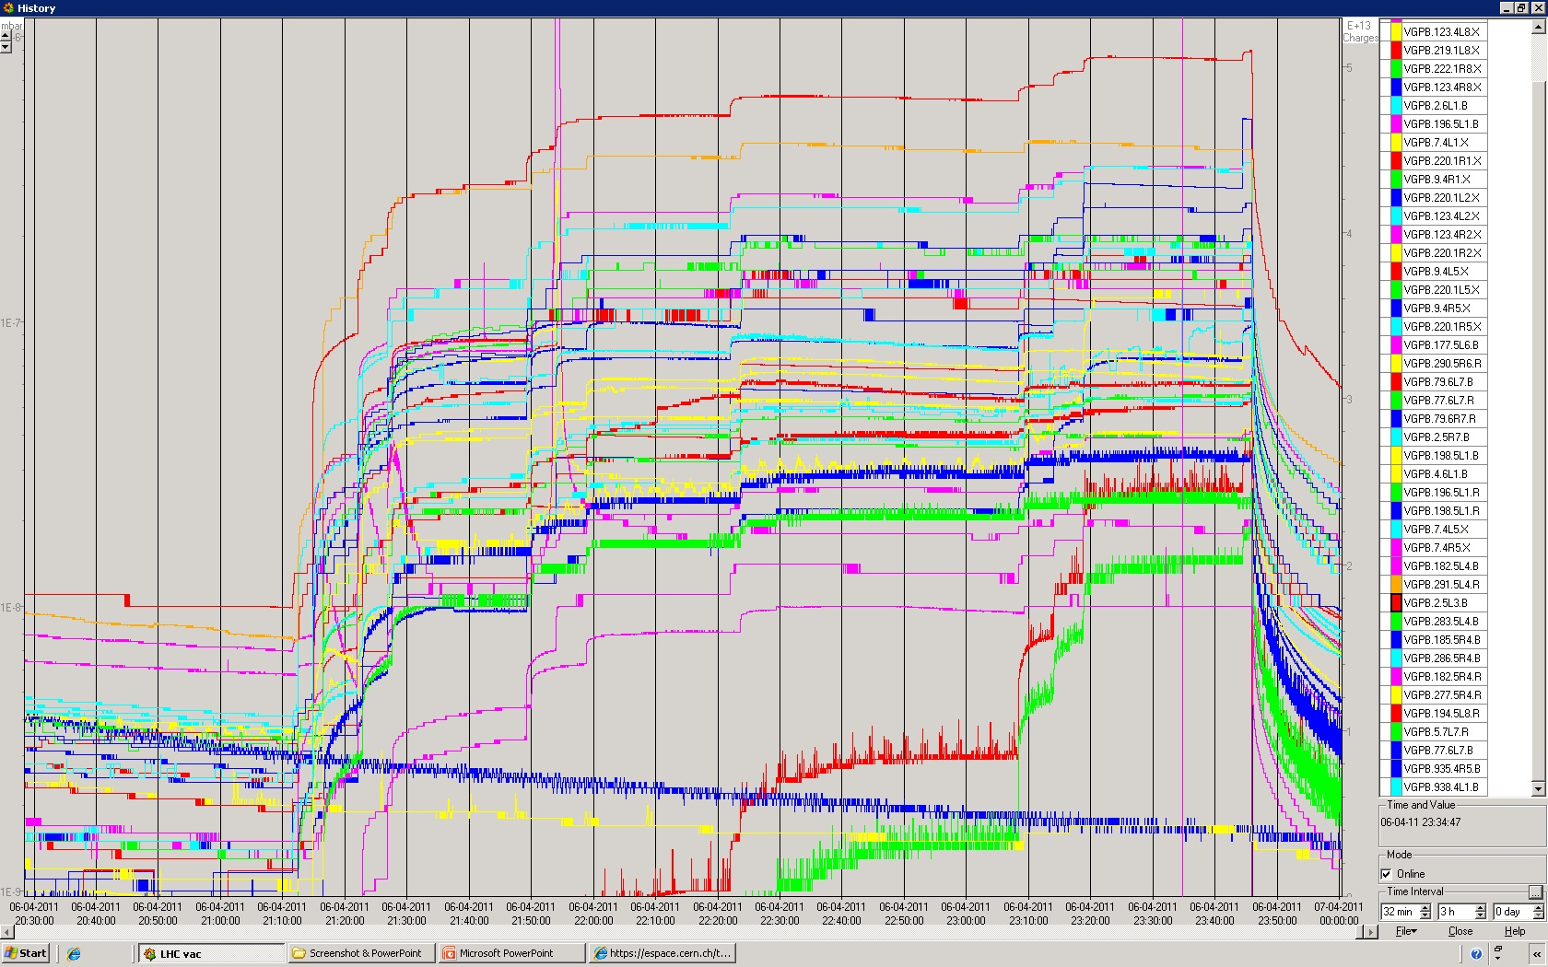
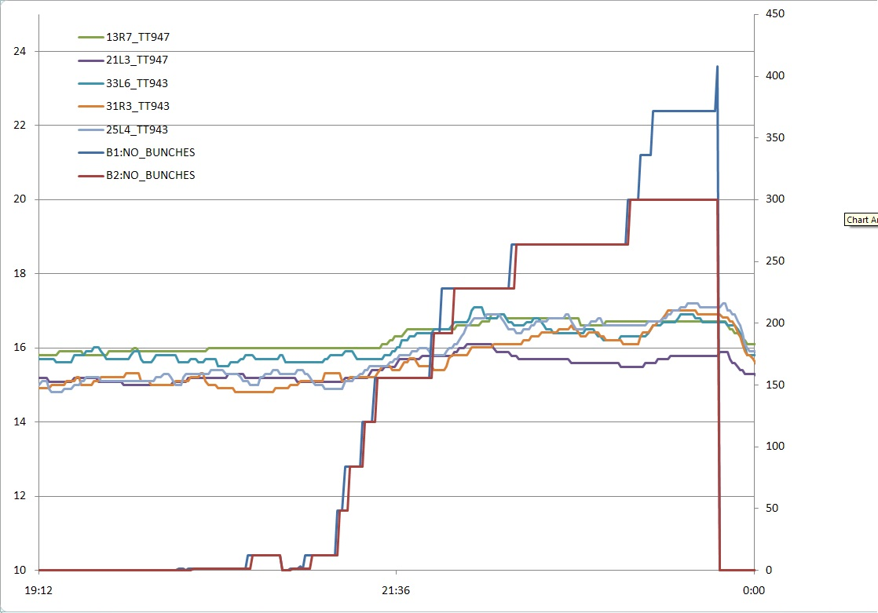
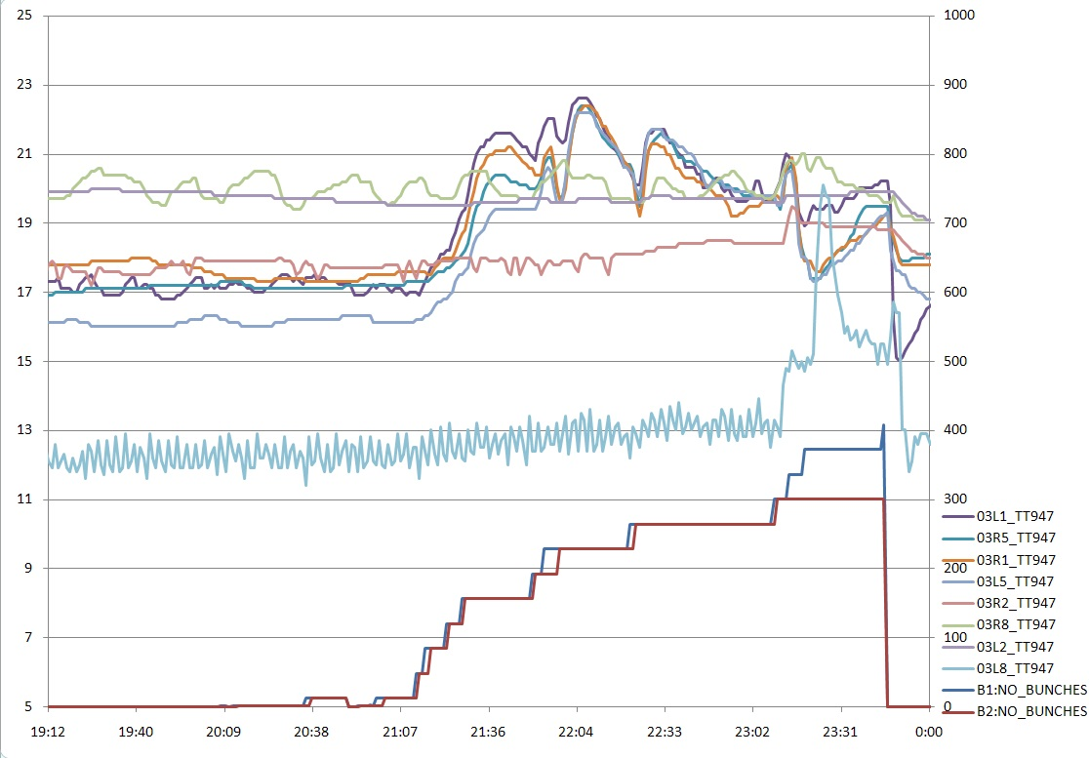
- 23:45: Dump => RB.A81 tripping on a TRG|BRIDGE_A_COOLING.
- TH 07/04:
- 00:39: Change in threshold of several vacuum gauges from 4e-07 to 1e-06:
- for VVGST.197.5L6.B VGPB.290.5L6.B and VGPB.177.5L6.B
- for VVGST.104.5L6.B VGPB.177.5L6.B and VGPB.4.5L6.B
- for VVGST.98.5R6.R VGPB.4.5R6.R and VGPB.171.5R6.R
- for VVGST.191.5R6.R VGPB.290.5R6.R and VGPB.171.5R6.R
- for VVGSH.78.6L7.B - VGPB.79.6L7.B and VGPB.77.6L7.B
- for VVGSH.78.6R7.B - VGPB.77.6R7.B and VGPB.79.6R7.B
Change in threshold of one vacuum gauge from 1e-06 to 2e-06:
- for VVGSH.3.5L3.B VGPB.4.5L3.B and VGPB.2.5L3.B
- The beam was then started to be re-injected at 04:04 and at 06:16 we had B1 = 408b + B2 = 336b.
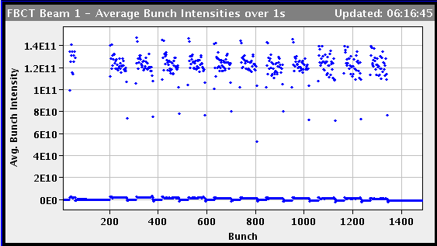
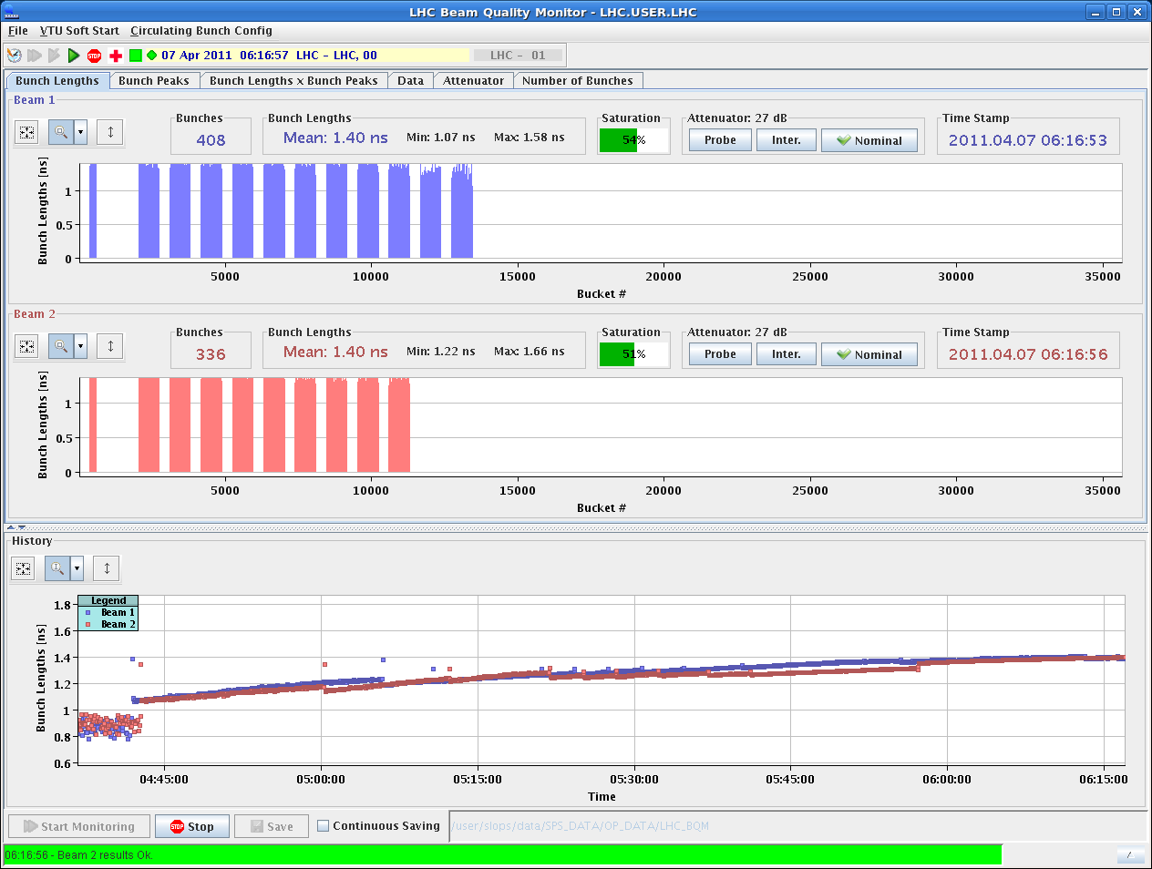
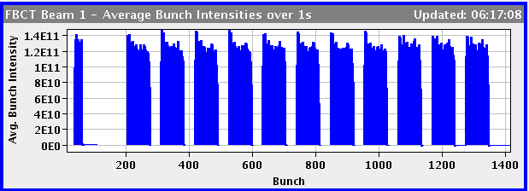
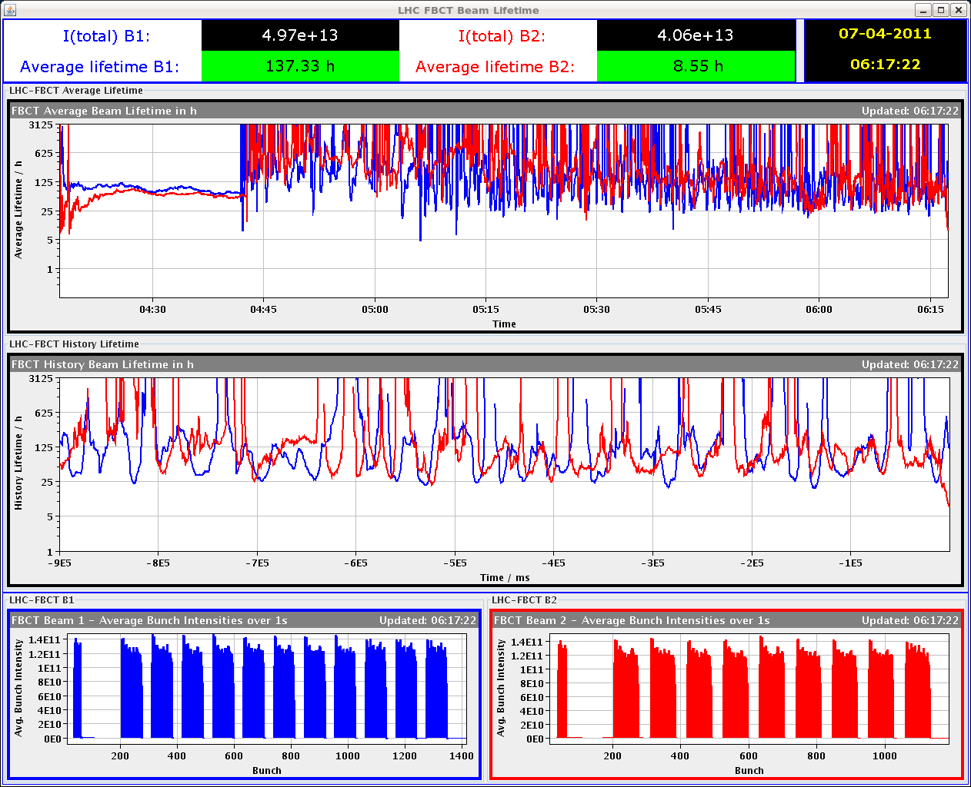
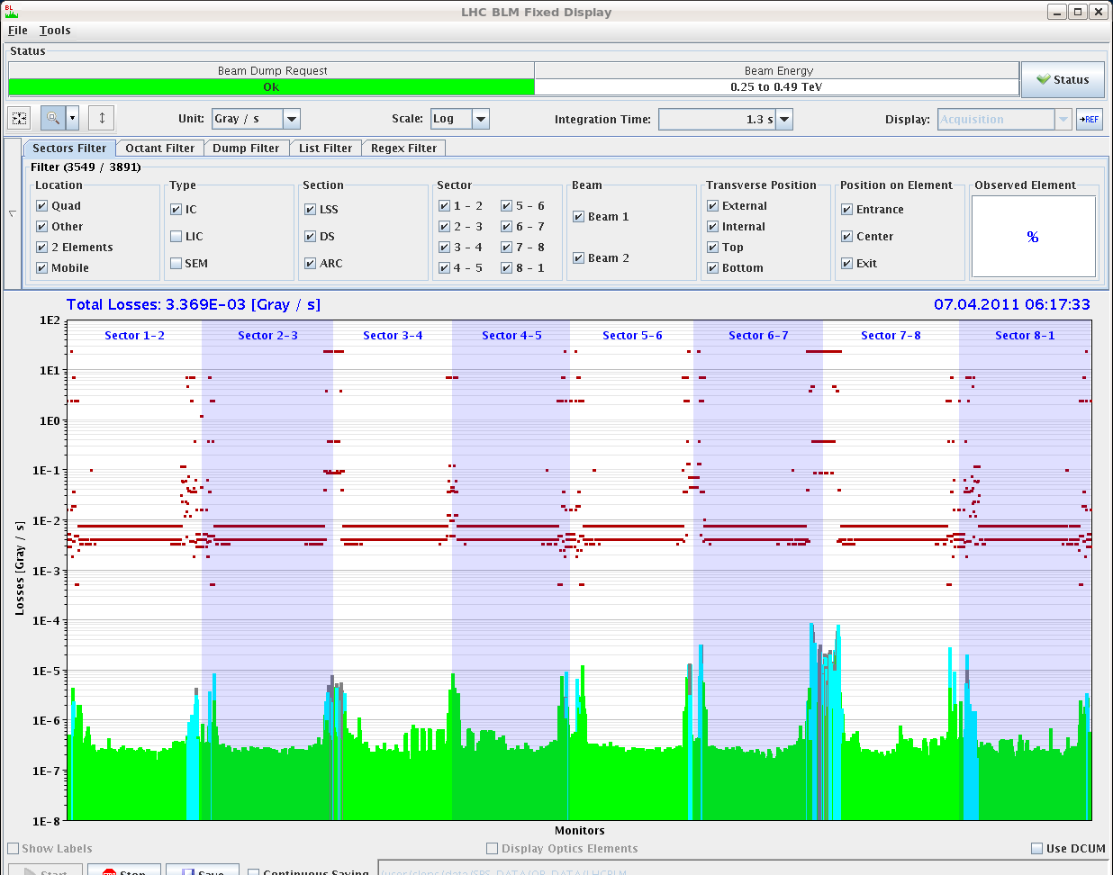
- 06:24: Beams dumped after loss of cryo in AR45. The cryo conditions were lost due to a jump in temperature on the TT891 of one current lead of the RB circuit: the temperature went from 50 K to -29 K in 20 sec. It seems to be a false contact and the temperature is coming back to normal, but we wait few minutes to see whether it gets crazy again.
- 07:01: Cryo evolution during the night.
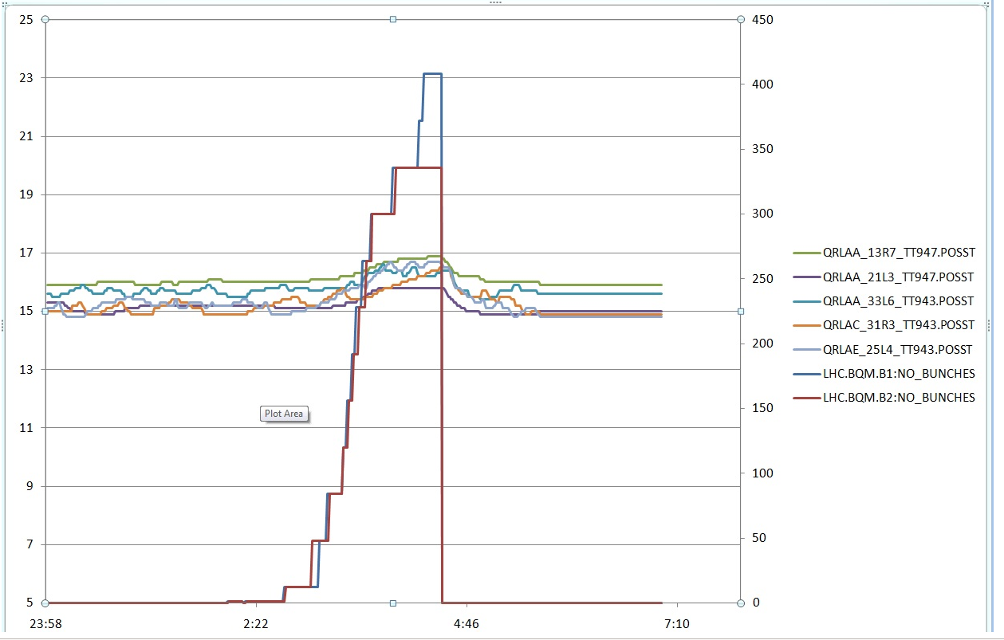
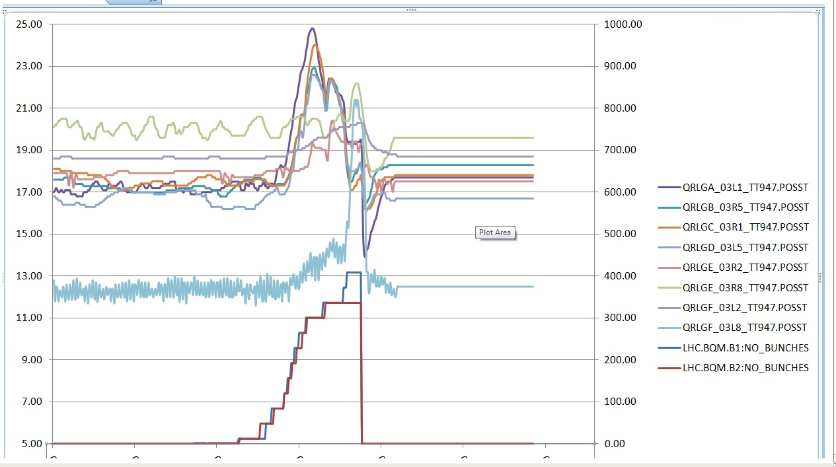
- 07:11: Transverse emittance measurements with BSRT from the last filling.
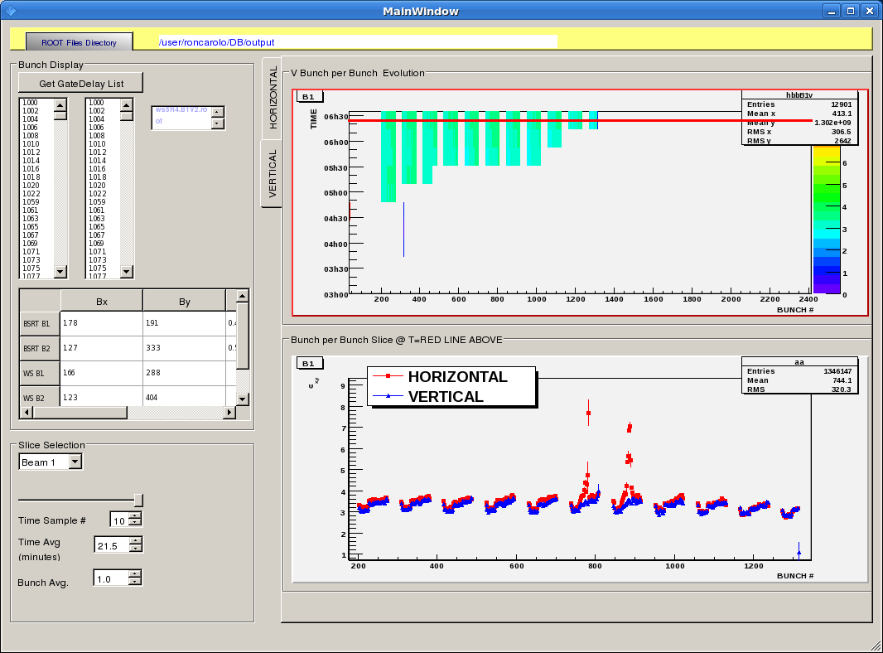
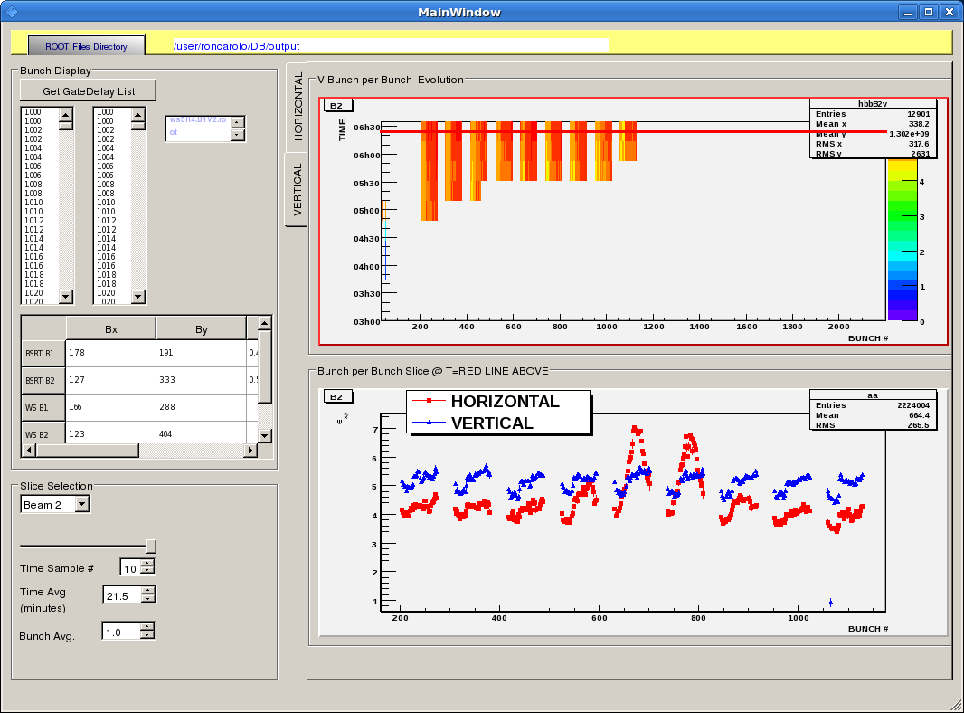
- FR 08/04:
- 11:47: Vacuum people will access with the QPS people to sort out the damper vacuum issues.
- Status at ~ 12:00: Beams hoped for this afternoon/evening…

