Fill 1704 (13/4/2011 – 12:16 to 16:47
Filling scheme (for both beams): 228 bunches/beam - Average intensity 1.22 e 11 p/bunch (first ramp after scrubbing): 50ns_1164b_36x2bi_18inj_scrub (cut at 228 bunches)
Injection # | Ring | RF bucket # | Bunch spacing [ns] | Bunches/inj | Spacing between PS trains | # PS trains/injection
1 | ring_1 | 1 | 0 | 1 | 0 | 1 | pilot
1 | ring_2 | 1 | 0 | 1 | 0 | 1 | pilot
2 | ring_1 | 441 | 50 | 12 | 0 | 1 | nominal
2 | ring_2 | 441 | 50 | 12 | 0 | 1 | nominal
3 | ring_1 | 1581 | 50 | 72 | 225 | 2 | nominal
3 | ring_2 | 1581 | 50 | 72 | 225 | 2 | nominal
4 | ring_1 | 3511 | 50 | 72 | 225 | 2 | nominal
4 | ring_2 | 3511 | 50 | 72 | 225 | 2 | nominal
5 | ring_1 | 5441 | 50 | 72 | 225 | 2 | nominal
5 | ring_2 | 5441 | 50 | 72 | 225 | 2 | nominal
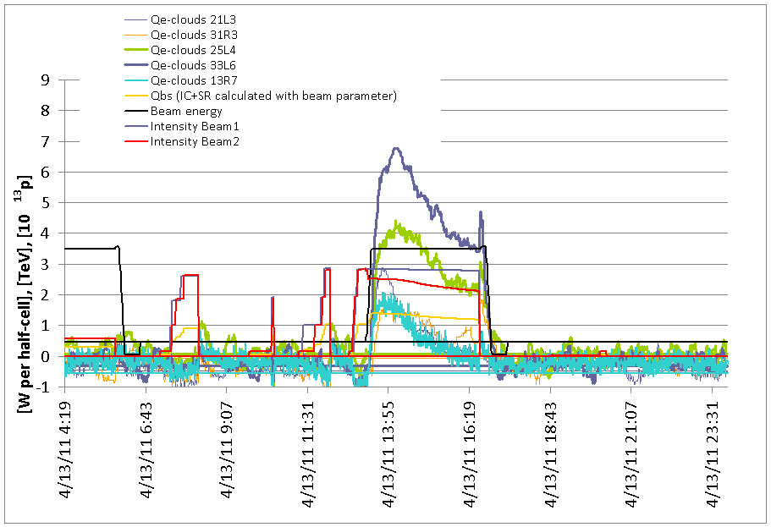

Fill 1707 (14/4/2011 – 3:44 to 5:46
Filling scheme (for both beams): 228 bunches - Average intensity 1.22 e 11 p/bunch): 50ns_1164b_36x2bi_18inj_scrub (cut at 228 bunches)
Injection # | Ring | RF bucket # | Bunch spacing [ns] | Bunches/inj | Spacing between PS trains | # PS trains/injection
1 | ring_1 | 1 | 0 | 1 | 0 | 1 | pilot
1 | ring_2 | 1 | 0 | 1 | 0 | 1 | pilot
2 | ring_1 | 441 | 50 | 12 | 0 | 1 | nominal
2 | ring_2 | 441 | 50 | 12 | 0 | 1 | nominal
3 | ring_1 | 1581 | 50 | 72 | 225 | 2 | nominal
3 | ring_2 | 1581 | 50 | 72 | 225 | 2 | nominal
4 | ring_1 | 3511 | 50 | 72 | 225 | 2 | nominal
4 | ring_2 | 3511 | 50 | 72 | 225 | 2 | nominal
5 | ring_1 | 5441 | 50 | 72 | 225 | 2 | nominal
5 | ring_2 | 5441 | 50 | 72 | 225 | 2 | nominal
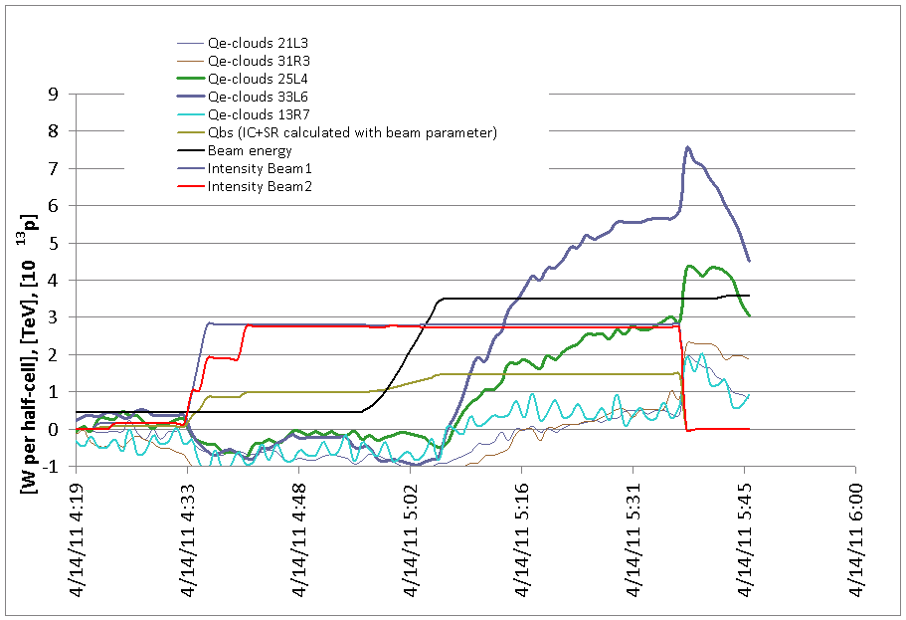
Fill 1709 (14/4/2011 – 14:12 – 16:21
Filling scheme (for both beams): 228 bunches - Average intensity 1.27 e 11 p/bunch) – Trip of power converter at injection: 50ns_228b+1small_214_12_180_36b
Injection # | Ring | RF bucket # | Bunch spacing [ns] | Bunches/inj | Spacing between PS trains | # PS trains/injection
1 | ring_1 | 1 | 0 | 1 | 0 | 1 | pilot
2 | ring_2 | 1 | 0 | 1 | 0 | 1 | pilot
3 | ring_1 | 381 | 50 | 12 | 0 | 1 | nominal
4 | ring_2 | 441 | 50 | 12 | 0 | 1 | nominal
5 | ring_1 | 1821 | 50 | 36 | 0 | 1 | nominal
6 | ring_2 | 1821 | 50 | 36 | 0 | 1 | nominal
7 | ring_1 | 10761 | 50 | 36 | 0 | 1 | nominal
8 | ring_2 | 10761 | 50 | 36 | 0 | 1 | nominal
9 | ring_1 | 17851 | 50 | 36 | 0 | 1 | nominal
10 | ring_2 | 17731 | 50 | 36 | 0 | 1 | nominal
11 | ring_1 | 19701 | 50 | 36 | 0 | 1 | nominal
12 | ring_2 | 19581 | 50 | 36 | 0 | 1 | nominal
13 | ring_1 | 26671 | 50 | 36 | 0 | 1 | nominal
14 | ring_2 | 26671 | 50 | 36 | 0 | 1 | nominal
15 | ring_1 | 28521 | 50 | 36 | 0 | 1 | nominal
16 | ring_2 | 28521 | 50 | 36 | 0 | 1 | nominal

Fill 1710 (14/4/2011 – 16:21 – 23:16
Filling scheme (for both beams): 228 bunches - Average intensity 1.25 e 11 p/bunch) – Dump during the squeeze due to tune feedback: 50ns_228b+1small_214_12_180_36b
Injection # | Ring | RF bucket # | Bunch spacing [ns] | Bunches/inj | Spacing between PS trains | # PS trains/injection
1 | ring_1 | 1 | 0 | 1 | 0 | 1 | pilot
2 | ring_2 | 1 | 0 | 1 | 0 | 1 | pilot
3 | ring_1 | 381 | 50 | 12 | 0 | 1 | nominal
4 | ring_2 | 441 | 50 | 12 | 0 | 1 | nominal
5 | ring_1 | 1821 | 50 | 36 | 0 | 1 | nominal
6 | ring_2 | 1821 | 50 | 36 | 0 | 1 | nominal
7 | ring_1 | 10761 | 50 | 36 | 0 | 1 | nominal
8 | ring_2 | 10761 | 50 | 36 | 0 | 1 | nominal
9 | ring_1 | 17851 | 50 | 36 | 0 | 1 | nominal
10 | ring_2 | 17731 | 50 | 36 | 0 | 1 | nominal
11 | ring_1 | 19701 | 50 | 36 | 0 | 1 | nominal
12 | ring_2 | 19581 | 50 | 36 | 0 | 1 | nominal
13 | ring_1 | 26671 | 50 | 36 | 0 | 1 | nominal
14 | ring_2 | 26671 | 50 | 36 | 0 | 1 | nominal
15 | ring_1 | 28521 | 50 | 36 | 0 | 1 | nominal
16 | ring_2 | 28521 | 50 | 36 | 0 | 1 | nominal

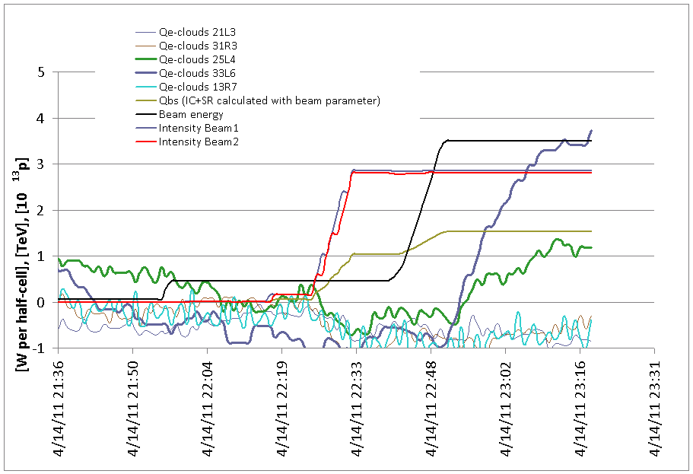
Fill 1711 (14/4/2011 – 23:16 – 15/4/2011 12:23
Filling scheme (for both beams): 228 bunches - Average intensity 1.25e 11 p/bunch) – Physics: 50ns_228b+1small_214_12_180_36b
Injection # | Ring | RF bucket # | Bunch spacing [ns] | Bunches/inj | Spacing between PS trains | # PS trains/injection
1 | ring_1 | 1 | 0 | 1 | 0 | 1 | pilot
2 | ring_2 | 1 | 0 | 1 | 0 | 1 | pilot
3 | ring_1 | 381 | 50 | 12 | 0 | 1 | nominal
4 | ring_2 | 441 | 50 | 12 | 0 | 1 | nominal
5 | ring_1 | 1821 | 50 | 36 | 0 | 1 | nominal
6 | ring_2 | 1821 | 50 | 36 | 0 | 1 | nominal
7 | ring_1 | 10761 | 50 | 36 | 0 | 1 | nominal
8 | ring_2 | 10761 | 50 | 36 | 0 | 1 | nominal
9 | ring_1 | 17851 | 50 | 36 | 0 | 1 | nominal
10 | ring_2 | 17731 | 50 | 36 | 0 | 1 | nominal
11 | ring_1 | 19701 | 50 | 36 | 0 | 1 | nominal
12 | ring_2 | 19581 | 50 | 36 | 0 | 1 | nominal
13 | ring_1 | 26671 | 50 | 36 | 0 | 1 | nominal
14 | ring_2 | 26671 | 50 | 36 | 0 | 1 | nominal
15 | ring_1 | 28521 | 50 | 36 | 0 | 1 | nominal
16 | ring_2 | 28521 | 50 | 36 | 0 | 1 | nominal
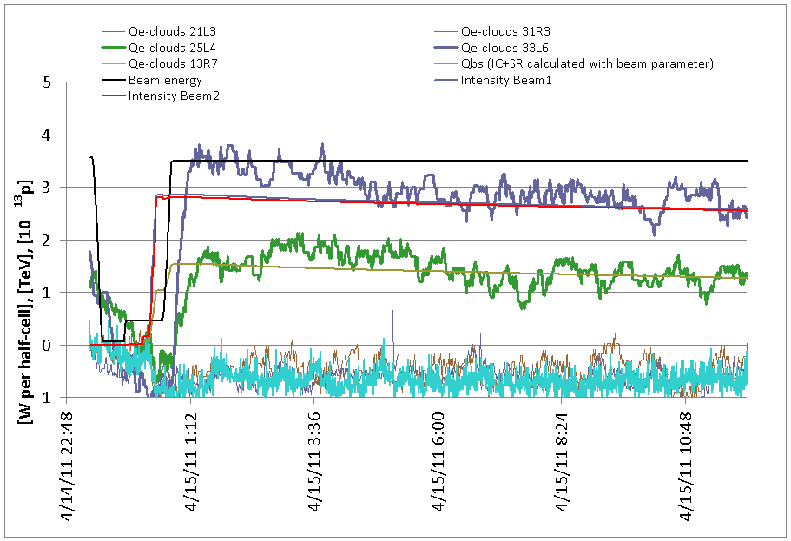

Fill 1712 (15/4/2011 12:23 – 20:11)
Filling scheme (for both beams): 228 bunches - Average intensity 1.25e 11 p/bunch) – Physics: 50ns_228b+1small_214_12_180_36b
Injection # | Ring | RF bucket # | Bunch spacing [ns] | Bunches/inj | Spacing between PS trains | # PS trains/injection
1 | ring_1 | 1 | 0 | 1 | 0 | 1 | pilot
2 | ring_2 | 1 | 0 | 1 | 0 | 1 | pilot
3 | ring_1 | 381 | 50 | 12 | 0 | 1 | nominal
4 | ring_2 | 441 | 50 | 12 | 0 | 1 | nominal
5 | ring_1 | 1821 | 50 | 36 | 0 | 1 | nominal
6 | ring_2 | 1821 | 50 | 36 | 0 | 1 | nominal
7 | ring_1 | 10761 | 50 | 36 | 0 | 1 | nominal
8 | ring_2 | 10761 | 50 | 36 | 0 | 1 | nominal
9 | ring_1 | 17851 | 50 | 36 | 0 | 1 | nominal
10 | ring_2 | 17731 | 50 | 36 | 0 | 1 | nominal
11 | ring_1 | 19701 | 50 | 36 | 0 | 1 | nominal
12 | ring_2 | 19581 | 50 | 36 | 0 | 1 | nominal
13 | ring_1 | 26671 | 50 | 36 | 0 | 1 | nominal
14 | ring_2 | 26671 | 50 | 36 | 0 | 1 | nominal
15 | ring_1 | 28521 | 50 | 36 | 0 | 1 | nominal
16 | ring_2 | 28521 | 50 | 36 | 0 | 1 | nominal
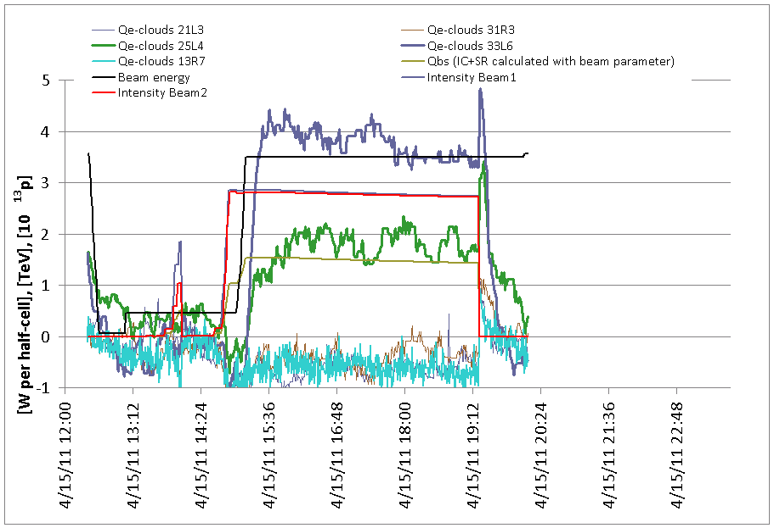

Fill 1713 (15/4/2011 20:11 – 16/4 5:21)
Filling scheme (for both beams): 228 bunches - Average intensity 1.25e 11 p/bunch) – Physics: 50ns_228b+1small_214_12_180_36b
Injection # | Ring | RF bucket # | Bunch spacing [ns] | Bunches/inj | Spacing between PS trains | # PS trains/injection
1 | ring_1 | 1 | 0 | 1 | 0 | 1 | pilot
2 | ring_2 | 1 | 0 | 1 | 0 | 1 | pilot
3 | ring_1 | 381 | 50 | 12 | 0 | 1 | nominal
4 | ring_2 | 441 | 50 | 12 | 0 | 1 | nominal
5 | ring_1 | 1821 | 50 | 36 | 0 | 1 | nominal
6 | ring_2 | 1821 | 50 | 36 | 0 | 1 | nominal
7 | ring_1 | 10761 | 50 | 36 | 0 | 1 | nominal
8 | ring_2 | 10761 | 50 | 36 | 0 | 1 | nominal
9 | ring_1 | 17851 | 50 | 36 | 0 | 1 | nominal
10 | ring_2 | 17731 | 50 | 36 | 0 | 1 | nominal
11 | ring_1 | 19701 | 50 | 36 | 0 | 1 | nominal
12 | ring_2 | 19581 | 50 | 36 | 0 | 1 | nominal
13 | ring_1 | 26671 | 50 | 36 | 0 | 1 | nominal
14 | ring_2 | 26671 | 50 | 36 | 0 | 1 | nominal
15 | ring_1 | 28521 | 50 | 36 | 0 | 1 | nominal
16 | ring_2 | 28521 | 50 | 36 | 0 | 1 | nominal

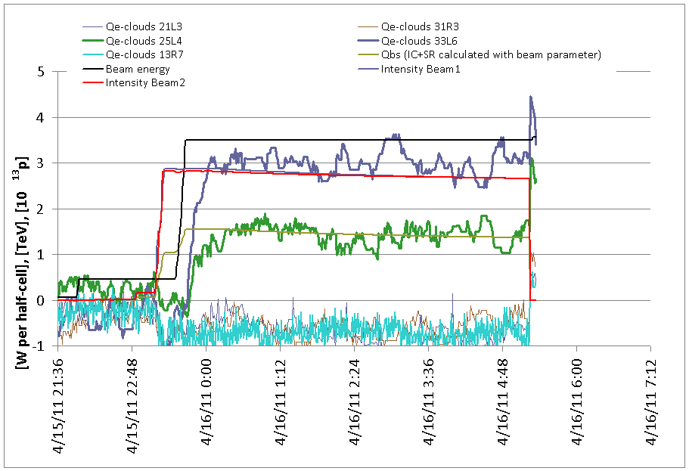
Fill 1714 (16/4 5:21 – 12:11)
Filling scheme (for both beams): 336 bunches - Average intensity 1.25e 11 p/bunch) – Dumped by problem with Orbit feedback: 50ns_336b+1small_322_14_288_72b
Injection # | Ring | RF bucket # | Bunch spacing [ns] | Bunches/inj | Spacing between PS trains | # PS trains/injection
1 | ring_1 | 1 | 0 | 1 | 0 | 1 | pilot
1 | ring_2 | 1 | 0 | 1 | 0 | 1 | pilot
2 | ring_1 | 381 | 50 | 12 | 0 | 1 | nominal
2 | ring_2 | 441 | 50 | 12 | 0 | 1 | nominal
3 | ring_1 | 1831 | 50 | 72 | 225 | 2 | nominal
3 | ring_2 | 1831 | 50 | 72 | 225 | 2 | nominal
4 | ring_1 | 10771 | 50 | 72 | 225 | 2 | nominal
4 | ring_2 | 10771 | 50 | 72 | 225 | 2 | nominal
5 | ring_1 | 19711 | 50 | 72 | 225 | 2 | nominal
5 | ring_2 | 19591 | 50 | 72 | 225 | 2 | nominal
6 | ring_1 | 26671 | 50 | 36 | 0 | 1 | nominal
6 | ring_2 | 26671 | 50 | 36 | 0 | 1 | nominal
7 | ring_1 | 28531 | 50 | 72 | 225 | 2 | nominal
7 | ring_2 | 28531 | 50 | 72 | 225 | 2 | nominal

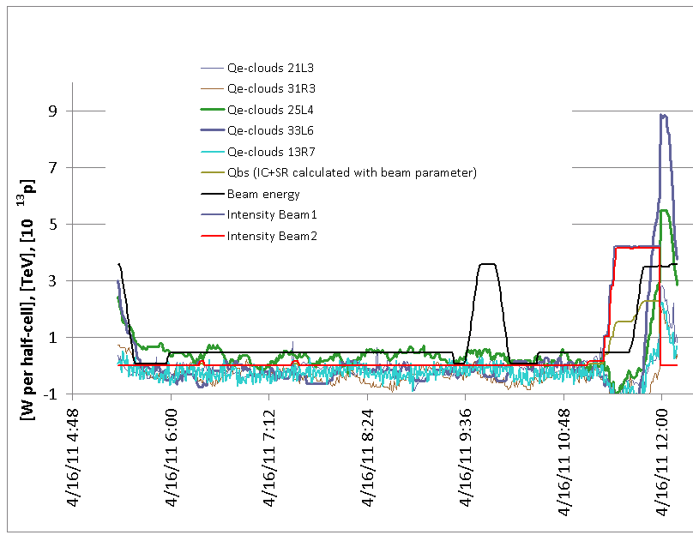
Fill 1715 (16/4 12:11 – 14:54)
336 bunches - Average intensity 1.25e 11 p/bunch) – Dumped when bringing in collision: 50ns_336b+1small_322_14_288_72b
Injection # | Ring | RF bucket # | Bunch spacing [ns] | Bunches/inj | Spacing between PS trains | # PS trains/injection
1 | ring_1 | 1 | 0 | 1 | 0 | 1 | pilot
1 | ring_2 | 1 | 0 | 1 | 0 | 1 | pilot
2 | ring_1 | 381 | 50 | 12 | 0 | 1 | nominal
2 | ring_2 | 441 | 50 | 12 | 0 | 1 | nominal
3 | ring_1 | 1831 | 50 | 72 | 225 | 2 | nominal
3 | ring_2 | 1831 | 50 | 72 | 225 | 2 | nominal
4 | ring_1 | 10771 | 50 | 72 | 225 | 2 | nominal
4 | ring_2 | 10771 | 50 | 72 | 225 | 2 | nominal
5 | ring_1 | 19711 | 50 | 72 | 225 | 2 | nominal
5 | ring_2 | 19591 | 50 | 72 | 225 | 2 | nominal
6 | ring_1 | 26671 | 50 | 36 | 0 | 1 | nominal
6 | ring_2 | 26671 | 50 | 36 | 0 | 1 | nominal
7 | ring_1 | 28531 | 50 | 72 | 225 | 2 | nominal
7 | ring_2 | 28531 | 50 | 72 | 225 | 2 | nominal
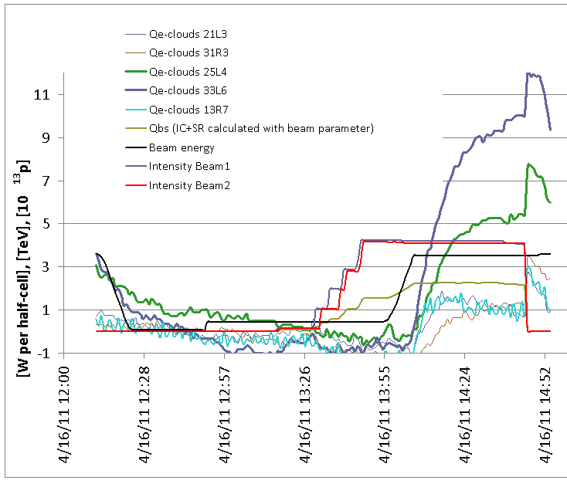

Fill 1716 (16/4 14:54 – 19:40)
336 bunches - Average intensity 1.25e 11 p/bunch) – Physics (36 bunches per train). Dumped by Sector 34 trip. 50ns_336b+1small_322_14_288_36b
Injection # | Ring | RF bucket # | Bunch spacing [ns] | Bunches/inj | Spacing between PS trains | # PS trains/injection
1 | ring_1 | 1 | 0 | 1 | 0 | 1 | pilot
1 | ring_2 | 1 | 0 | 1 | 0 | 1 | pilot
2 | ring_1 | 381 | 50 | 12 | 0 | 1 | nominal
2 | ring_2 | 441 | 50 | 12 | 0 | 1 | nominal
3 | ring_1 | 1831 | 50 | 36 | 225 | 1 | nominal
3 | ring_2 | 1831 | 50 | 36 | 225 | 1 | nominal
4 | ring_1 | 4481 | 50 | 36 | 225 | 1 | nominal
4 | ring_2 | 4481 | 50 | 36 | 225 | 1 | nominal
5 | ring_1 | 10771 | 50 | 36 | 225 | 1 | nominal
5 | ring_2 | 10771 | 50 | 36 | 225 | 1 | nominal
6 | ring_1 | 13421 | 50 | 36 | 225 | 1 | nominal
6 | ring_2 | 13421 | 50 | 36 | 225 | 1 | nominal
7 | ring_1 | 19711 | 50 | 36 | 225 | 1 | nominal
7 | ring_2 | 19591 | 50 | 36 | 225 | 1 | nominal
8 | ring_1 | 22361 | 50 | 36 | 225 | 1 | nominal
8 | ring_2 | 22241 | 50 | 36 | 225 | 1 | nominal
9 | ring_1 | 26671 | 50 | 36 | 225 | 1 | nominal
9 | ring_2 | 26671 | 50 | 36 | 225 | 1 | nominal
10 | ring_1 | 28531 | 50 | 36 | 225 | 1 | nominal
10 | ring_2 | 28531 | 50 | 36 | 225 | 1 | nominal
11 | ring_1 | 31181 | 50 | 36 | 225 | 1 | nominal
11 | ring_2 | 31181 | 50 | 36 | 225 | 1 | nominal
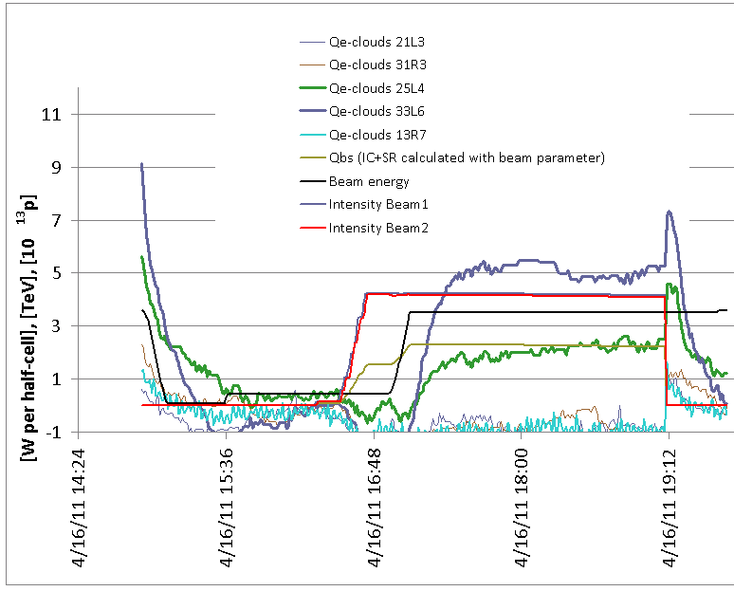
Fill 1717 (16/4 19:40 – 17/4 01:01)
336 bunches - Average intensity 1.25e 11 p/bunch) – Physics (36 bunches per train). Dumped by orbit feedback. 50ns_336b+1small_322_14_288_36b
Injection # | Ring | RF bucket # | Bunch spacing [ns] | Bunches/inj | Spacing between PS trains | # PS trains/injection
1 | ring_1 | 1 | 0 | 1 | 0 | 1 | pilot
1 | ring_2 | 1 | 0 | 1 | 0 | 1 | pilot
2 | ring_1 | 381 | 50 | 12 | 0 | 1 | nominal
2 | ring_2 | 441 | 50 | 12 | 0 | 1 | nominal
3 | ring_1 | 1831 | 50 | 36 | 225 | 1 | nominal
3 | ring_2 | 1831 | 50 | 36 | 225 | 1 | nominal
4 | ring_1 | 4481 | 50 | 36 | 225 | 1 | nominal
4 | ring_2 | 4481 | 50 | 36 | 225 | 1 | nominal
5 | ring_1 | 10771 | 50 | 36 | 225 | 1 | nominal
5 | ring_2 | 10771 | 50 | 36 | 225 | 1 | nominal
6 | ring_1 | 13421 | 50 | 36 | 225 | 1 | nominal
6 | ring_2 | 13421 | 50 | 36 | 225 | 1 | nominal
7 | ring_1 | 19711 | 50 | 36 | 225 | 1 | nominal
7 | ring_2 | 19591 | 50 | 36 | 225 | 1 | nominal
8 | ring_1 | 22361 | 50 | 36 | 225 | 1 | nominal
8 | ring_2 | 22241 | 50 | 36 | 225 | 1 | nominal
9 | ring_1 | 26671 | 50 | 36 | 225 | 1 | nominal
9 | ring_2 | 26671 | 50 | 36 | 225 | 1 | nominal
10 | ring_1 | 28531 | 50 | 36 | 225 | 1 | nominal
10 | ring_2 | 28531 | 50 | 36 | 225 | 1 | nominal
11 | ring_1 | 31181 | 50 | 36 | 225 | 1 | nominal
11 | ring_2 | 31181 | 50 | 36 | 225 | 1 | nominal
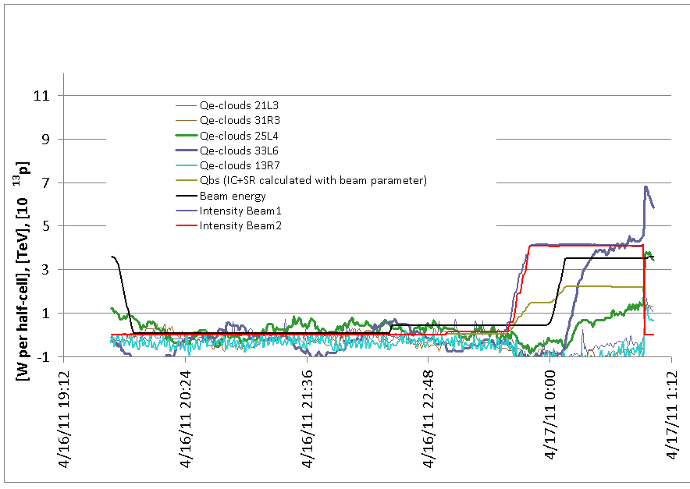

Fill 1718 (17/4 01:01 - ongoing)
336 bunches - Average intensity 1.25e 11 p/bunch) – Physics (36 bunches per train): 50ns_336b+1small_322_14_288_36b
Injection # | Ring | RF bucket # | Bunch spacing [ns] | Bunches/inj | Spacing between PS trains | # PS trains/injection
1 | ring_1 | 1 | 0 | 1 | 0 | 1 | pilot
1 | ring_2 | 1 | 0 | 1 | 0 | 1 | pilot
2 | ring_1 | 381 | 50 | 12 | 0 | 1 | nominal
2 | ring_2 | 441 | 50 | 12 | 0 | 1 | nominal
3 | ring_1 | 1831 | 50 | 36 | 225 | 1 | nominal
3 | ring_2 | 1831 | 50 | 36 | 225 | 1 | nominal
4 | ring_1 | 4481 | 50 | 36 | 225 | 1 | nominal
4 | ring_2 | 4481 | 50 | 36 | 225 | 1 | nominal
5 | ring_1 | 10771 | 50 | 36 | 225 | 1 | nominal
5 | ring_2 | 10771 | 50 | 36 | 225 | 1 | nominal
6 | ring_1 | 13421 | 50 | 36 | 225 | 1 | nominal
6 | ring_2 | 13421 | 50 | 36 | 225 | 1 | nominal
7 | ring_1 | 19711 | 50 | 36 | 225 | 1 | nominal
7 | ring_2 | 19591 | 50 | 36 | 225 | 1 | nominal
8 | ring_1 | 22361 | 50 | 36 | 225 | 1 | nominal
8 | ring_2 | 22241 | 50 | 36 | 225 | 1 | nominal
9 | ring_1 | 26671 | 50 | 36 | 225 | 1 | nominal
9 | ring_2 | 26671 | 50 | 36 | 225 | 1 | nominal
10 | ring_1 | 28531 | 50 | 36 | 225 | 1 | nominal
10 | ring_2 | 28531 | 50 | 36 | 225 | 1 | nominal
11 | ring_1 | 31181 | 50 | 36 | 225 | 1 | nominal
11 | ring_2 | 31181 | 50 | 36 | 225 | 1 | nominal
